Harrold Zion Evangelical Lutheran Church
9th Sunday of Pentecost
Sunday July 21, 2024 10:30 am

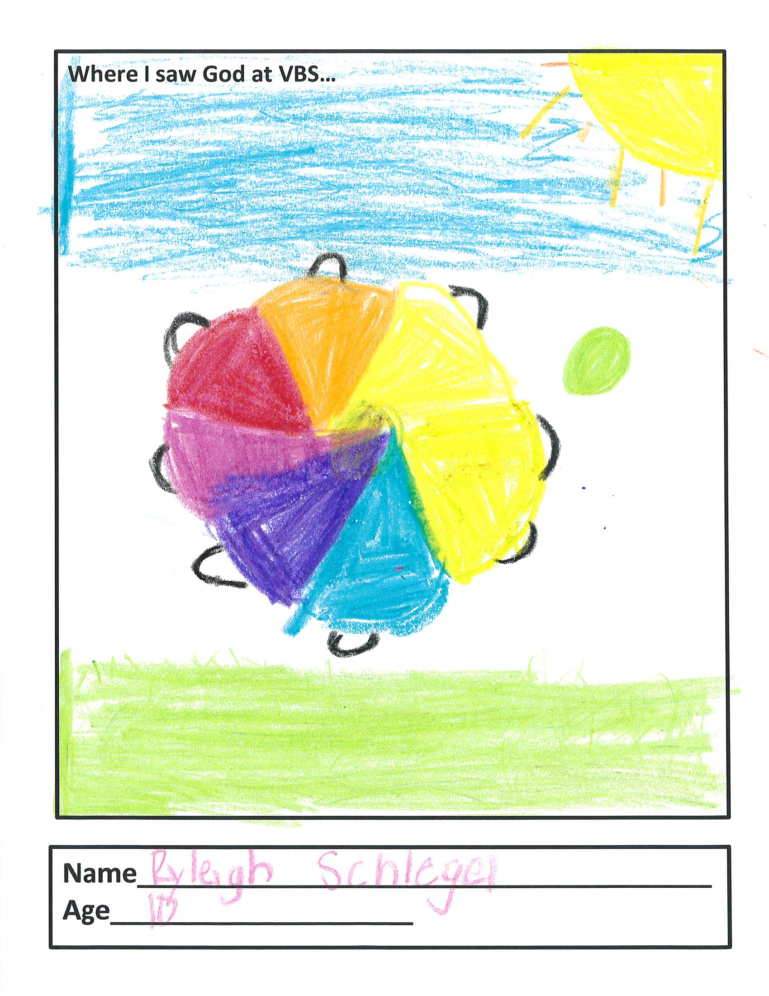

WELCOME TO OUR WORSHIP!

- It is a joy to welcome our visitors! Please sign the guest book in the
Communication Center at the rear of the church, to the right as you exit, and take a Welcome Packet which is filled with information about Harrold Zion. Please introduce yourself to the pastor as you leave worship. We hope you return soon!
- Children’s bags are available in the Narthex.
- There is a prayer request book on a podium in the Welcome Center. Please
write name(s) in the book prior to the service to have names included in the prayers.
- Large print bulletins are available from any usher for those needing them.
- Hearing devices are available from any usher for those needing them.
- An AED machine can be found on the wall after the Ladies Room on the left.
- Receiving Holy Communion - We believe the body and blood of Christ to be present in the bread and wine. All who are baptized are invited to share in this meal. Please come forward at the usher's direction. Non-communing children may come forward for a blessing. If you desire communion in the pew, please inform one of the ushers so that you may receive communion there.

Our MISSION
To Worship and Serve God,
Grow Disciples and Love our Neighbors
Our Vision
Building Faith that’s Open, Affirming, Authentic,
Positive, Inviting, and that Serves Others.

GATHERING -The Holy Spirit calls us together as the people of God.
Welcome, Announcements, Carings and Sharings

Prelude: Sanctuary

Confession and Forgiveness: Please stand, as able.
All may make the sign of the cross, the sign that is marked at baptism.
Blessed be the holy Trinity, ☩ one God, the God of manna, the God of miracles, the God of mercy. Amen.
Drawn to Christ and seeking God’s abundance, let us confess our sin.
Assembly may kneel or stand. Silence is kept for reflection.
God, our provider, help us. It is hard to believe there is enough to share.
We question your ways when they differ from the ways of the world in which we live. We turn to our own understanding rather than trusting in you. We take offense at your teachings and your ways. Turn us again to you. Where else can we turn? Share with us the words of eternal life and feed us for life in the world. Amen.
Beloved people of God: in Jesus, the manna from heaven, you are fed and nourished. By Jesus, the worker of miracles, there is always more than enough.
Through Jesus, ☩ the bread of life, you are shown God’s mercy: you are forgiven and loved into abundant life. Amen.

Gathering Hymn # 526 God is Here

Apostolic Greeting
The grace of our Lord Jesus Christ, the love of God, and the
communion of the Holy Spirit be with you all. And also with you.

Hymn of Praise: Praise Him
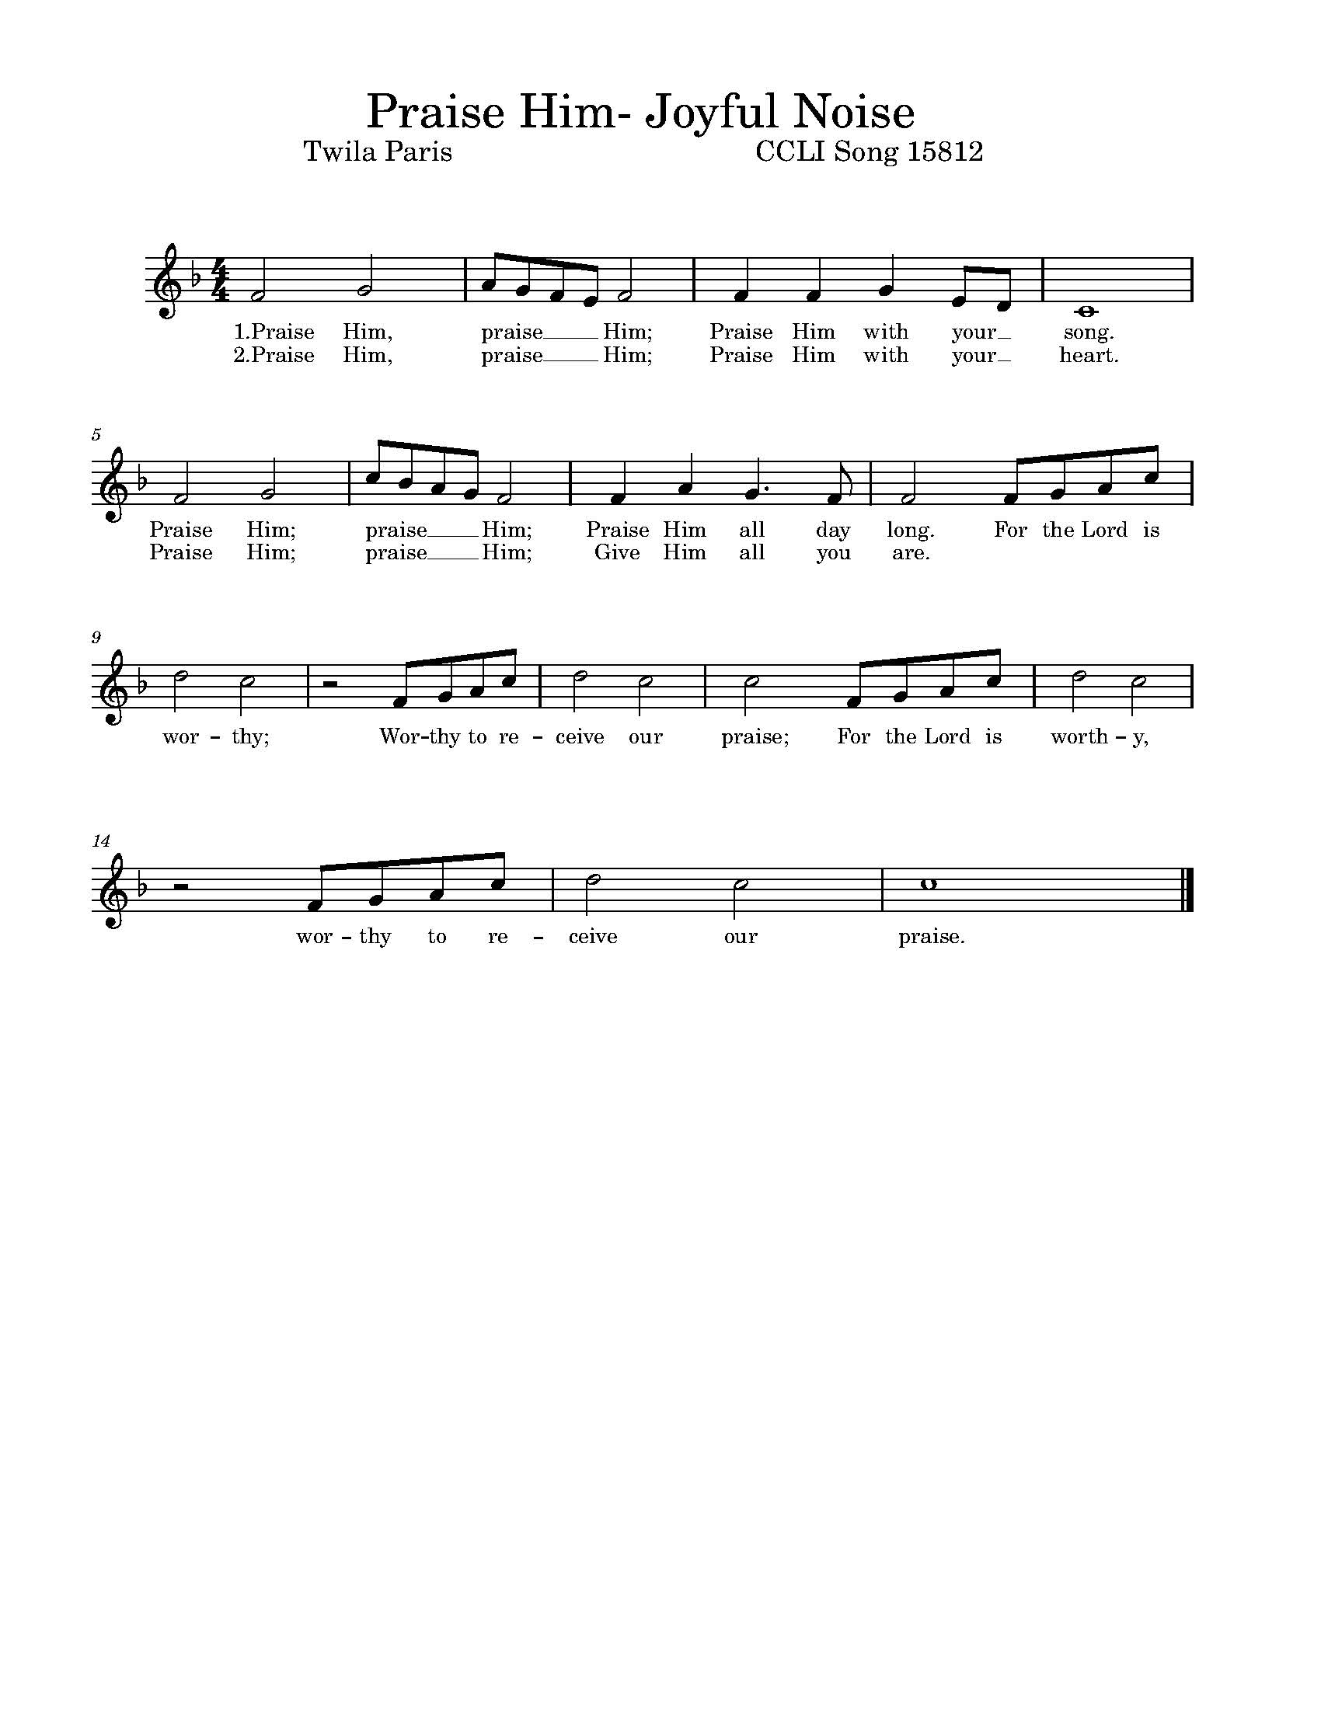
WORD- We hear God’s teachings to guide our path of serving.

Prayer of the Day
Let us pray together, O God, powerful and compassionate, you shepherd your people, faithfully feeding and protecting us. Heal each of us, and make us a whole people, that we may embody the justice and peace of your Son, Jesus Christ, our Savior and Lord. Amen.
Please be seated.

First Reading: 2 Samuel 7:1-14a
A reading from the 2nd book of Samuel:
¹ Now when the king was settled in his house, and the Lord had given him rest from all his enemies around him, ² the king said to the prophet Nathan, “See now, I am living in a house of cedar, but the ark of God stays in a tent.” ³ Nathan said to the king, “Go, do all that you have in mind; for the Lord is with you.” ⁴ But that same night the word of the Lord came to Nathan: ⁵ Go and tell my servant David: Thus says the Lord: Are you the one to build me a house to live in? ⁶ I have not lived in a house since the day I brought up the people of Israel from Egypt to this day, but I have been moving about in a tent and a tabernacle. ⁷ Wherever I have moved about among all the people of Israel, did I ever speak a word with any of the tribal leaders of Israel, whom I commanded to shepherd my people Israel, saying, “Why have you not built me a house of cedar?” ⁸ Now therefore thus you shall say to my servant David: Thus says the Lord of hosts: I took you from the pasture, from following the sheep to be prince over my people Israel; ⁹ and I have been with you wherever you went, and have cut off all your enemies from before you; and I will make for you a great name, like the name of the great ones of the earth. ¹⁰ And I will appoint a place for my people Israel and will plant them, so that they may live in their own place, and be disturbed no more; and evildoers shall afflict them no more, as formerly, ¹¹ from the time that I appointed judges over my people Israel; and I will give you rest from all your enemies. Moreover the Lord declares to you that the Lord will make you a house. ¹² When your days are fulfilled and you lie down with your ancestors, I will raise up your offspring after you, who shall come forth from your body, and I will establish his kingdom. ¹³ He shall build a house for my name, and I will establish the throne of his kingdom forever. ^{14a} I will be a father to him, and he shall be a son to me. The word of the Lord. Thanks be to God.

PSALM: 89:20-37
²⁰ “I have found David my servant;
with my holy oil have I anointed him.
²¹ My hand will hold him fast
and my arm will make him strong.
²² No enemy shall deceive him,
nor shall the wicked bring him down.
²³ I will crush his foes before him
and strike down those who hate him.
²⁴ My faithfulness and steadfast love are with him,
and he shall be victorious through my name.
²⁵ I will set his hand on the sea,
and his right hand on the rivers.
²⁶ He will say to me, ‘You are my father,
my God, and the rock of my salvation.’
²⁷ I will make him my firstborn
and higher than the kings of the earth.
²⁸ I will keep my love for him forever,
and my covenant will stand firm for him.
²⁹ I will establish his line forever
and his throne as the days of heaven.”
³⁰ If his children forsake my teaching
and do not walk according to my judgments;
³¹ if they break my statutes
and do not keep my commandments;
³² I will punish their transgressions with a rod
and their iniquities with the lash;
³³ but I will not take my love from him,
nor let my faithfulness prove false. R
³⁴ I will not break my covenant,
nor change what has gone out of my lips.
³⁵ Once for all I have sworn by my holiness:
I will not lie to David.
³⁶ His line shall endure forever
and his throne as the sun before me;
³⁷ it shall stand fast forevermore like the moon,
the abiding witness in the sky.”

Second Reading: Ephesians 2:11-22
A reading from Ephesians.
¹¹ Remember that at one time you Gentiles by birth, called “the uncircumcision” by those who are called “the circumcision”—a physical circumcision made in the flesh by human hands—¹² remember that you were at that time without Christ, being aliens from the commonwealth of Israel, and strangers to the covenants of promise, having no hope and without God in the world. ¹³ But now in Christ Jesus you who once were far off have been brought near by the blood of Christ. ¹⁴ For he is our peace; in his flesh he has made both groups into one and has broken down the dividing wall, that is, the hostility between us. ¹⁵ He has abolished the law with its commandments and ordinances, that he might create in himself one new humanity in place of the two, thus making peace, ¹⁶ and might reconcile both groups to God in one body through the cross, thus putting to death that hostility through it. ¹⁷ So he came and proclaimed peace to you who were far off and peace to those who were near; ¹⁸ for through him both of us have access in one Spirit to the Father. ¹⁹ So then you are no longer strangers and aliens, but you are citizens with the saints and also members of the household of God, ²⁰ built upon the foundation of the apostles and prophets, with Christ Jesus himself as the cornerstone. ²¹ In him the whole structure is joined together and grows into a holy temple in the Lord; ²² in whom you also are built together spiritually into a dwelling place for God.
The word of the Lord. Thanks be to God.

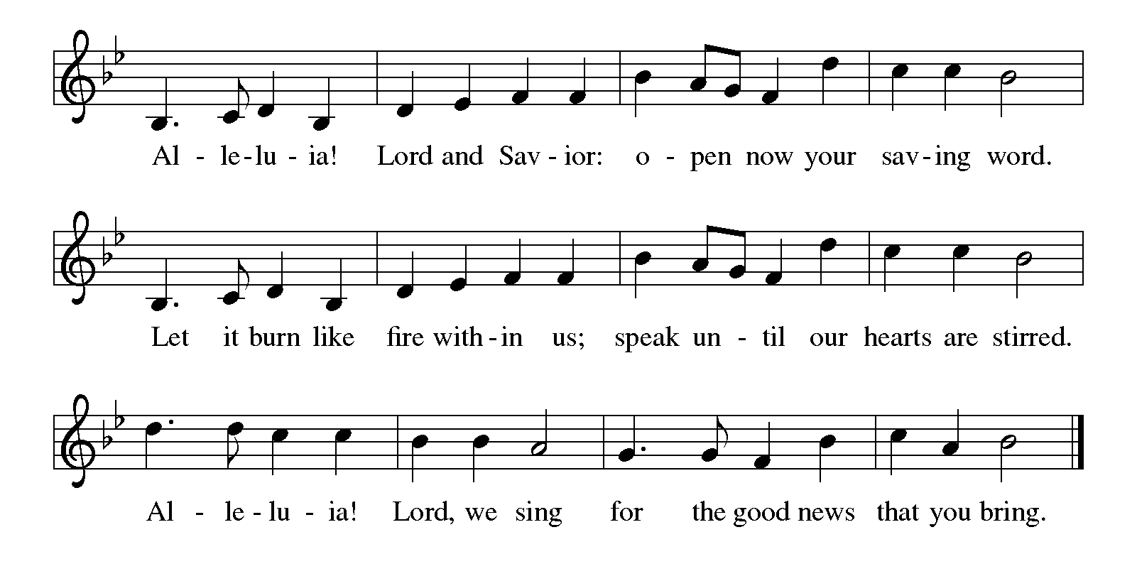
Gospel Acclamation Please stand, as able
Holy Gospel: Mark 6:30-34, 53-56
The holy gospel according to Mark.
Glory to you, O Lord.
³⁰ The apostles gathered around Jesus and told him all that they had done and taught. ³¹ He said to them, “Come away to a deserted place all by yourselves and rest a while.” For many were coming and going, and they had no leisure even to eat. ³² And they went away in the boat to a deserted place by themselves. ³³ Now many saw them going and recognized them, and they hurried there on foot from all the towns and arrived ahead of them. ³⁴ As he went ashore, he saw a great crowd; and he had compassion for them, because they were like sheep without a shepherd; and he began to teach them many things. ⁵³ When they had crossed over, they came to land at Gennesaret and moored the boat. ⁵⁴ When they got out of the boat, people at once recognized him, ⁵⁵ and rushed about that whole region and began to bring the sick on mats to wherever they heard he was. ⁵⁶ And wherever he went, into villages or cities or farms, they laid the sick in the marketplaces, and begged him that they might touch even the fringe of his cloak; and all who touched it were healed.
The Gospel of the Lord. Praise to you, O Christ.

Please be seated.

Children’s Message

Sermon

Hymn of the Day # 638 Blessed Assurance
Please stand, as able
Apostles’ Creed
I believe in God, the Father almighty,
creator of heaven and earth.
I believe in Jesus Christ, God's only Son, our Lord,
who was conceived by the power of the Holy Spirit,
born of the Virgin Mary,
suffered under Pontius Pilate,
was crucified, died, and was buried;
he descended to the dead.
On the third day he rose again;
he ascended into heaven,
he is seated at the right hand of the Father,
and he will come to judge the living and the dead.
I believe in the Holy Spirit,
the holy catholic Church,
the communion of saints,
the forgiveness of sins,
the resurrection of the body,
and the life everlasting. Amen

Prayers of the Intercession
(petitions)
…Lord in your mercy, Hear our prayer.
(prayer concludes)
…Amen.

Sharing of the Peace

MEAL -We are fed and nourished by the unending life of God.

Offering Onward, Christian Soldiers

Offertory #686 We Give Thee but Thine Own - Verses 1 & 2
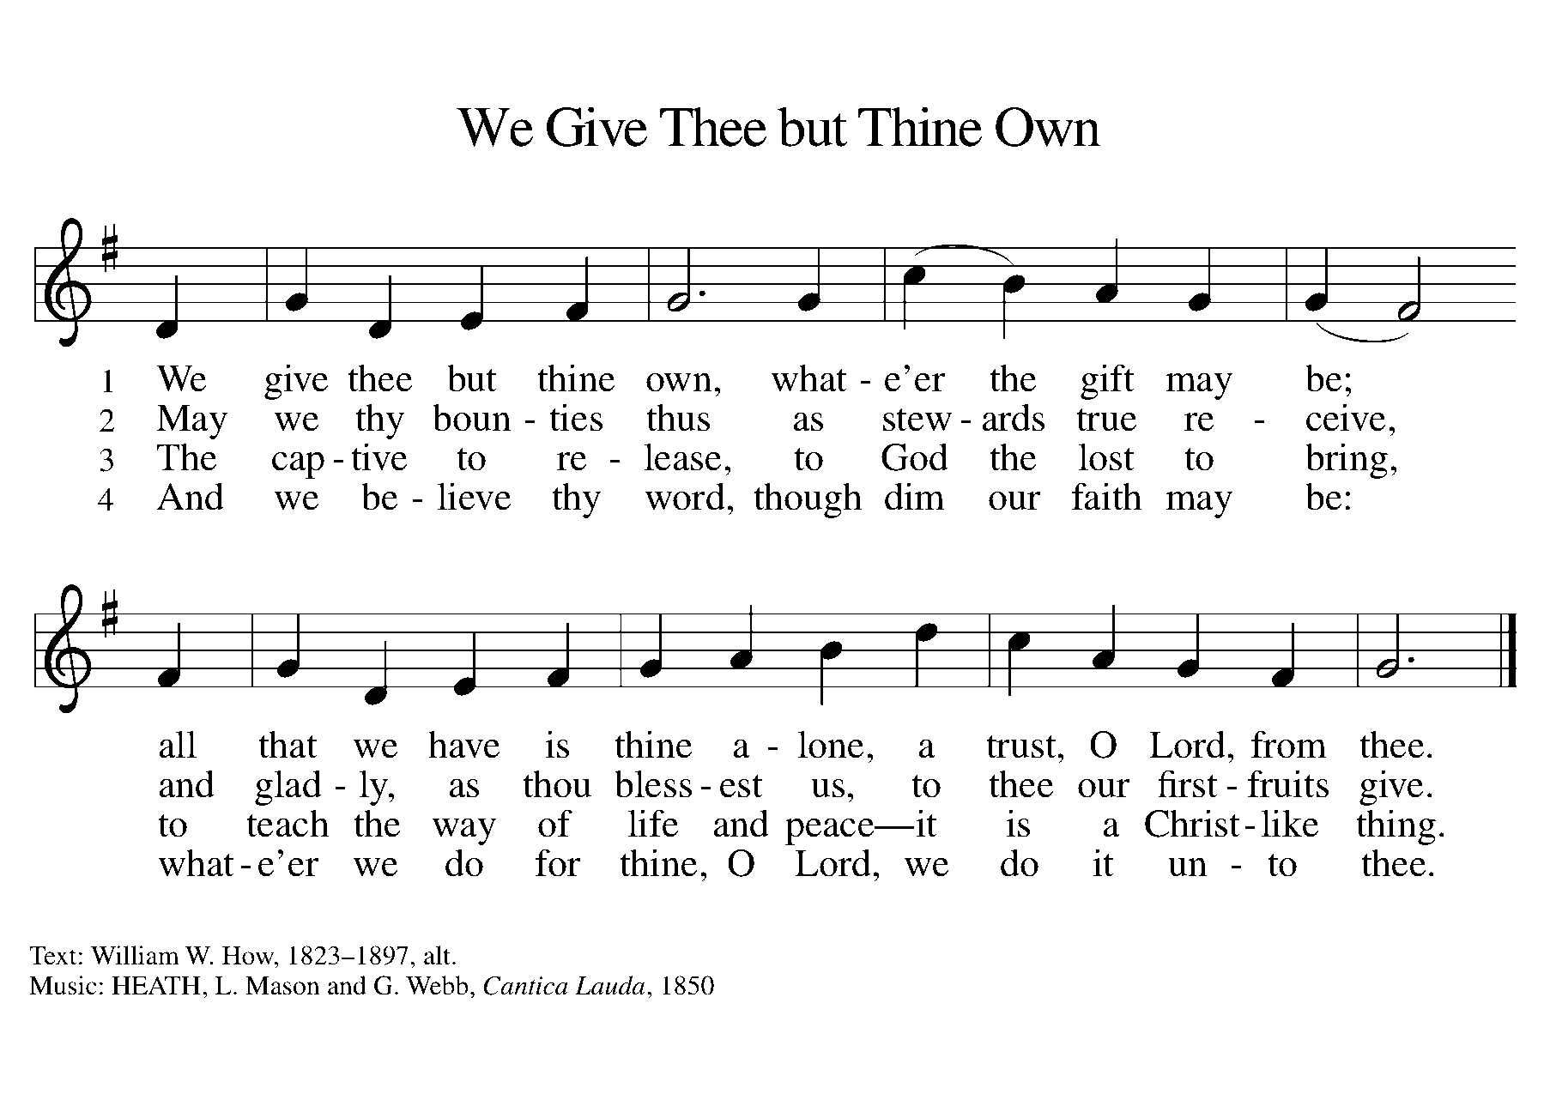

Offertory Prayer
Let us pray together. God of field and forest, sea and sky, you are the giver of all good things. Sustain us with these gifts of your creation,
and multiply your graciousness in us, that the world may be fed with your love, through Jesus Christ, our Savior and Lord. Amen.

The Great Thanksgiving and Proper Preface
The Lord be with you.
And also with you.
Lift up your hearts.
We lift them to the Lord.
Let us give thanks to the Lord our God.
It is right to give God thanks and praise.
It is indeed our duty and our joy… and join their unending hymn:
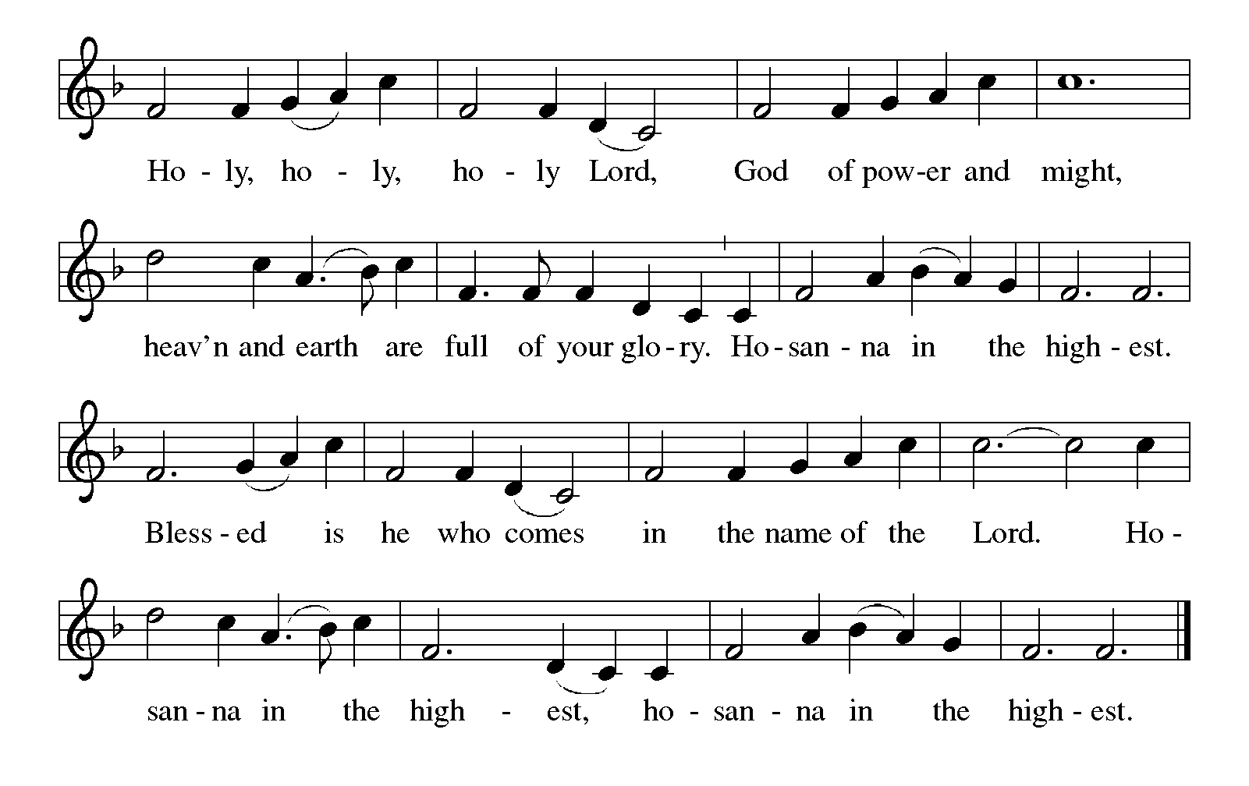

Eucharistic Prayer

The Lord's Prayer
Our Father, who art in heaven, hallowed be thy name, thy kingdom
come, thy will be done, on earth as it is in heaven. Give us this day
our daily bread; and forgive us our trespasses, as we forgive those
who trespass against us; and lead us not into temptation, but deliver
us from evil. For thine is the kingdom, and the power, and the glory,
forever and ever. Amen.

Breaking the Bread and Invitation to Communion
All people are called to Christ’s table.
Come, eat what is good.
Please be seated

Lamb of God
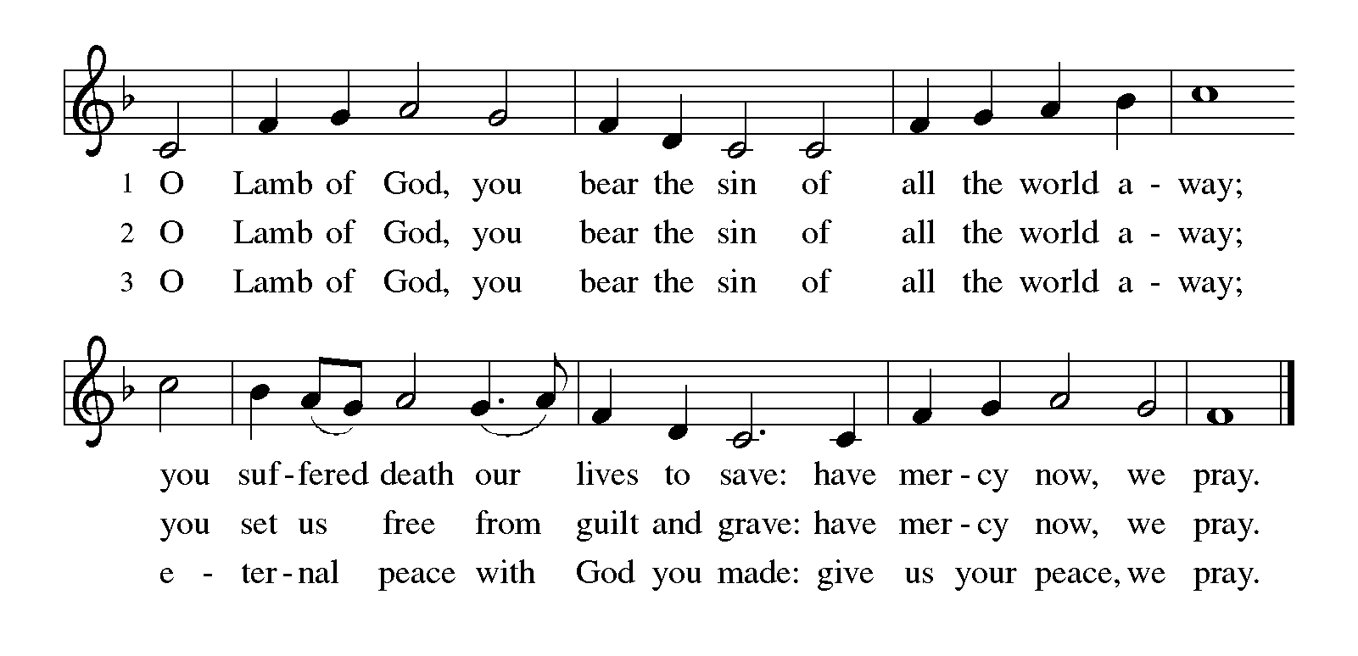
The proclamation is shared for those communing in their place with an all-in-one kit or home elements.

Sharing the elements:
The Body of Christ given for you.
The Blood of Christ shed for you.
Each person may respond: Amen.

The leaders share Holy Communion. Gluten free wafers and grape juice are in the center of each tray. The assembly is invited to come forward by the direction of the ushers by the center aisle and receive Holy communion, then return via the side aisle.

Communion Hymns: Because He Lives, Amazing Grace

SENDING -We are sent out to share hope and make disciples.

Post-Communion Blessing The assembly is invited to stand.

Prayer after Communion
Let us pray together. We thank you, generous God, for the refreshment we have received at your banquet table. Send us now to spread your generosity into all the world, through the one who is our dearest treasure, Jesus Christ, our Savior and Lord. Amen.

Blessing
The God who calls across the cosmos and speaks in the smallest seed ☩ bless, keep, and sustain you now and to the end of the age. Amen.
Sending Hymn # 538 The Lord Now Send Us Forth

Quiet Meditation

Dismissal
Go in peace. Share the harvest. Thanks be to God.

Postlude

From sundaysandseasons.com. Copyright © 2023 Augsburg Fortress. All rights reserved. Reprinted by permission under Augsburg Fortress Liturgies Annual License #SAS006821. New Revised Standard Version Bible, Copyright © 1989, Division of Christian Education of the National Council of the Churches of Christ in the United States of America. Used by permission. All rights reserved. Revised Common Lectionary, Copyright © 1992 Consultation on Common Texts, admin Augsburg Fortress. Used by permission. "Sanctuary" CCLI Song #24140; "Because He Lives" CCLI Song #16880; "Praise Him" CCLI Song #15812. CCLI Streaming License #20189555 CCLI, Church Copyright License #11344725. "God Is Here" One License Song #00059 and #73262; "The Lord Now Sends Us Forth" One License Song #02757. Livestreamed with permission under ONE License, License # A-732944 All Rights Reserved.

THE ALTAR FLOWERS are dedicated to God and in honor of Pat Boyer on his birthday, Happy Birthday Pat, all my love, Linda and Happy Birthday Dad, with love, your children, Lynn, Dana and Jeff. Happy Birthday Kim Elias. I’m so blessed to call you a friend. Have a wonderful day, Love Deb Mertz.
THE ROSES ON THE ALTAR are in dedicated to God and in Loving Memory of Sandy Heasley from her children and in honor of Ron Brown on his birthday by Marilyn Brown.
THE CANDLE is dedicated to God and in honor of Pap Pap’s Birthday (Pat Boyer) with love grandchildren Colleen, Brian, Stephanie, Alyssa, Ava, Eden and Elijah.
THE BULLETIN is dedicated to God and in honor of PaPa’s (Pat Boyer) birthday, with love, your great grandchildren Joey, and Logan.
Service Participants
Acolyte: 10:30 am Caleb Heasley
Lectors: 10:30 am Deb Mertz
Communion Assistants: 10:30 am Bob Kebe, Erin Black
Ushers: 10:30 am Cheryl Eckles, Dale Mertz, Fred Wineman
Altar Guild: Ann Wineman, Lori Farrell

THIS WEEK….
Robyn OFFICE HOURS M-F. 9:00 AM –2:00 PM FRIDAY 9-12PM

SUNDAY
8 am Service
10:30 Joyful Noise Service
9:20 am Donuts & Discussion
11:45 am Evangelism
MONDAY
6:30 Property Committee
TUESDAY
10:00 am Prayer Shawl Ministry
WEDNESDAY
THURSDAY
FRIDAY
SATURDAY
5:00 pm Worship w/ Communion

Building Fund
There are envelopes in the Communication Center for donations for our building fund. Please use these to support the sealing of the parking lot (about $15000). Thank you in advance for your support and generosity in how you prayerfully consider responding!

Hempfield Manor Hymn Sing and Holy Communion
Our next Hymn Sings at Hempfield Manor will be Thursday August 1st 6pm, Tuesday September 10th 1pm, Monday October 21st 10 am, Saturday November 2nd 2 pm, Tuesday December 17th 6 pm. Come join us as we sing classic hymns that the residents have requested. All are welcome!
Youth Singers and Instrumentalists Needed for Rally Day!
I am looking for Youth Singers and Instrumentalists to present the "Rally Day Song" at the September 8th Rally Day Service! Please contact Laurie at lracculia@yahoo.com if interested. All instruments and skill levels are welcome! Upcoming opportunities for youth musicians will also include Reformation Weekend (October 26/27) and Christmas Eve.

Donuts and Divine Discussion:
Share in a time of circular talks and circular snacks. Hangout with Pastor Andrew for a time of fellowship, casual Bible study, theological conversation, and if there are any current or news events, we will circle those in too! These will be in the hole between the circle of the Sunday worship services (around 9:20-10:10) on July 21, August 11 & 25

Trip to see the Washington Wild Things take on the New York Boulders at 7:05 July 26th. It’s a fireworks night! We will meet outside the box office at 6:15 to purchase tickets. General Admission is $15 per seat. Carpoolers need to be at church at 5 pm. There are various give-away and promotions between innings. There is a sign-up sheet in the communication center if you are interested in attending the game. There is a place to check if you are interested in car-pooling to Washington Pa.

Splash Day and Church Picnic
Sunday, July 28th at 2:00pm (Aug. 11th rain-date). Join us for some summer fun with our giant slip and slide, hot dogs and hamburgers, and fellowship. Wanting to care for our neighbors, we are asking for donations of water and gatorade type drinks for our local first responders. Please sign-up in the Communication Center to get a count for food.
Church wide picnic in conjunction with Splash Day on Sun. July 28th, with a rain date of Aug. 11th. We will be grilling burgers and dogs (possibly cooking hotdogs over the fire if it’s not too hot). There will be other picnic foods and drinks as well. You are welcome to bring a dessert/side to share but it is not necessary. The picnic is for all ages. Starting at 3pm food will be available. There will be Giant Jenga, Connect 4, and other yard games. Perhaps we can have a corn-hole tournament??? Please sign up in the communication center if you are interested in attending the event.
ITEMS AVAILABLE FOR SPONSORSHIP:
Altar Vases: July 27,28 (1 Vase), August 3,4 (2 Vases),
August 10,11 (2 Vases)
Roses: July 27,28 (2 Roses), August 3,4 (2 Roses), August 10,11 (1Rose)
Candle: July 27,28, August 3,4, August 10,11
Bulletin: July 27, 28, August 3,4, August 10,11
To sponsor items, please sign up in the Communication Center

Church Staff and Office – 724-837-7327
Rev. Andrew Fitch, Senior Pastor pastorfitch@outlook.com
Rev. Caroline Clifford, PhD, Asst. Pastor pastorcarolinehzlc@gmail.com
Robyn Henry, Secretary robynhzlc@gmail.com
Sheri Anderson, Coordinator of Family Ministries hzlcyouth@gmailcom
Laurie Racculia, Director of Music Ministries lracculia@yahoo.com
Debby Schlegel, Custodian
Joanne Gebhardt, Sunday Organist
Melanie Altman, Saturday Organist

A few of our Favorite Hymns: This summer we will be using favorite hymns that YOU choose! Please fill out the tear off slip below and contribute to some summer worship music fun! Hymns will be used for all hymns and the hymn of praise. If you know that someone else will be picking the same hymn, then please contribute another one. If we get enough, we will keep using these in worship planning into the fall!

MY FAVORITE HYMN CHOICE

#_______ Title___________________________________________
Submitted by ___________________________
Place in offering plate or basket in entrance area.

