Harrold Zion Evangelical Lutheran Church
Season of Creation 3
God’s Work Our Hands Day of Service
Sunday September 8, 2024, 8 am, 10:30am
Rally Day


WELCOME TO OUR WORSHIP!

- It is a joy to welcome our visitors! Please sign the guest book in the
Communication Center at the rear of the church, to the right as you exit, and take a Welcome Packet which is filled with information about Harrold Zion. Please introduce yourself to the pastor as you leave worship. We hope you return soon!
- Children’s bags are available in the Narthex.
- There is a prayer request book on a podium in the Welcome Center. Please
write name(s) in the book prior to the service to have names included in the prayers.
- Large print bulletins are available from any usher for those needing them.
- Hearing devices are available from any usher for those needing them.
- An AED machine can be found on the wall after the Ladies Room on the left.
- Receiving Holy Communion - We believe the body and blood of Christ to be present in the bread and wine. All who are baptized are invited to share in this meal. Please come forward at the usher's direction. Non-communing children may come forward for a blessing. If you desire communion in the pew, please inform one of the ushers so that you may receive communion there.

Our MISSION
To Worship and Serve God,
Grow Disciples and Love our Neighbors
Our Vision
Building Faith that’s Open, Affirming, Authentic,
Positive, Inviting, and that Serves Others.

GATHERING -The Holy Spirit calls us together as the people of God.
Welcome, Announcements, Carings and Sharings

Blessing of the Teachers

Prelude Sarabande Lully

Confession and Forgiveness: Please stand, as able.
All may make the sign of the cross, the sign that is marked at baptism.
Blessed be the holy Trinity, ☩ one God,
who forgives all our sin,
whose mercy endures forever.
Amen.
Let us confess our sin and come to God for healing.
Silence is kept for reflection.
Gracious God,
have mercy on us.
We confess that we have honored you with our lips,
but have harmed our neighbors with our tongues.
The cravings at war within us
cause conflicts and disputes.
In our desire to be first
we make distinctions among ourselves.
We place the needs of the poor and the suffering last.
In your great mercy, forgive us our sins.
Draw near to us with grace in time of need,
and turn us to follow in the way of Jesus Christ,
our Savior and Lord.
Amen.
God promises to forgive our iniquity
and to remember our sin no more.
By grace you have been saved.
In the name of ☩ Jesus Christ,
the source of eternal healing,
your sins are forgiven.
Amen.

Gathering Hymn Revive Us Again

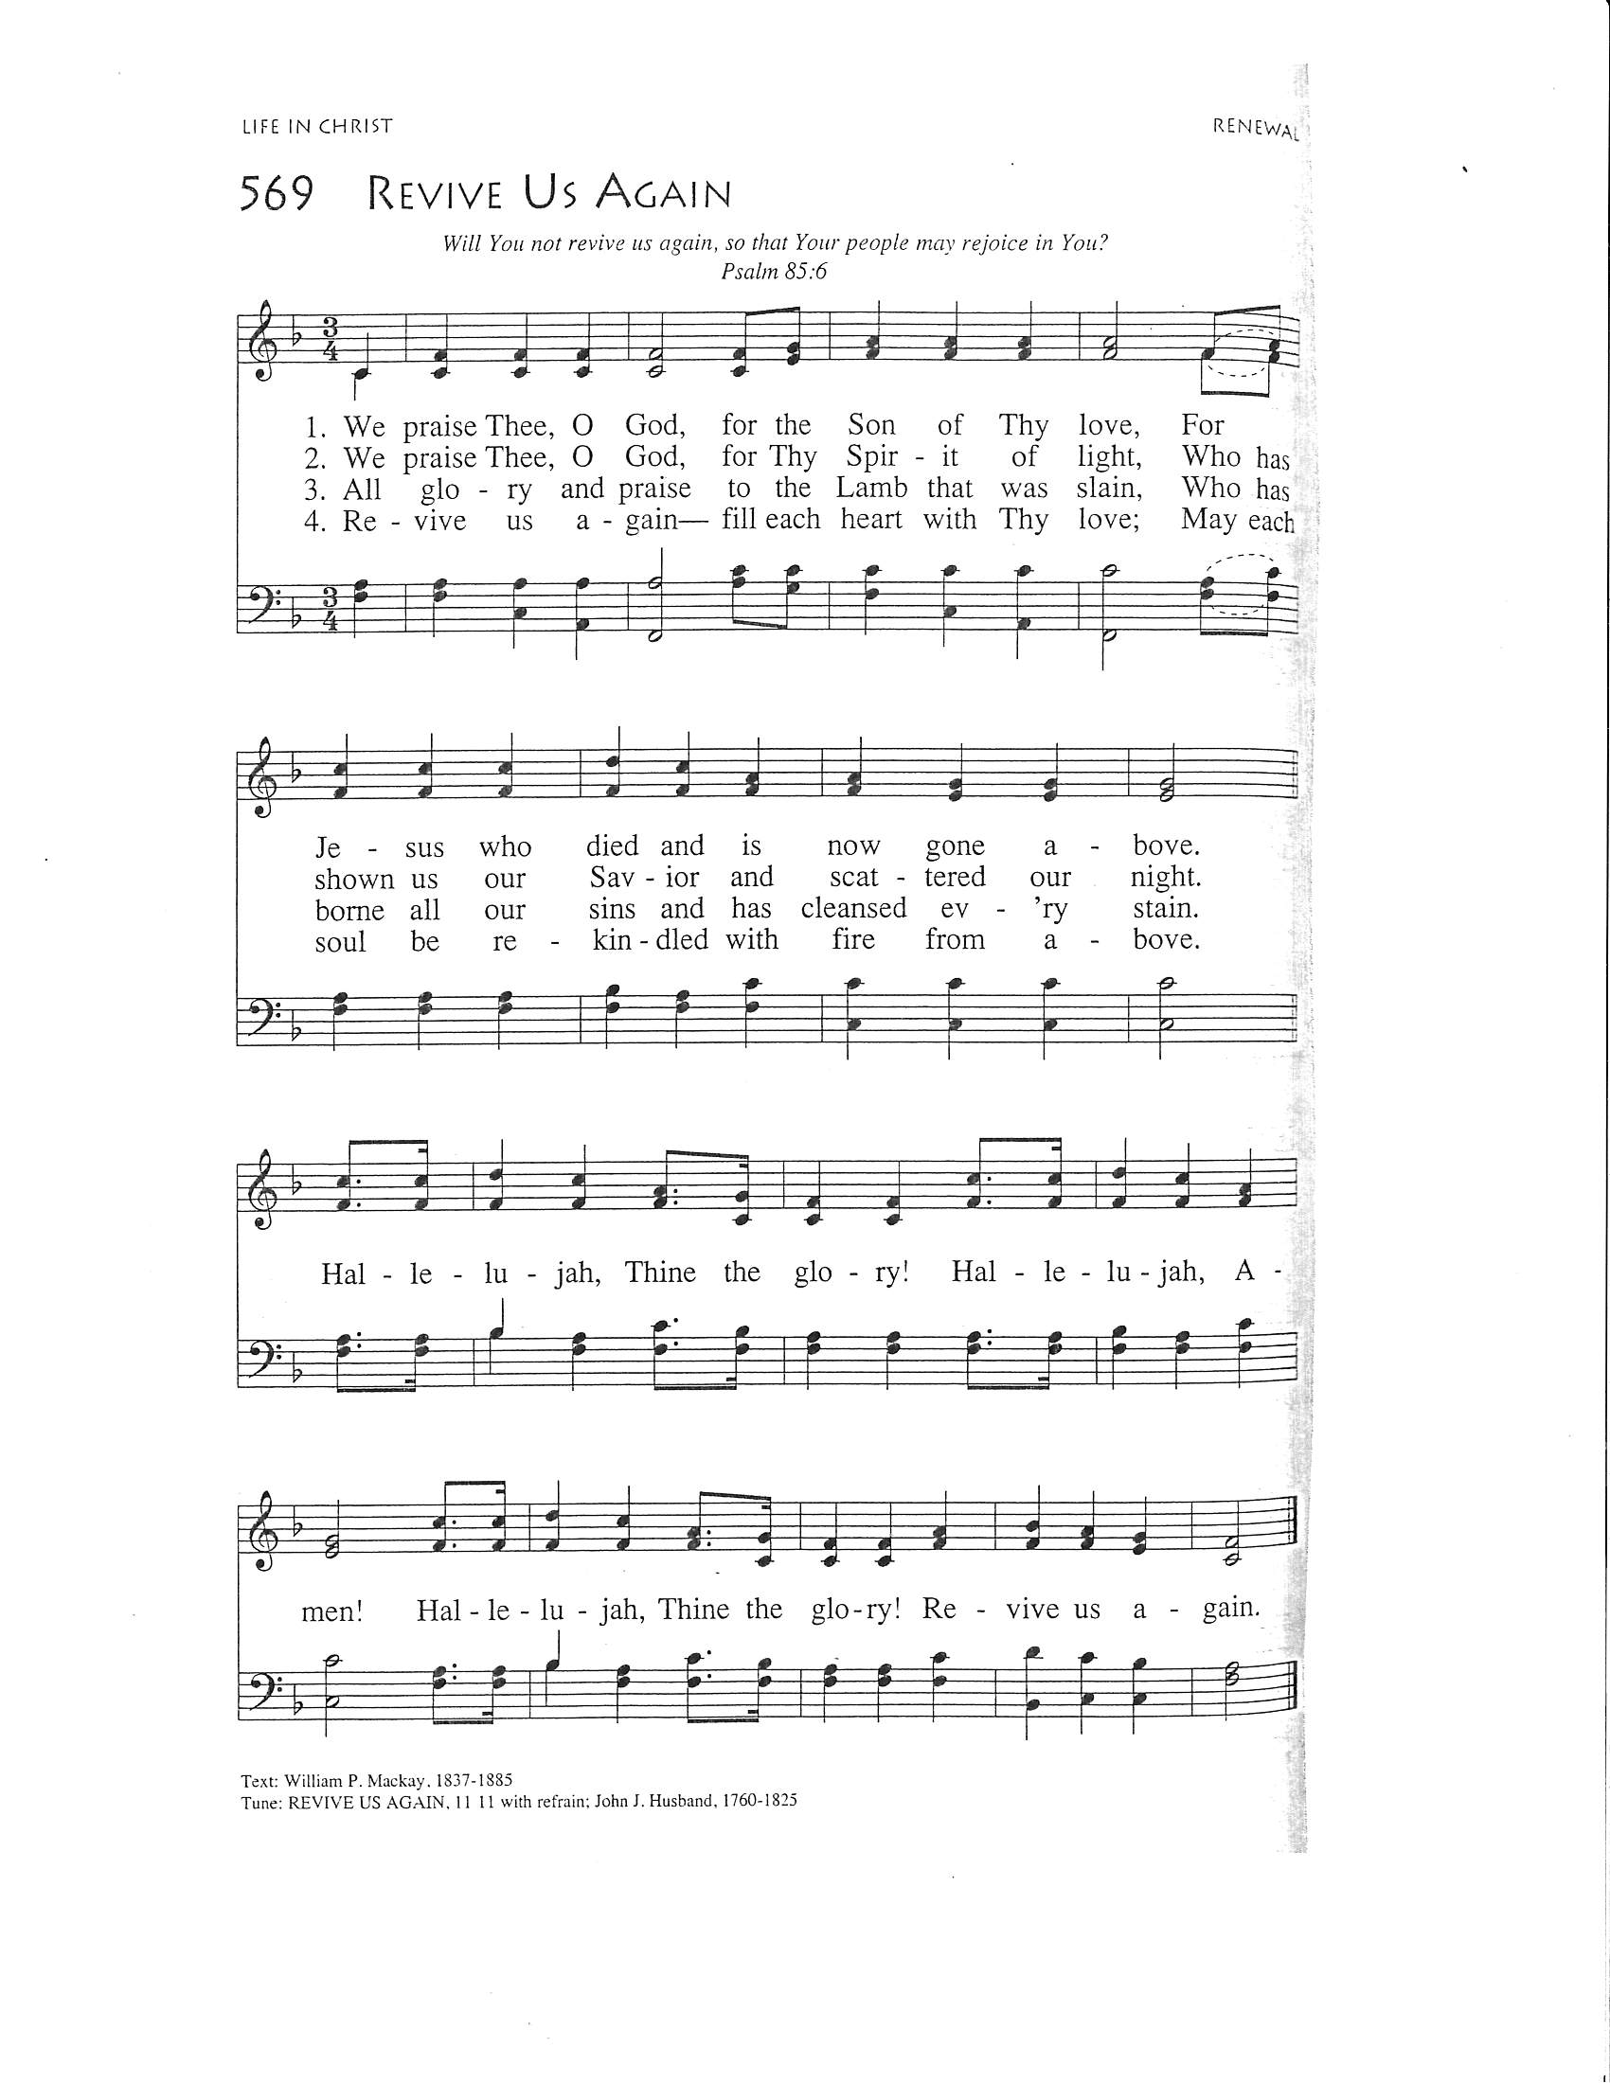

Apostolic Greeting
The grace of our Lord Jesus Christ, the love of God, and the
communion of the Holy Spirit be with you all. And also with you.

Hymn of Praise: # # 836 Joyful, Joyful, We Adore Thee

WORD- We hear God’s teachings to guide our path of serving.

Prayer of the Day
Let us pray together. Grant us, O Lord, to trust in you with all our hearts; for, as you always resist the powerful who oppress and dominate Creation, so you never forsake your creatures who live in harmony with nature’s order; through Jesus Christ the Wisdom of Creation, who lives and reigns with you and the Holy Spirit, now and for ever. Amen.
Please be seated.
First Reading Proverbs 22:1-2, 8-9, 22-23
¹A good name is to be chosen rather than great riches,
and favor is better than silver or gold.
²The rich and the poor have this in common:
the Lord is the maker of them all.
⁸Whoever sows injustice will reap calamity,
and the rod of anger will fail.
⁹Those who are generous are blessed,
for they share their bread with the poor.
²²Do not rob the poor because they are poor,
or crush the afflicted at the gate;
²³for the Lord pleads their cause
and despoils of life those who despoil them. Thanks be to God. Word of God, word of life. The word of the Lord. Thanks be to God.

Anthem:10:30 am The Rally Day Song

Psalm 125
¹Those who trust in the Lord are like Mount Zion,
which cannot be moved, but stands fast forever.
²The mountains surround Jerusalem;
so you surround your people, O Lord, from this time forth for- evermore.
³The scepter of the wicked shall not hold sway over the land allotted to the just, so that the just shall not put their hands to evil.
⁴Show your goodness, O Lord, to those who are good
and to those who are true of heart.
⁵As for those who turn aside to crooked ways, the Lord will lead them away with the evildoers; but peace be upon Israel.

Second Reading: James 2:1-10 [11-13] 14-17
A reading from James:
¹My brothers and sisters, do you with your acts of favoritism really believe in our glorious Lord Jesus Christ? ²For if a person with gold rings and in fine clothes comes into your assembly, and if a poor person in dirty clothes also comes in, ³and if you take notice of the one wearing the fine clothes and say, “Have a seat here, please,” while to the one who is poor you say, “Stand there,” or, “Sit at my feet,” ⁴have you not made distinctions among yourselves, and become judges with evil thoughts? ⁵Listen, my beloved brothers and sisters. Has not God chosen the poor in the world to be rich in faith and to be heirs of the kingdom that he has promised to those who love him? ⁶But you have dishonored the poor. Is it not the rich who oppress you? Is it not they who drag you into court? ⁷Is it not they who blaspheme the excellent name that was invoked over you?
⁸You do well if you really fulfill the royal law according to the scripture, “You shall love your neighbor as yourself.” ⁹But if you show partiality, you commit sin and are convicted by the law as transgressors. ¹⁰For whoever keeps the whole law but fails in one point has become accountable for all of it. [¹¹For the one who said, “You shall not commit adultery,” also said, “You shall not murder.” Now if you do not commit adultery but if you murder, you have become a transgressor of the law. ¹²So speak and so act as those who are to be judged by the law of liberty. ¹³For judgment will be without mercy to anyone

¹³For judgment will be without mercy to anyone who has shown no mercy; mercy triumphs over judgment.]
¹⁴What good is it, my brothers and sisters, if you say you have faith but do not have works? Can faith save you? ¹⁵If a brother or sister is naked and lacks daily food, ¹⁶and one of you says to them, “Go in peace; keep warm and eat your fill,” and yet you do not supply their bodily needs, what is the good of that? ¹⁷So faith by itself, if it has no works, is dead. The Word of the Lord. Thanks be to God.

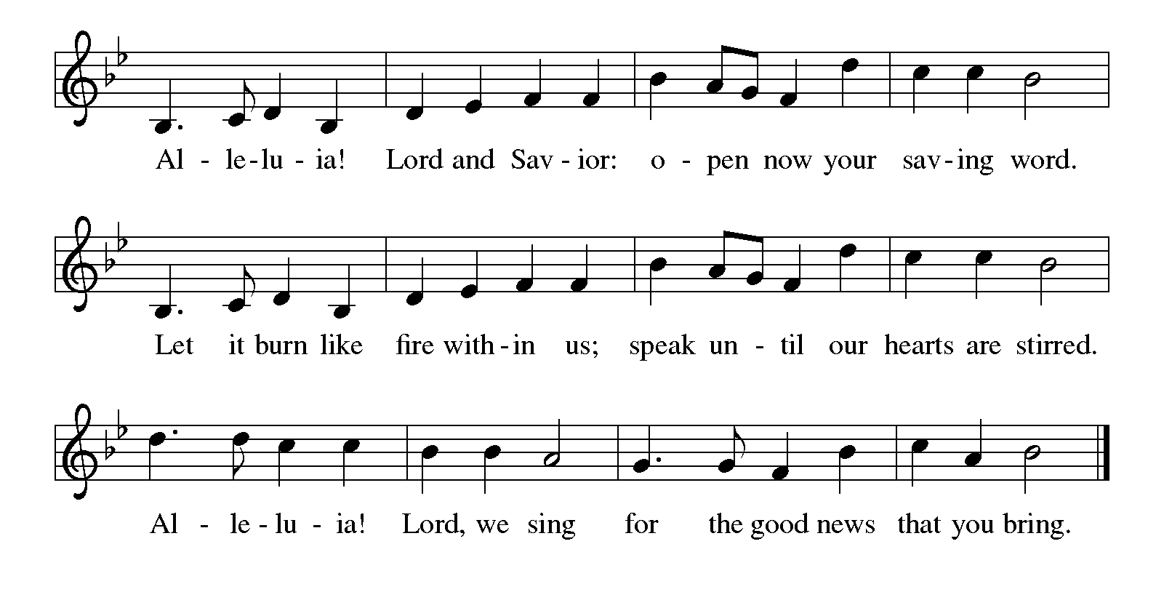
Gospel Acclamation Please stand, as able
Holy Gospel: Mark 7:24-37
The holy gospel according to Mark.
Glory to you, O Lord.
²⁴[Jesus] set out and went away to the region of Tyre. He entered a house and did not want anyone to know he was there. Yet he could not escape notice,²⁵but a woman whose little daughter had an unclean spirit immediately heard about him, and she came and bowed down at his feet. ²⁶Now the woman was a Gentile, of Syrophoenician origin. She begged him to cast the demon out of her daughter. ²⁷He said to her, “Let the children be fed first, for it is not fair to take the children’s food and throw it to the dogs.” ²⁸But she answered him, “Sir, even the dogs under the table eat the children’s crumbs.” ²⁹Then he said to her, “For saying that, you may go—the demon has left your daughter.” ³⁰So she went home, found the child lying on the bed, and the demon gone.
³¹Then he returned from the region of Tyre, and went by way of Sidon towards the Sea of Galilee, in the region of the Decapolis. ³²They brought to him a deaf man who had an impediment in his speech; and they begged him to lay his hand on him. ³³He took him aside in private, away from the crowd, and put his fingers into his ears, and he spat and touched his tongue. ³⁴Then looking up to heaven, he sighed and said to him, “Ephphatha,” that is, “Be opened.” ³⁵And immediately his ears were opened, his tongue was released, and he spoke plainly. ³⁶Then Jesus ordered them to tell no one; but the more he ordered them, the more zealously they proclaimed it. ³⁷They were astounded beyond measure, saying, “He has done everything well; he even makes the deaf to hear and the mute to speak. The gospel of the Lord. Praise to you, O Christ.

Please be seated.

Children’s Message

Sermon

Hymn of the Day # ACS 1000 God’s Work, Our Hands
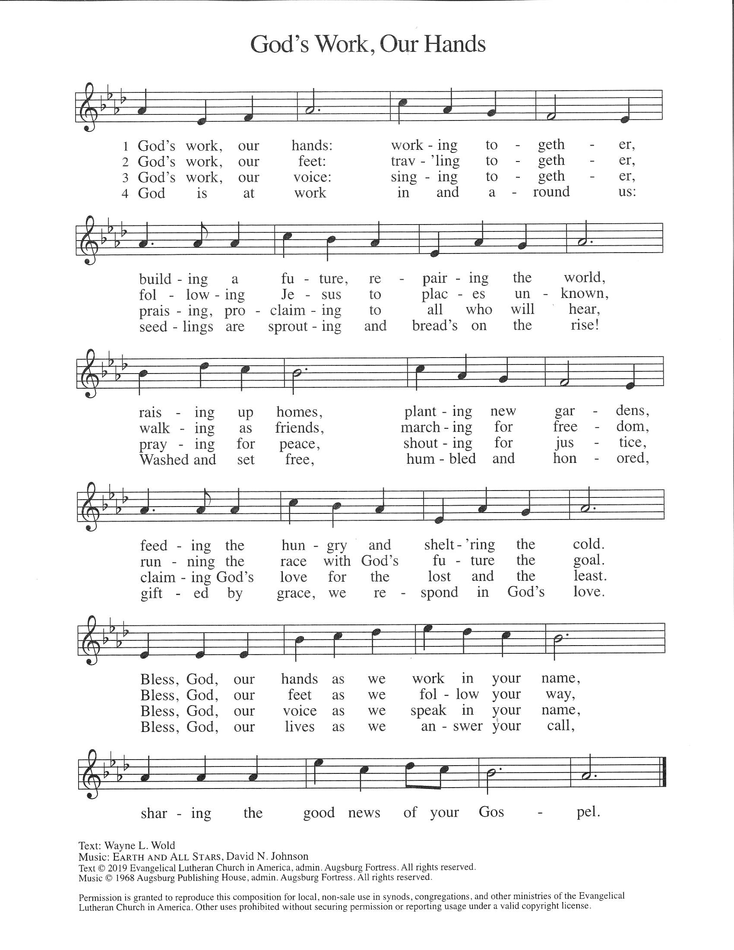
Please stand, as able
Blessing of the Food for Food 2 Go 4 Kids
Apostles’ Creed
I believe in God, the Father almighty,
creator of heaven and earth.
I believe in Jesus Christ, God's only Son, our Lord,
who was conceived by the power of the Holy Spirit,
born of the Virgin Mary,
suffered under Pontius Pilate,
was crucified, died, and was buried;
he descended to the dead.
On the third day he rose again;
he ascended into heaven,
he is seated at the right hand of the Father,
and he will come to judge the living and the dead.
I believe in the Holy Spirit,
the holy catholic Church,
the communion of saints,
the forgiveness of sins,
the resurrection of the body,
and the life everlasting. Amen

Prayers of the Intercession
(petitions)
…Lord in your mercy, Hear our prayer.
(prayer concludes)
…Amen.

Sharing of the Peace
Tithely Secure Giving


Offering The Abundant Life Parker

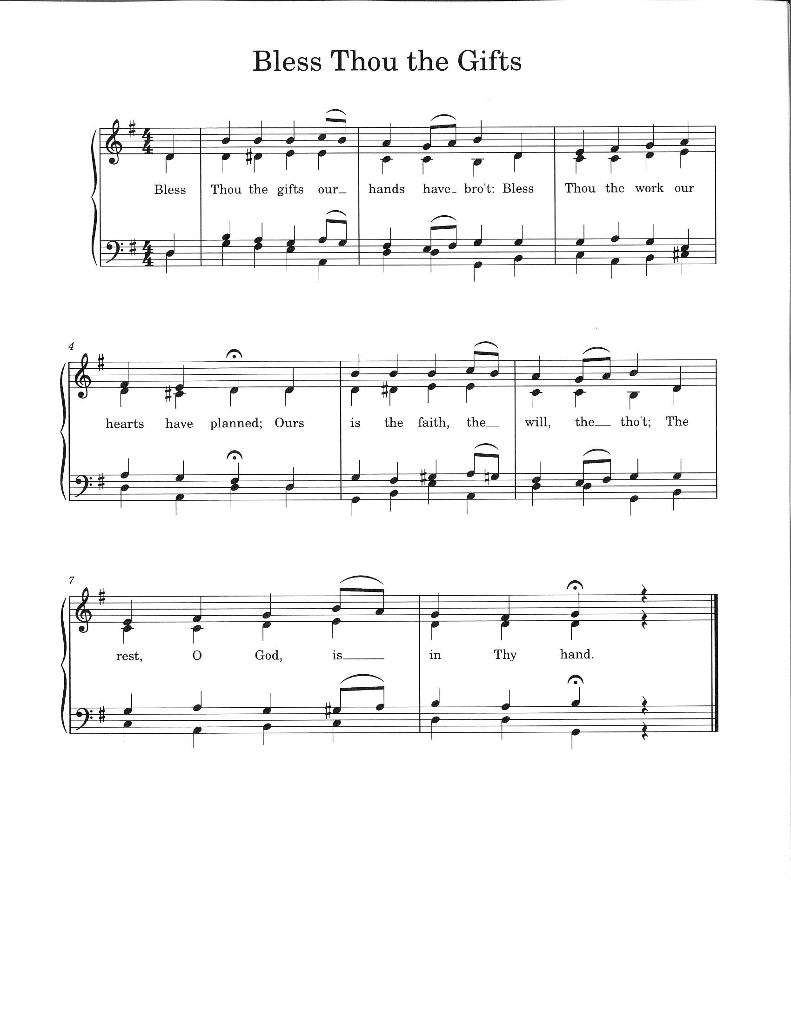
Offertory Bless Thou The Gifts (sung twice)
Offertory Prayer
Let us pray together. Blessed are you, O God,
Source of every gift of your creation. By these gifts and with our lives,
help us to serve one another and all in need, through Jesus Christ, our Savior and Lord. Amen.

The Lord's Prayer
Our Father, who art in heaven, hallowed be thy name, thy kingdom
come, thy will be done, on earth as it is in heaven. Give us this day
our daily bread; and forgive us our trespasses, as we forgive those
who trespass against us; and lead us not into temptation, but deliver
us from evil. For thine is the kingdom, and the power, and the glory,
forever and ever. Amen.

Blessing
God all mighty, God most merciful ☩ bless you, keep you, and give you peace.
Amen.

Sending Hymn # 579 Lord, You Give the Great Commission

Quiet Meditation

Prayer of Remembrance for Patriot Day (9/11)
Great God of all peoples, We praise you for your love and care for all. Teach us to learn and teach your way of peace. We thank you for all those who serve and protect our communities as first responders. We remember before you all those who died on September 11th and in all wars and conflicts…(pause for remembrance). Continue to show us how to honor, respect, and love one another. Guide us in our living out of your commandment to love our enemies. In your holy name we pray. Amen

911 Memorial Song: Turn Your Eyes Upon Jesus

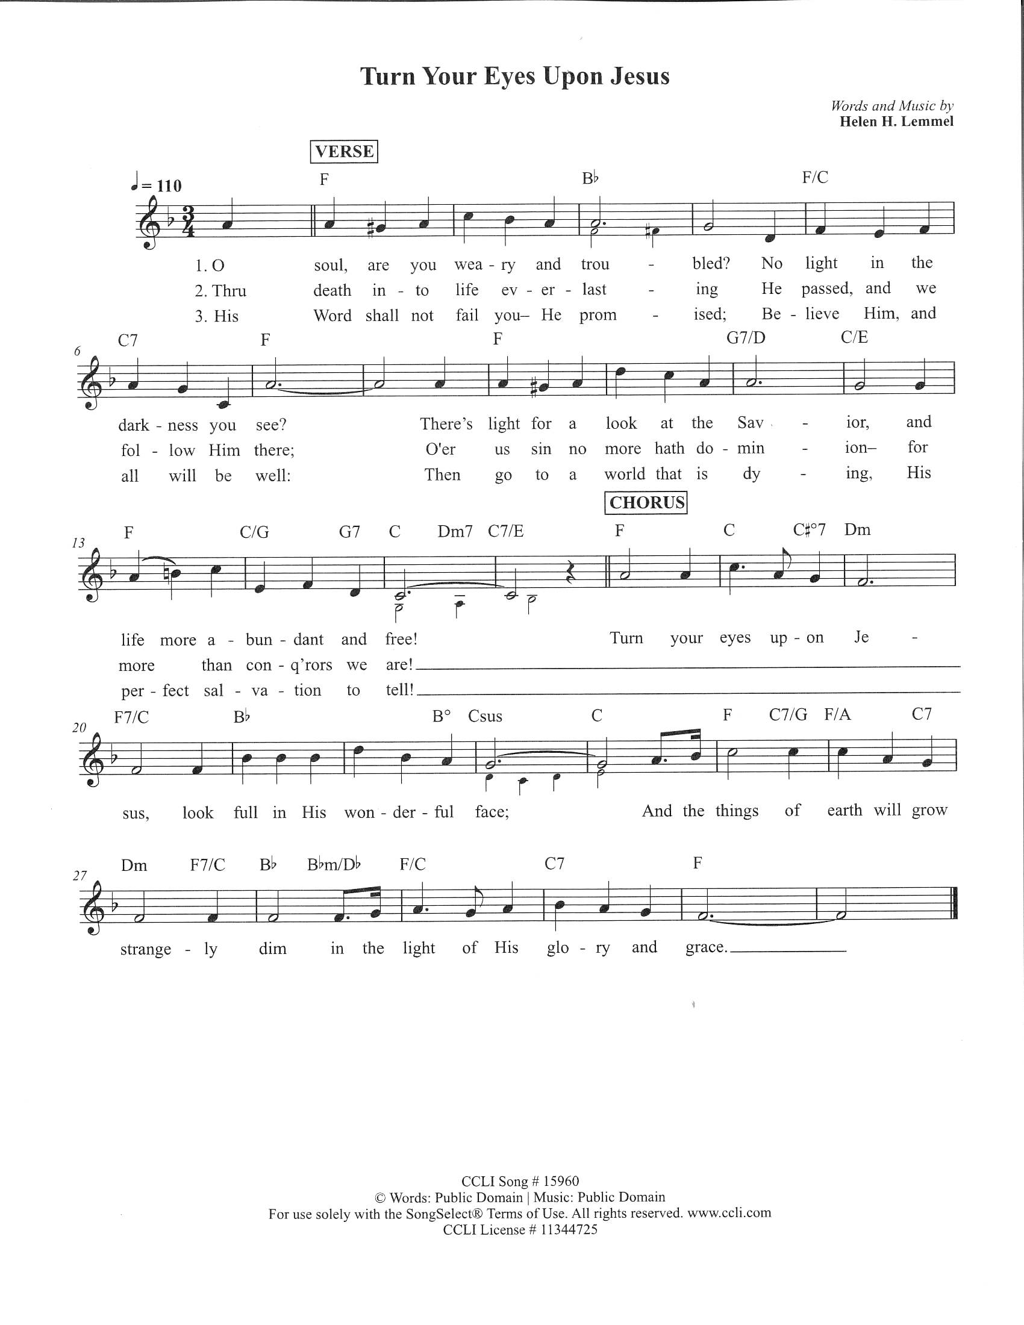
Dismissal
Go in peace. Follow Jesus. Thanks be to God. We will!

Postlude: Sent forth by God’s Blessing Welsh Folk Tune

From sundaysandseasons.com. Copyright © 2023 Augsburg Fortress. All rights reserved. Reprinted by permission under Augsburg Fortress Liturgies Annual License #SAS006821. New Revised Standard Version Bible, Copyright © 1989, Division of Christian Education of the National Council of the Churches of Christ in the United States of America. Used by permission. All rights reserved. Revised Common Lectionary, Copyright © 1992 Consultation on Common Texts, admin Augsburg Fortress. Used by permission. CCLI Streaming License #20189555 CCLI, Church Copyright License #11344725. "God's Work, Our Hands" One License Song #AF2019201; "Lord, You Give the Great Commission" One License Song #26961; "The Abundant Life" One License #211239; Livestreamed with permission under ONE License, License # A-732944 All Rights Reserved.

THE FLOWERS ON THE ALTAR are given to the glory of God, and in celebration of our 50th Wedding Anniversary, Bill & Vickie Fadrosh.
THE CANDLE is given to the glory of God and in loving memory of Bessie B Benson by Mark & Arlene Wagner.
Service Participants
Acolytes
8 am Heidi Koehl
10:30 am Ben Hayes
Lectors
8 am Linda Boyer
10:30 am Jack Molnar
Ushers 8 am Regis Bombach, Bonny Free
10:30 AM Diane Ihlenfeld, Kevin Kurimsky, Stacy Winfield, Jason Barnhart
Altar Guild: Missy Houston

THIS WEEK…. Robyn OFFICE HOURS M-TH. 9:00 AM – 2:00 PM FRIDAY 9AM- NOON

Sunday
Rally Day
9:15 am Parent’s Breakfast
9:15-10:15 am All Sunday School Classes begin today
11:45 am (new Group: Evangelism, Stewardship & Fellowship)
Monday
10:00 am Revelation (Social Hall)
10:30 am Quilting
1:00 pm Quilting
5:00 pm Thyme for Herbs
6:00 pm Joyful Noise
7:00 pm Worship Music

Tuesday
10:00 am Prayer Shawl Ministry
1:00 pm Hymn Sing
6:30 pm Book Study
7:00 pm Open Forum
7:30 pm Compassionate Friends
Wednesday
9: 00 am PS Library
6:00 pm Bell Choir Rehearsal
7:00 pm Adult Choir
Thursday
3:00 pm Grief Support
7:00 pm Boy Scouts
7:00 pm Council
Friday

Saturday
8:00 am Men’s Breakfast
9:00 am Joyful Noise Practice
5:00 pm Worship w/ Communion

Ladies Bible Study will resume in October.

Thank you to Susan Molnar for serving as this Sunday’s Organist! Thank you also to Eli and Isaac Schilling and Maria Gacek for the instrumental music during the Rally Day Song!

Helping Hands is sponsoring a Craft Show on Saturday November 9th from 10 am to 4 pm, here in the Social Hall. Anyone interested in a table or donating baked goods please contact Barbara Rigoni at 724-523-2069.
Building Fund
There are envelopes in the Communication Center for donations for our building fund. Please use these to support the sealing of the parking lot (about $15000). Thank you in advance for your support and generosity in how you prayerfully consider responding!

Hempfield Manor Hymn Sing and Holy Communion
Our next Hymn Sing at Hempfield Manor will be Tuesday, September 10 at 1 pm. Come join us as we sing classic hymns that the residents have requested. We will share an abbreviated Holy Communion service led by Pastor Caroline with the residents! All are welcome.

Rally Day and God’s Work Our Hands – September 7/8
We are collecting for Food2Go Ministry:
Chef Boyardee Pasta Variety 7.5oz cup, microwaveable
Kraft Original Mac & Cheese 2.5oz cups, microwaveable
Pepperidge Farm goldfish snack-size bags
Go Go Squeeze, applesauce, individual packs
Kellogg’s Assorted breakfast cereals, individual size boxes.
Nutra Grain bars, variety. See Newsletter for more details

REVELATION FOR EVERYONE – Bible Study in Four Sessions 9/9, 9/16, 9/23, 10/7 at 10am (in Social Hall)
(and separate online postings) See our Newsletter for more details.

Open Forum -Budget Preparations- September 10 at 7pm
All Committee leaders with questions and wanting more information about budget preparations are encouraged to come to this session with our Treasurer, Denny.


Sunday, September 15th, from 5:30 pm - 7:30 pm, Harrold Zion Community Youth Group. For kindergarten through 12th grade. We will be learning about The Good Samaritan. Use the QR code to pre register.

FIRST COMMUNION +++ SEPTEMBER 21st 2-4pm
If you child is showing an interest in receiving the Sacrament, please check you schedule and consider attending this event, a future event, or contacting Pastor Andrew for a session. Jesus extends a radical welcome to all at the Table. We are still learning how radical in love Jesus is! Come learn together—“There is a Place for You.” We use this helpful book by Pastor Daniel Erlander to help us understand our place at the Table.
Please sign up so that we can be sure there are enough materials for everyone.
Sign up by sending an email or text message to Pastor Andrew that you are interested.

LOCAL PEACEMAKERS’ TOOLBOX - SEPTEMBER 25 at 1 pm
Let’s make peace right here and right now
Let there be peace on Earth and let it begin with me
This introductory session will share some tools and tips to help to foster peace in difficult conversations. Like peace, this session is open to all.
To be clear, this is to empower us to find common ground, to appreciate others perspectives, and to listen respectfully. This is not one-sided and there is no agenda other than this – to work together for peace among our local communities.
If you are interested in future sessions to share these tools with community members, please let Pastor Andrew know.

BOOK STUDY: EVERYDAY SPIRITUALITY by James Hazelwood
Are you interested in maturing as a Christian, but unsure about spirituality and practices? Our first session will be September 26th at 6:30pm
Advance preparation – read the Introduction and section one of the Book Everyday Spirituality by James Hazelwood.
Future sessions October 24 at 6:30 and November 21 at 6:30pm
See Pastor Andrew with any questions

Laugh with the Lutherans - Comedy Night at Harrold Zion on Friday Nov. 22nd Doors will open at 5:30, dinner served at 6:00, and entertainment to begin around 7:30. All proceeds will go towards the church general operating cost. Tickets will go on sale starting the weekend of Sept. 14th & 15th. Save the date and start rounding up your favorite friends & family members who love to laugh, cheer, and have a jolly good time at the Harrold Zion Comedy See Newsletter for more details.

Youth Singers and Instrumentalists Needed for Rally Day!
I am looking for Youth Singers and Instrumentalists to present the "Rally Day Song" at the September 8th Rally Day Service! Please contact Laurie at lracculia@yahoo.com if interested. All instruments and skill levels are welcome! Upcoming opportunities for youth musicians will also include Reformation Weekend (October 26/27) and Christmas Eve.

Fall Book Class: Pastor Caroline is offering a class this fall using the book, “Believe: Living the story of the Bible to become like Jesus,” edited by Randy Frazee. We will be doing the third 10 lessons of the book. We are having the class on Tuesdays, 6:30 PM, here at the church. It will begin Tuesday, September 10th, and it will last 10 weeks.

Grief Support Group: The group will begin on September 12th at 3 PM here at the church. If you are interested or have questions, please contact Pr. Caroline at pastorcarolinehzlc@gmail.com or call the church office.

WORSHIP NOTES: We will be adding Setting 8 liturgical musical into our worship beginning in September. We will start celebrating Holy Communion on the 5th Sunday of the month (starting this month).

Donuts and Divine Discussion:
Share in a time of circular talks and circular snacks. Hangout with Pastor Andrew for a time of fellowship, casual Bible study, theological conversation, and if there are any current or news events, we will circle those in too! This will be in the hole between the circle of the Sunday worship services (around 9:20-10:10) on September 8th

ITEMS AVAILABLE FOR SPONSORSHIP:
Altar Flowers: September 21,22 (2 Vases), September 28,29 (2 Vases), October 5,6 (1 Vase), October 12,13 (2 Vases).
Roses: September 14,15 (2 Roses), September 21,22 (2 Roses),
September 28,29 (2 Roses) October 5,6 (1 Rose), October 12,13 (2 Roses)
Candle: September 14,15, September 21,22, September 28,29, October 5,6, October 12,13
Bulletin: September 14,15, September 21,22, September 28,29, October 5,6, October 12,13.
To sponsor items, please sign up in the Communication Center

Church Staff and Office – 724-837-7327
Rev. Andrew Fitch, Senior Pastor pastorfitch@outlook.com
Rev. Caroline Clifford, PhD, Asst. Pastor pastorcarolinehzlc@gmail.com
Robyn Henry, Secretary robynhzlc@gmail.com
Sheri Anderson, Coordinator of Family Ministries hzlcyouth@gmailcom
Laurie Racculia, Director of Music Ministries lracculia@yahoo.com
Debby Schlegel, Custodian
Joanne Gebhardt, Sunday Organist
Melanie Altman, Saturday Organist

