**Harrold Zion Evangelical Lutheran Church**

**Sunday May 19, 2024 – 10:30 AM Joyful Noise**

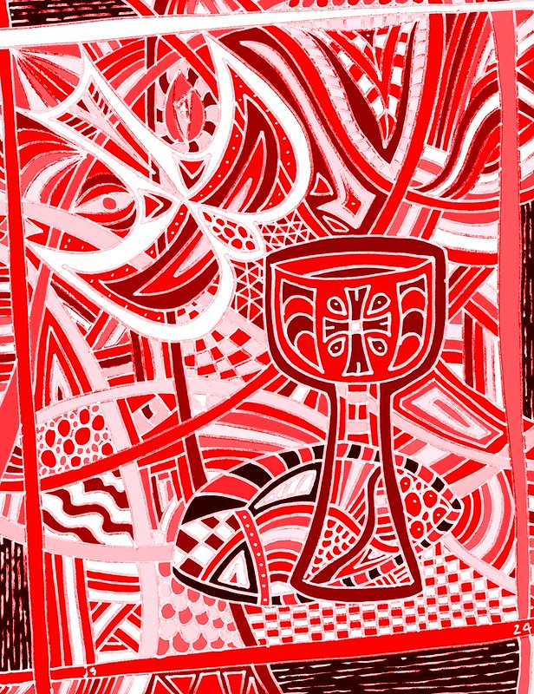

Affirmation of Baptism for Confirmation:

***Dixon Sidney Fait***

***Alexandra Reagan Perry***

Our MISSION

***To Worship and Serve God,***

***Grow Disciples and Love our Neighbors***

Our Vision

***Building Faith that’s Open, Affirming, Authentic,***

***Positive, Inviting, and that Serves Others.***

**WELCOME TO OUR WORSHIP!**

* **It is a joy to welcome our visitors!** Please sign the guest book in the

Communication Center at the rear of the church, to the right as you exit, and take a Welcome Packet which is filled with information about Harrold Zion. Please introduce yourself to the pastor as you leave worship. We hope you return soon!

* **Children’s bags** are available in the Narthex.
* **There is a prayer request book** on a podium in the Welcome Center. Please

write name(s) in the book prior to the service to have names included in the prayers.

* **Large print bulletins** are available from any usher for those needing them.
* **Hearing devices** are available from any usher for those needing them.
* **An AED machine** can be found on the wall after the Ladies Room on the left.
* **Receiving Holy Communion -** We believe the body and blood of Christ to be present in the bread and wine. All who are baptized are invited to share in this meal. Please come forward at the usher's direction. Non-communing children may come forward for a blessing. If you desire communion in the pew, please inform one of the ushers so that you may receive communion there.

*Like us on Facebook*

Welcome, Announcements and Joys & Concerns

*We rejoice this weekend with:*

*those Affirming their Baptism by Confirmation:*

*Cecilia Angeline Loughner and Isaac Heath Shilling (in 5pm worship),*

*Heidi Sue Koehl and Faith Nicole Orczeck (in 8am worship),*

*Dixon Sidney Fait and Alexandra Reagan Perry (10:30am worship)*

*We welcome and rejoice with Robert Koerber and Brittany Scuglia (parents) joining with us and Elainah Jean Koerber baptized in our 5pm worship.*

Blessing for Graduates

Prelude *Crash Collection*

Confession and Forgiveness *Please stand, as able.*

God of all mercy and consolation, come to the help of your people, turning us from our sin to live for you alone. Give us the power of your Holy Spirit that we may confess our sin, receive your forgiveness, and grow into the fullness of Jesus Christ, our Savior and Lord.

**Amen.** *The assembly kneels or stands. Silence is kept for reflection.*

Most merciful God, **we confess that we are captive to sin and cannot free ourselves. We have sinned against you in thought, word, and deed, by what we have done and by what we have left undone. We have not loved you with our whole heart; we have not loved our neighbors as ourselves. For the sake of your Son, Jesus Christ, have mercy on us. Forgive us, renew us, and lead us, so that we may delight in your will and walk in your ways, to the glory of your holy name. Amen.**

**In the mercy of almighty God, Jesus Christ was given to die for us, and for his sake God forgives us all our sins. As a called and ordained minister of the church of Christ, and by his authority, I therefore declare to you the entire forgiveness of all your sins, in the name of the Father, and of the ☩** Son**, and of the Holy Spirit. Amen.**

*Please stand, as able.*

Gathering Hymn: *Revive Us Again*

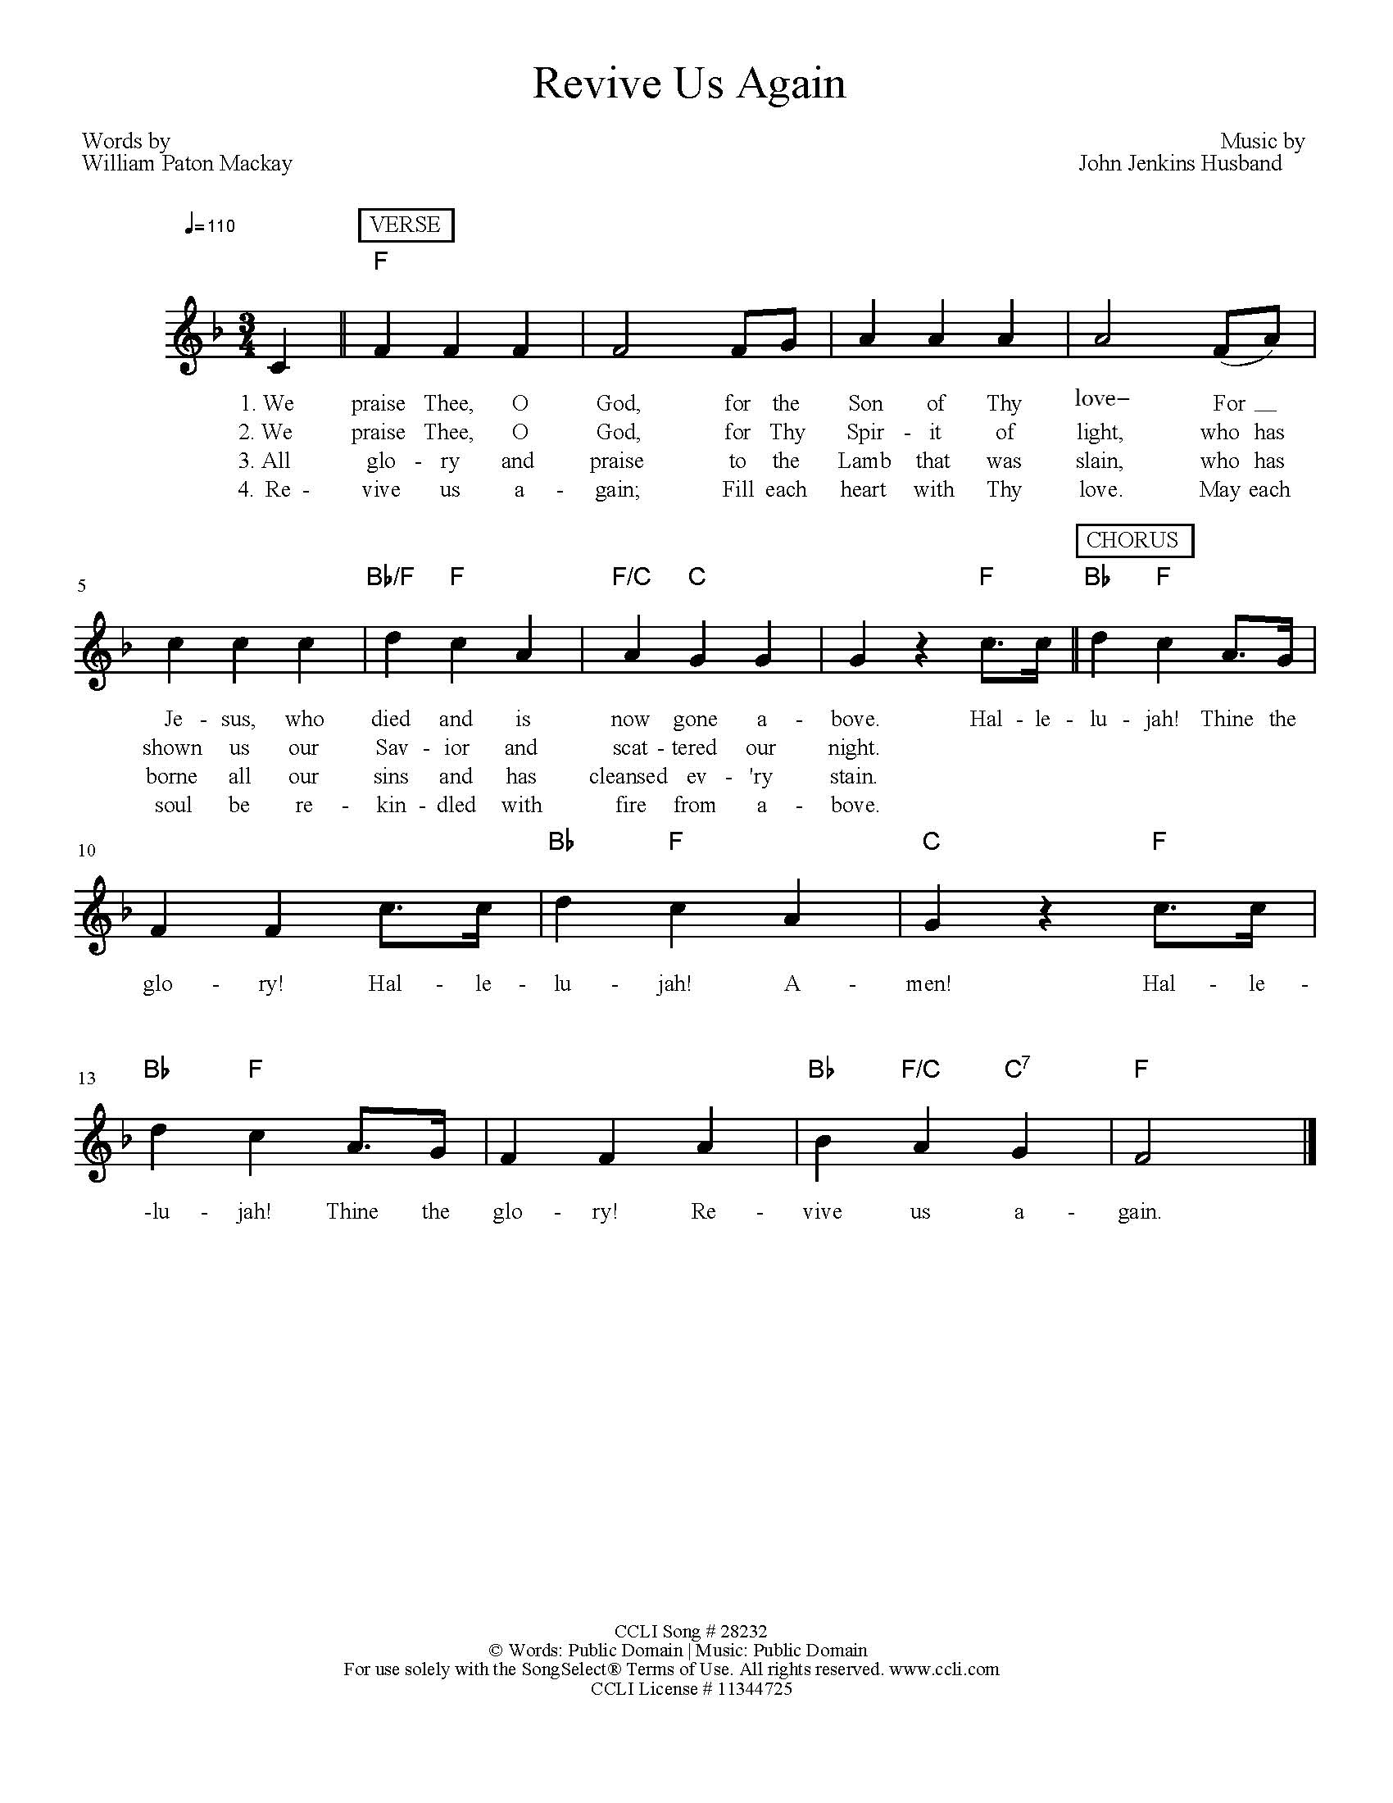

Greeting

The grace of our Lord Jesus Christ, the love of God, and the

communion of the Holy Spirit be with you all. **And also with you.**

Hymn of Praise

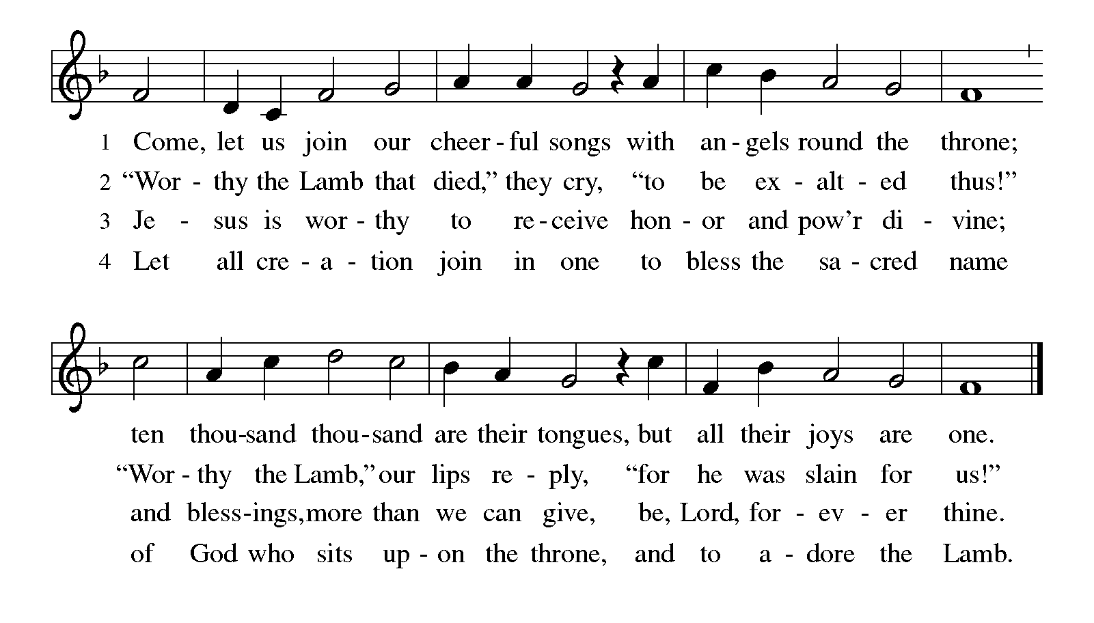

Prayer of the Day

Let us pray together. **Mighty God, you breathe life into our bones, and your Spirit brings truth to the** **world. Send us this Spirit, transform us by your truth, and give us language to proclaim your gospel, through Jesus Christ, our Savior and Lord, who lives and reigns with you and the Holy Spirit, one God, now and forever.**

**Amen.**

**WORD *Please be seated.***

First Lesson: Acts 2:1-21

1When the day of Pentecost had come, [the apostles] were all together in one place. 2And suddenly from heaven there came a sound like the rush of a violent wind, and it filled the entire house where they were sitting. 3Divided tongues, as of fire, appeared among them, and a tongue rested on each of them. 4All of them were filled with the Holy Spirit and began to speak in other languages, as the Spirit gave them ability.  
 5Now there were devout Jews from every nation under heaven living in Jerusalem. 6And at this sound the crowd gathered and was bewildered, because each one heard them speaking in the native language of each. 7Amazed and astonished, they asked, “Are not all these who are speaking Galileans? 8And how is it that we hear, each of us, in our own native language? 9Parthians, Medes, Elamites, and residents of Mesopotamia, Judea and Cappadocia, Pontus and Asia, 10Phrygia and Pamphylia, Egypt and the parts of Libya belonging to Cyrene, and visitors from Rome, both Jews and proselytes, 11Cretans and Arabs—in our own languages we hear them speaking about God’s deeds of power.” 12All were amazed and perplexed, saying to one another, “What does this mean?” 13But others sneered and said, “They are filled with new wine.”14But Peter, standing with the eleven, raised his voice and addressed them, “Men of Judea and all who live in Jerusalem, let this be known to you, and listen to what I say. 15Indeed, these are not drunk, as you suppose, for it is only nine o’clock in the morning. 16No, this is what was spoken through the prophet Joel:17‘In the last days it will be, God declares, that I will pour out my Spirit upon all flesh, and your sons and your daughters shall prophesy, and your young men shall see visions, and your old men shall dream dreams.18Even upon my slaves, both men and women, in those days I will pour out my Spirit; and they shall prophesy. And I will show portents in the heaven above and signs on the earth below, blood, and fire, and smoky mist. 0The sun shall be turned to darkness and the moon to blood, before the coming of the Lord’s great and glorious day. Then everyone who calls on the name of the Lord shall be saved.’ ”

The word of the Lord.

**Thanks be to God.**

### Psalm: 104:24-34, 35b *Read responsively*

### 24How manifold are your works, O Lord!   In wisdom you have made them all; the earth is full of your creatures.  25Yonder is the sea, great and wide, with its swarms too many to number,   living things both small and great.  26There go the ships to and fro,   and Leviathan, which you made for the sport of it.  27All of them look to you   to give them their food in due season.   28You give it to them; they gather it;   you open your hand, and they are filled with good things.  29When you hide your face, they are terrified;  when you take away their breath, they die and return to their dust.  30You send forth your Spirit, and they are created;   and so you renew the face of the earth.  31May the glory of the Lord endure forever;   O Lord, rejoice in all your works.   32You look at the earth and it trembles;   you touch the mountains and they smoke.  33I will sing to the Lord as long as I live;   I will praise my God while I have my being.  34May these words of  mine please God.   I will rejoice in the Lord.  35bBless the Lord, O my soul.   Hallelujah! ****Bless the Lord, O my soul. Hallelujah!****

### Second Lesson: Romans 8:22-27

### We know that the whole creation has been groaning in labor pains until now; 23and not only the creation, but we ourselves, who have the first fruits of the Spirit, groan inwardly while we wait for adoption, the redemption of our bodies. 24For in hope we were saved. Now hope that is seen is not hope. For who hopes for what is seen? 25But if we hope for what we do not see, we wait for it with patience.6Likewise the Spirit helps us in our weakness; for we do not know how to pray as we ought, but that very Spirit intercedes with sighs too deep for words. 27And God, who searches the heart, knows what is the mind of the Spirit, because the Spirit intercedes for the saints according to the will of God. The word of the Lord. Thanks be to God.

*Please stand, as able.*

Gospel Acclamation

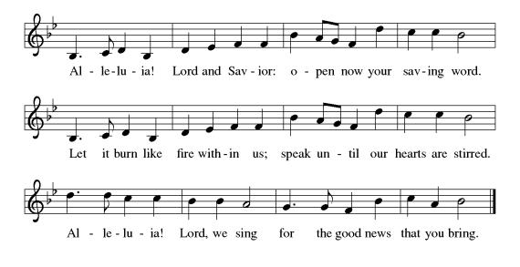

Holy Gospel: John 15:26-27; 16:4b-15

The holy gospel according to John.

**Glory to you, O Lord.**

[Jesus said,] 26“When the Advocate comes, whom I will send to you from the Father, the Spirit of truth who comes from the Father, he will testify on my behalf. 27You also are to testify because you have been with me from the beginning“I did not say these things to you from the beginning, because I was with you. 5But now I am going to him who sent me; yet none of you asks me, ‘Where are you going?’ 6But because I have said these things to you, sorrow has filled your hearts. 7Nevertheless I tell you the truth: it is to your advantage that I go away, for if I do not go away, the Advocate will not come to you; but if I go, I will send him to you. 8And when he comes, he will prove the world wrong about sin and righteousness and judgment: 9about sin, because they do not believe in me; 10about righteousness, because I am going to the Father and you will see me no longer; 11about judgment, because the ruler of this world has been condemned. I still have many things to say to you, but you cannot bear them now. 13When the Spirit of truth comes, he will guide you into all the truth; for he will not speak on his own, but will speak whatever he hears, and he will declare to you the things that are to come. 14He will glorify me, because he will take what is mine and declare it to you. 15All that the Father has is mine. For this reason I said that he will take what is mine and declare it to you.”

The Gospel of the Lord. **Praise to you, O Christ.**

*Please be seated.*

Children’s Message

Sermon

*Please stand, as able.*

Hymn of the Day # 396 *Spirit of Gentleness*

**AFFIRMATION OF BAPTISM: Confirmation**

Introduction

Presentation

I present *Dixon Sidney Fait and Alexandra Reagan Perry* who desire to make public affirmation of their baptism for confirmation.

Let us pray.

Merciful God, we thank you for *this sister and brother*

whom you have made your own by water and the Word in baptism.

You have called *them* to yourself,

enlightened *them* with the gifts of your Spirit,

and nourished *them* in the community of faith.

Uphold your *servants* in the gifts and promises of baptism,

and unite the hearts of all whom you have brought to new birth.

We ask this in the name of Christ.

**Amen.**

*The assembly stands.*

Profession of Faith

*The presiding minister addresses candidates those making public affirmation of baptism. The assembly may join in the responses.*

I ask you to profess your faith in Christ Jesus, reject sin, and confess the faith of the church.

Do you renounce the devil and all the forces that defy God?

**I renounce them.**

Do you renounce the powers of this world that rebel against God?

**I renounce them.**

Do you renounce the ways of sin that draw you from God?

**I renounce them.**

*The presiding minister addresses the candidates and the assembly.*

Do you believe in God the Father?

**I believe in God, the Father almighty,**

**creator of heaven and earth.**

Do you believe in Jesus Christ, the Son of God?

**I believe in Jesus Christ, God’s only Son, our Lord,**

**who was conceived by the Holy Spirit,**

**born of the virgin Mary,**

**suffered under Pontius Pilate,**

**was crucified, died, and was buried;**

**he descended into hell.**

**On the third day he rose again;**

**he ascended into heaven,**

**he is seated at the right hand of the Father,**

**and he will come to judge the living and the dead.**

Do you believe in God the Holy Spirit?

**I believe in the Holy Spirit,**

**the holy catholic church,**

**the communion of saints,**

**the forgiveness of sins,**

**the resurrection of the body,**

**and the life everlasting.**

Affirmation of Baptism for Confirmation

*The presiding minister addresses those making public affirmation of baptism.*

You have made public profession of your faith.

Do you intend to continue in the covenant God made with you in holy baptism:

to live among God’s faithful people,

to hear the word of God and share in the Lord’s supper,

to proclaim the good news of God in Christ through word and deed,

to serve all people, following the example of Jesus,

and to strive for justice and peace in all the earth?

*Response:*I do, and I ask God to help and guide me.

*The minister addresses the assembly.*

People of God,

do you promise to support *those* who *are* baptized today,

and making public affirmation of *her* baptism,

and to pray for *them* in *their* life in Christ?

**We do, and we ask God to help and guide us.**

*Those making affirmation of baptism may kneel.*

Let us pray.

We give you thanks, O God, that through water and the Holy Spirit you give us new birth, cleanse us from sin, and raise us to eternal life.

*The presiding minister may lay both hands on the head of each person making affirmation of baptism and say:*

Stir up in *Dixon Sidney / Alexandra Reagan* the gift of your Holy Spirit: the spirit of wisdom and understanding, the spirit of counsel and might, the spirit of knowledge and the fear of the Lord, the spirit of joy in your presence, both now and forever.

**Amen.**

*Each confirmand is anointed with a cross as a reminder of the seal of Baptism. A flower is given to share in gratitude with parent(s) for guidance with baptismal vows up to this point.*

Let us rejoice with these sisters and brothers in Christ.

**We rejoice with you in the life of baptism.**

**Together we will give thanks and praise to God**

**and proclaim the good news to all the world.**

Presentation of Gifts

*Confirmands are presented with gifts to mark this day of beginnings.*

Baptismal Hymn – #451 *We are Baptized in Christ Jesus*

*With sprinkling of water as a reminder of baptism*

*Those who have gathered at the font may return to their places.*

Prayers of the Church

(petitions)…Lord in your mercy. **Hear our prayer.**

(prayer concludes)…**Amen.**

Sharing of the Peace

**MEAL** *We are fed and nourished to be built up in the body of Christ.*

Offering *Breathe on Me, Breath of God*

Offertory

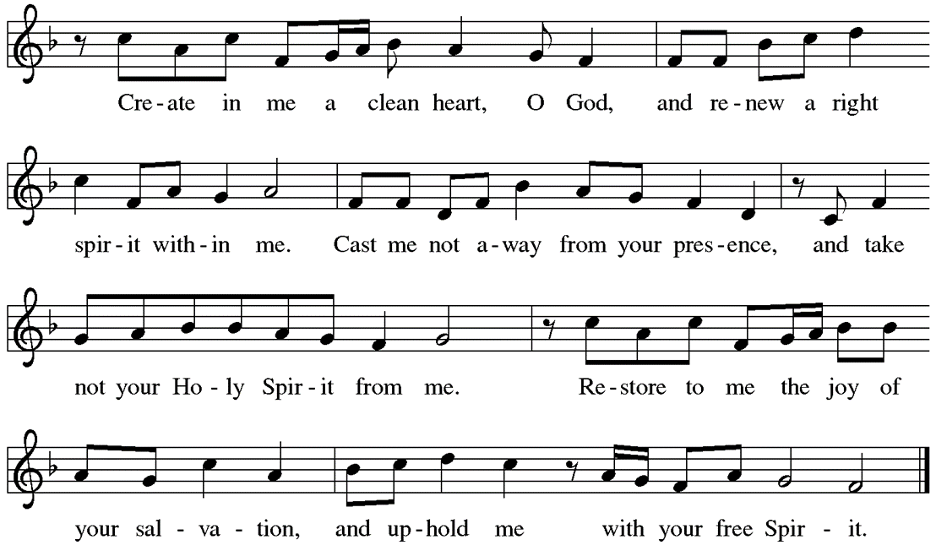

Offertory Prayer

Let us pray together. **Holy God, gracious and merciful, you bring forth food from the earth and nourish your whole creation. Turn our hearts toward those who hunger in any way, that all may know your care; and prepare us now to feast on the bread of life, Jesus Christ, our Savior and Lord.Amen.**

Thanksgiving, Proper Preface, and Sanctus

The Lord be with you.

**And also with you.**

Lift up your hearts.

**We lift them to the Lord.**

Let us give thanks to the Lord our God.

**It is right to give him thanks and praise.**

It is indeed right and salutary…we praise your name and join their unending hymn:



Thanksgiving at the Table Prayer

Blessed are you, O God of the universe….

With this bread and cup we remember our Lord's passover from death to life as we proclaim the mystery of faith:

**Christ has died. Christ is risen. Christ will come again.**

O God of resurrection and new life: … Grace our table with your presence.

**Come, Holy Spirit.**

Reveal yourself to us in the breaking of the bread. … Send us forth, burning with justice, peace, and love.

**Come, Holy Spirit.**

With your holy ones of all times and places, with the earth and all its creatures, with sun and moon and stars, we praise you, O God, blessed and holy Trinity, now and forever.

**Amen.**

Lord’s Prayer

Lord remember us in your kingdom and teach us to pray.

**Our Father, who art in heaven, hallowed be thy name, thy kingdom**

**come, thy will be done, on earth as it is in heaven. Give us this day**

**our daily bread; and forgive us our trespasses, as we forgive those**

**who trespass against us; and lead us not into temptation, but deliver**

**us from evil. For thine is the kingdom, and the power, and the glory,**

**forever and ever. Amen.**

Breaking the Bread and Invitation to Communion

The risen Christ is made known to us in the breaking of the bread.

Come and eat at God’s table.

*Please be seated.*

Lamb of God



*The proclamation is shared for those communing in their place with an all-in-one kit or home elements. Sharing the elements:*

The Body of Christ given for you. The Blood of Christ shed for you.

*Each person may respond:* **Amen.**

*The leaders share Holy Communion. The assembly is invited to come forward by the direction of the ushers by the center aisle and receive Holy communion, then return via the side aisle. You may receive the Sacrament around the altar or at the floor stations.*

Communion Hymns:  *Every time I Feel the Spirit, Sweet Hour of Prayer,*

*Spirit of the Living God*

**SENDING –** *We are set out to share hope and make disciples.*

Blessing *You are invited to stand.*

Prayer after Communion

Let us pray together. **Shepherding God, you have prepared a table before us and nourished us with your love. Send us forth from this banquet to proclaim your goodness and share the abundant mercy of Jesus, our redeemer and friend. Amen.**

Benediction

Alleluia! Christ is risen!

**Christ is risen indeed! Alleluia!**

The God of resurrection power, the Christ of unending joy, and the Spirit of Easter hope ☩ bless you now and always.

**Amen.**

Sending Hymn: #400 *God of Tempest, God Of Whirlwind*

Dismissal

Alleluia! Go in peace. Rejoice and be glad.

**Thanks be to God. Alleluia!**

Postlude

From [sundaysandseasons.com](http://sundaysandseasons.com/). Copyright © 2023 Augsburg Fortress. All rights reserved. Reprinted by permission under Augsburg Fortress Liturgies Annual License #SAS006821. New Revised Standard Version Bible, Copyright © 1989, Division of Christian Education of the National Council of the Churches of Christ in the United States of America. Used by permission. All rights reserved. Revised Common Lectionary, Copyright © 1992 Consultation on Common Texts, admin Augsburg Fortress. Used by permission. "Spirit of the Living Good" CCLI Song #23488; CCLI Streaming License #20189555 CCLI, Church Copyright License #11344725. "Spirit of Gentleness" One License Song #44816; "Every Time I Feel the Spirit" One License Song #95026; "We Are Baptized in Christ Jesus" One License Song #CT-002; "God of Tempest, God of Whirlwind" One License Song #21497. Livestreamed with permission under ONE License, License # A-732944  All Rights Reserved.

**Service Participants**

Lector: Missy Houston

Acolyte: Kelsey Coppetti

Communion Assistants: Mary Lou Millward, John Millward

Ushers: Kevin Kurimsky, Jason or Jackie Nester, Tony & Jaime Gacek

Altar Guild: Judy Miller, Mary Lou Millward

**THE FLOWERS ON THE ALTAR** are dedicated to the glory of God and in honor of my daughter-in-law, Kristin Hohman on her birthday by Jackie Hohman. In honor of Jim Stratton, on his 80th Birthday, Love, Shar.

**THE FLOWERS** in front of the baptismal font are dedicated to the glory of God and in honor of Ron & Kathy on their Wedding Anniversary, Love Marilyn.

**THE ETERNAL CANDLE** isdedicated to the glory of God and in memory of Susanne R. Colecchi by Mark & Arlene Wagner.

THIS WEEK

Robyn’s OFFICE HOURSare MON-TH 9:00 AM–2:00 PM, FRIDAY 9 AM-12PM

On Call for pastoral emergencies: Pastor Caroline

**SUNDAY**

Pentecost / Confirmation Sunday

Joyful Noise

9:15amConfirm.Meeting/Large Sunday School Room

11:45 am Evangelism Committee

3 pm PS Decorating Church

**MONDAY**

8 am PS in church, SH & Pavilion

**TUESDAY**

8 am PS in church, SH & Pavilion

6:30 pm B Study/P Caroline & Deb Mertz

**WEDNESDAY**

6 pm Bell Choir

6 pm Youth Meeting

7 pm Adult Choir

**THURSDAY**

3 pm Grief Support Group

7 pm Boy Scout

**FRIDAY**

10 am Ladies Bible Study

**SATURDAY**

8:00 AM Sanctuary Reserved

5:00 PM Worship w/ Communion

**Building Fund**

There are envelopes in the Communication Center for donations for our building fund. Please use these to support the sealing of the parking lot (about $15000). Thank you in advance for your support and generosity in how you prayerfully consider responding!

**Hempfield Manor Hymn Sing and Holy Communion**

Our next Hymn Sing at Hempfield Manor will be Saturday June 22nd at 2 pm. Come join us as we sing classic hymns that the residents have requested.  We will share an abbreviated Holy Communion service led by Pastor Caroline with the residents! All are welcome!  Upcoming Hymn Sing dates is Wednesday, July 10th 10:00am

**Coming Soon: “Lemonade and Lectio” –** Single Session Bible Studies on various topics in varying time slots with Pastor Andrew. Let him know if you have burning question about a set of Bible passages!

**Camp registrations are now open for summer campers**! $100 off for first time campers…IT IS $50 OFF for half week campers. There is a discount code for this it is **First.** It doesn’t apply for Family Camp, Confirmation Camp, Day Camps, or Small Fry Days. Register at LUTHERLYN.COM/SUMMERCAMP Please see/or call Rob Hepler for more information. 724-446-2174. We want to be sure that every child or youth that wants to go to Lutherlyn can go—we have camp scholarships!

**Giant Yard Sale/Craft Vendors**  
Saturday June 1st from 8 AM – 1 PM Harrold Zion will be having a Yard Sale/Craft Sales.  If you have stuff to sell, this is the event for you.  To be a vendor at the event, the cost will be $20 for parking lot space or $25 for space and one table provided by the church for your setup (Only 20 table are available for first 20 registered).  If you have items to sale but do not want to be a vendor during the event, we will be accepting donations of sellable items which will be sold by the Trash & Treasure Sale volunteers.   (There is a separate Sign up in communication center for this) You may bring your items to church on May 28th, 29th, or 30th from 5 – 7 PM.  Drop off will be in the upstairs Pre-School room.  All items will be tagged and marked to sell so please don’t be emotionally upset if items are priced different than what you intend.  Please sign-up in the communication center to reserve spot and if you need a table.   We would also like to have baked goods to sell at the event so we are looking for volunteers to bake cookies/cakes/pies/breads/etc… There will be a concession table selling breakfast and lunch items for sale all day.  All proceeds from the rentals, item donations, and concession/baked goods tables go towards the church general fund and meeting the yearly budget.  Vendors are always welcome to donate a percentage of their earnings from the event. Registration money is payable to Brad Zundel or the church office (You will receive a numbered Vendor ticket).

**Grief Support Group**: We have a grief support group here at Harrold Zion for those who have lost loved ones. The group meets on Thursdays at 3:00 PM here at the church. The group will meet for at least six weeks. We may have other groups after this group ends. If you are interested or have questions, please contact Pr. Caroline at pastorcarolinehzlc@gmail.com or call the church office.

**Summer Book Class**: Deb Mertz and Pr. Caroline are offering a class this summer using the book, “Believe: Living the story of the Bible to become like Jesus,” edited by Randy Frazee. We will be doing the second 10 lessons of the book. You are welcome to attend even if you could not attend the previous class. There is a book and a study guide. Please contact Pr. Caroline at pastorcarolinehzlc@gmail.com or Deb Mertz at deb_mertz@att.net if you are interested or talk to either one at church. We are having the class on Tuesdays, 6:30 PM, here at the church. It will begin Tuesday, April 16th, and it will last 10 weeks. We will not meet during the week of VBS, June 11th. The last class will be on June 25th.



**VBS** Thank you for donating egg cartons and cereal boxes for Bible School. We have met our goal with those. We are still in need of 20 oz. empty Gatorade bottles.

**Back by popular demand – Crash Weekends!**  Let’s Crash the Summer Slump.  The summer months have traditionally been challenging meeting the financial obligations towards our church.  Let’s be proactive and get a head start on the summer by bringing in our loose change.  There will be two Crash Weekends – May 18th & 19th and May 25th & 26th.  Change will be collected during the Prelude.

**Begonias:**

***The flowers are presented to the glory of God and are placed as follows:***

**In loving memory:**

Our Parents Bernard & Carolyn Zundel

Joan Starenchak The Houston Family

Debbie Barnett Denny Barnett

J. Paul & Evelyn Wineman Fred & Ann Wineman

Scott P. & Evelyn Weyandt Mark & Arlene Wagner

W.H.& Lorraine Wagner Mark & Arlene Wagner

Don A. Wagner Mark & Arlene Wagner

Harry G. & Bessie B. Benson Mark & Arlene Wagner

Jack & Barbara Baluh Norman & Linda Bono

Ralph & Mary Alice Bono Norman & Linda Bono

Richard (Dick) Campbell Faye Campbell

Our Loved Ones Mary Lou & John Millward

Husband, Merle Donna Mull

Loved Ones Andy, Jen and Heidi Koehl

All Loved Ones Denny & Sue Ernette

Jack Cope His Family

Dave Cortazzo Cheryl Cortazzo & Family

David Silvis Cheryl Cortazzo & Family

Beloved Husband, Melvin D. Brown Mary Ann Brown

Ken Diffenderfer Mary Jane Diffenderfer

Bob McEwen Denny & Karen Henry

George McEwen Denny & Karen Henry Our Mothers, Sara & Rose Wayne & Doris Kebe

Izzo & Kurpiel Family Ann & Lou Izzo Gene Fritz Karen Fritz

David Clifford Pastor Caroline Jim & Elizabeth Burgess, Venus Capes Pastor Caroline

My Mom, Judy Deb Mertz

**In honor of**

The Ladies of Friday Bible Study Deb Mertz

Our Children, Grandchildren, and Great Grandchildren Bernard & Carolyn Zundel

Our Families The Siniawski Family Kevin & Joanne Mary Lou & John Millward Family Members Donna Mull

Children & Grandchildren Carol Cope

Carson Shuglie, graduating from Hempfield High School

Your grandmother, Cheryl Cortazzo

Hunter & Caleb Curtis & Rita Heasley

Our Children Joanne Gebhardt & Kevin Torrance

Our Grandchildren Susan & Rick Yaksic

Our Grandchildren, Bella, Audrey & Colton Denny & Karen Henry

MaryEllen Conard Mary Jane Diffenderfer

My family Barb Appleby

Our Children & Grandchildren Rob & Jennifer Hepler

Our Children & Grandchildren Shawn & Susie Carolan

Our Loved Ones Jason & Karen Barnhart

**ITEMS AVAILABLE FOR SPONSORSHIP:**

Flowers Available:

Altar Arrangements: May 25,26 (2 Vases) June 1,2 (2 Vases)

Roses June 1,2 (2 Roses), June 8,9 (2 Roses)

Candle, June 8,9

Bulletin May 25,26, June1,2, June 8,9

***To sponsor items, please sign up in the Communication Center.***

**Church Staff and Office – 724-837-7327**

Rev. Andrew Fitch, Senior Pastor [pastorfitch@outlook.com](mailto:pastorfitch@outlook.com)

Rev. Caroline Clifford, PhD, Asst. Pastor [pastorcarolinehzlc@gmail.com](mailto:pastorcarolinehzlc@gmail.com)

Robyn Henry, Secretary [robynhzlc@gmail.com](mailto:robynhzlc@gmail.com)

Sheri Anderson, Coordinator of Family Ministries hzlcyouth@gmailcom

Laurie Racculia, Director of Music Ministries [lracculia@yahoo.com](mailto:lracculia@yahoo.com)

Debby Schlegel, Custodian

Joanne Gebhardt, Sunday Organist

Melanie Altman, Saturday Organist

**A few of our Favorite Hymns:** This summer we will be using favorite hymns that YOU choose! Please fill out the tear off slip below and contribute to some summer worship music fun! Hymns will be used for all hymns and the hymn of praise. If you know that someone else will be picking the same hymn, then please contribute another one. If we get enough, we will keep using these in worship planning into the fall!

**MY FAVORITE HYMN CHOICE**

**#_______ Title___________________________________________**

*Submitted by* **___________________________**

*Place in offering plate or basket in entrance area.*