Harrold Zion Evangelical Lutheran Church
March 23th 5pm & March 24th 8 & 10:30am
Palm Sunday 2024

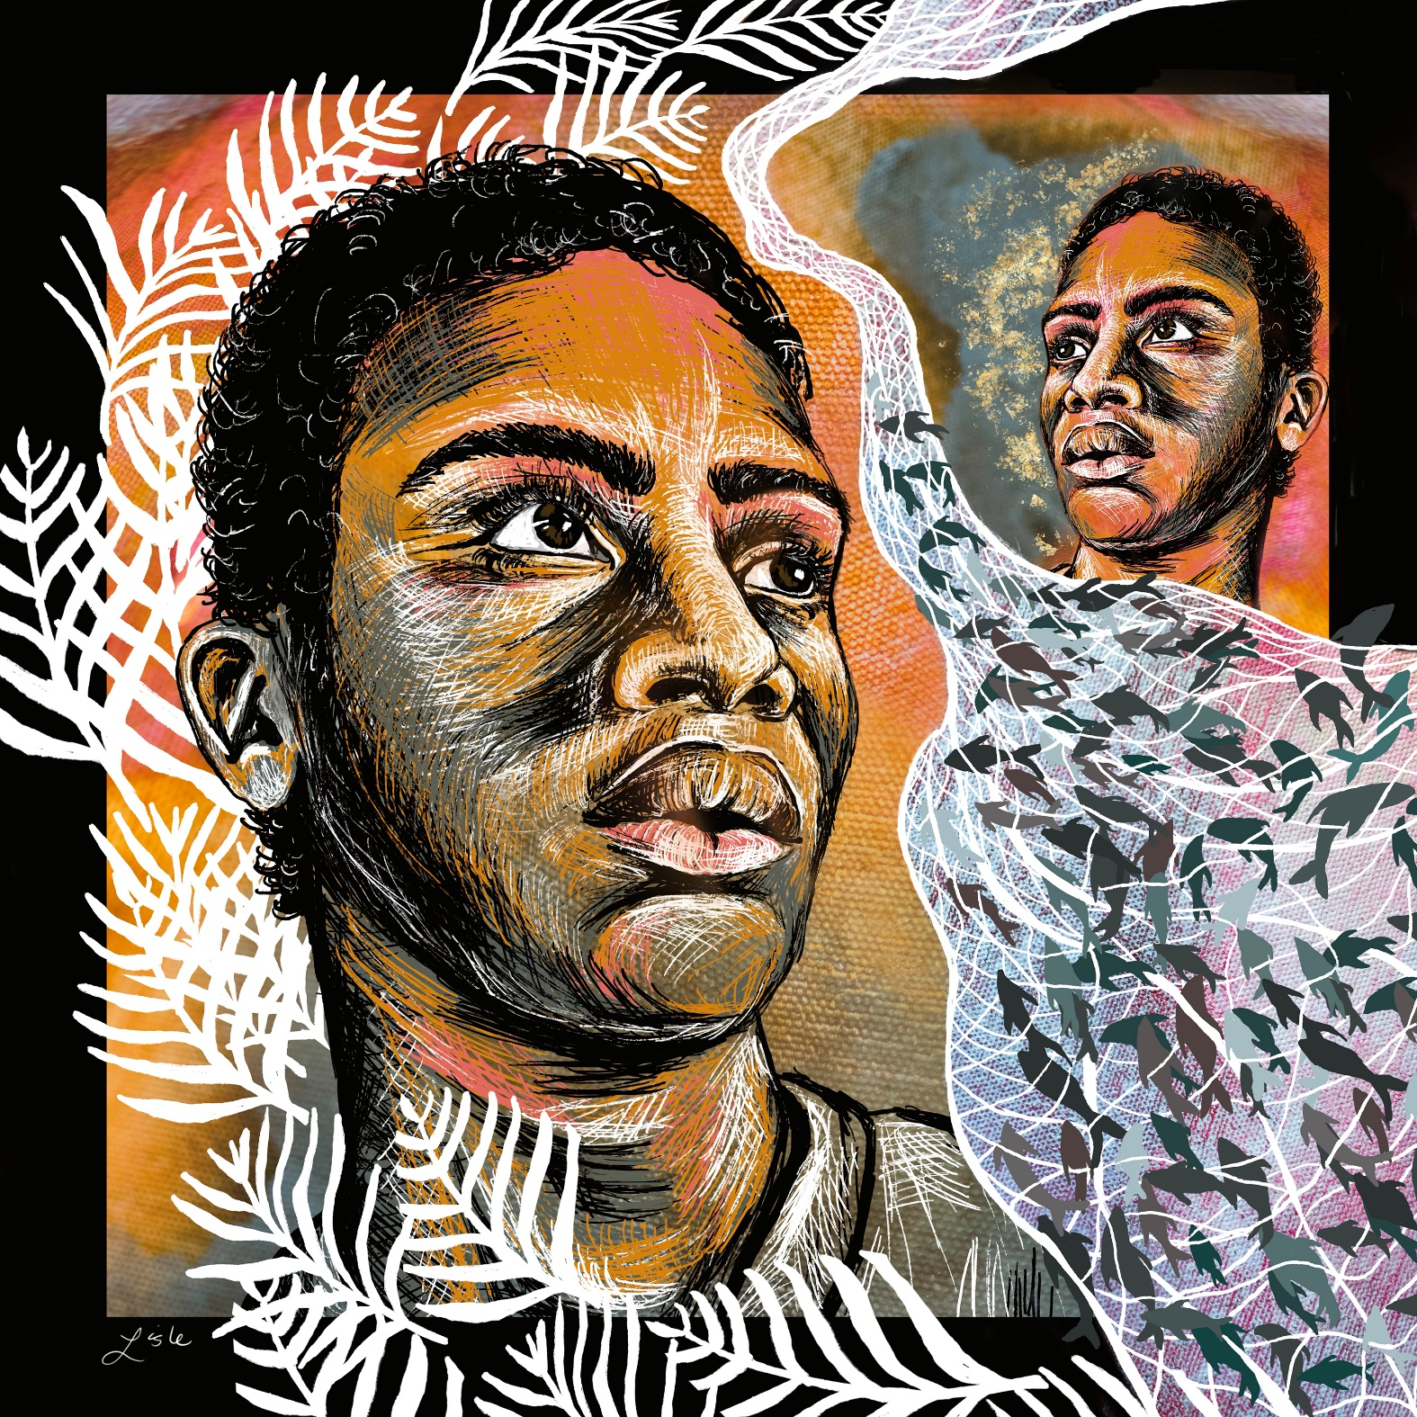

WELCOME TO OUR WORSHIP!
- It is a joy to welcome our visitors! Please sign the guest book in the
Communication Center at the rear of the church, to the right as you exit, and take a Welcome Packet which is filled with information about Harrold Zion. Please introduce yourself to the pastor as you leave worship. We hope you return soon! Follow us on social media!
- Children’s bags are available in the Narthex.
- There is a prayer request book on a podium in the Welcome Center. Please write name(s) in the book prior to the service to have names included in the prayers.
- Large print bulletins are available from any usher for those needing them.
- Hearing devices are available from any usher for those needing them.
- An AED machine can be found on the wall after the Ladies Room on the left.
- Receiving Holy Communion - We believe the body and blood of Christ to be present in the bread and wine. All who are baptized are invited to share in this meal. Please come forward at the usher's direction. Non-communing children may come forward for a blessing. If you desire communion in the pew, please inform one of the ushers so that you may receive communion there.

Our MISSION
To Worship and Serve God,
Grow Disciples and Love our Neighbors

Our Vision
Building Faith that’s Open, Affirming, Authentic,
Positive, Inviting, and that Serves Others.

GATHERING – We are brought together to remember who and whose we are.

Worship procession begins outside (weather permitting). We form in this order: Cross, acolytes, choir, people, pastors. Those not processing are invited to turn and follow the cross with your body orientation as it passes your pew.

Welcome, Sharings and Announcements

Please stand, as able
Call to Worship
Sing songs of loudest praise!
Hosanna! (raising palms)
Sing songs that are unashamed.
Hosanna! (raising palms)
Sing songs without being afraid.
Hosanna! (raising palms)
Sing for the God of tomorrow and today.
Hosanna! (raising palms)
Blessed is the one who comes in the name of the Lord.
Hosanna in the highest! (raising palms)

Processional Gospel: Mark 11:1-11
The holy gospel according to Mark the eleventh chapter.
Glory to you, O Lord.
When they were approaching Jerusalem, at Bethphage and Bethany, near the Mount of Olives, he sent two of his disciples ² and said to them, “Go into the village ahead of you, and immediately as you enter it you will find tied there a colt that has never been ridden; untie it and bring it. ³ If anyone says to you, ‘Why are you doing this?’ just say this: ‘The Lord needs it and will send it back here immediately.’ ” ⁴ They went away and found a colt tied near a door, outside in the street. As they were untying it, ⁵ some of the bystanders said to them, “What are you doing, untying the colt?” ⁶ They told them what Jesus had said, and they allowed them to take it. ⁷ Then they brought the colt to Jesus and threw their cloaks on it, and he sat on it. ⁸ Many people spread their cloaks on the road, and others spread leafy branches that they had cut in the fields. ⁹ Then those who went ahead and those who followed were shouting,
“Hosanna!
Blessed is the one who comes in the name of the Lord!
¹⁰ Blessed is the coming kingdom of our ancestor David!
Hosanna in the highest heaven!”
¹¹ Then he entered Jerusalem and went into the temple, and when he had looked around at everything, as it was already late, he went out to Bethany with the twelve.
The gospel of the Lord. Praise to you, O Christ.

The Blessing of the Palms
The Lord be with you. And also with you.
Let us pray. We praise you, O God, for redeeming the world through
our Savior Jesus Christ. Today he entered the holy city in triumph and was
proclaimed Messiah and king by those who spread garments and
branches along his way.

Raise your palm branches.

Bless these branches and those who carry them. Grant us grace to follow
our Lord in the way of the cross, so that, joined to his death and
resurrection, we enter into life with you; through the same Jesus Christ,
who lives and reigns with you and the Holy Spirit, one God, now and
forever. Amen.
Let us go forth in peace, in the name of Christ. Amen.

The procession begins. [Order: Cross, acolytes, choir, people, pastors.]
Please continue to face the cross as it processes.

You may continue to wave palms during procession.

Entrance Hymn #344 All Glory, Laud, and Honor

Blessed is the one who comes in the name of the Lord.
Hosanna in the highest! (raising palms)
The Lord be with you.
And also with you.

WORD – We hear God’s teachings to guide our path of serving.

Prayer of the Day
Let us pray together.
Sovereign God, you have established your rule in the human heart through the servanthood of Jesus Christ. By your Spirit, keep us in the joyful procession of those who with their tongues confess Jesus as Lord and with their lives praise him as Savior, who lives and reigns with you and the Holy Spirit, one God, now and forever.
Amen.
Please be seated.
First Reading: Isaiah 50:4-9a
⁴The Lord God has given me the tongue of a teacher, that I may know how to sustain the weary with a word. Morning by morning he wakens—
wakens my ear to listen as those who are taught. ⁵The Lord God has opened my ear, and I was not rebellious, I did not turn backward. ⁶I gave my back to those who struck me, and my cheeks to those who pulled out the beard; I did not hide my face from insult and spitting. ⁷The Lord God helps me; therefore I have not been disgraced; therefore I have set my face like flint, and I know that I shall not be put to shame; ⁸he who vindicates me is near. Who will contend with me? Let us stand up together. Who are my adversaries? Let them confront me. ^{9a}It is the Lord God who helps me;
who will declare me guilty?
The word of the Lord. Thanks be to God.

Choir Anthem: Sing We Hosanna! --Liebergen

Psalm: 31:9-16 Read responsively
⁹Have mercy on me, O Lord, for I am in trouble;
my eye is consumed with sorrow, and also my throat and my belly.
¹⁰For my life is wasted with grief, and my years with sighing;
my strength fails me because of affliction, and my bones are consumed.
¹¹I am the scorn of all my enemies, a disgrace to my neighbors, a dismay to my acquaintances;
when they see me in the street they avoid me.
¹²Like the dead I am forgotten, out of mind;
I am as useless as a broken pot.
¹³For I have heard the whispering of the crowd; fear is all around;
they put their heads together against me; they plot to take my life.
¹⁴But as for me, I have trusted in you, O Lord.
I have said, “You are my God.
¹⁵My times are | in your hand;
rescue me from the hand of my enemies, and from those who persecute me.
¹⁶Let your face shine upon your servant;
save me in your | steadfast love.”

Second Reading: Philippians 2:5-11
A reading from Philippians:
⁵Let the same mind be in you that was in Christ Jesus, ⁶who, though he was in the form of God, did not regard equality with God as something to be exploited, ⁷but emptied himself, taking the form of a slave, being born in human likeness. And being found in human form, ⁸he humbled himself
and became obedient to the point of death—even death on a cross.
⁹Therefore God also highly exalted him and gave him the name that is above every name, ¹⁰so that at the name of Jesus every knee should bend,
in heaven and on earth and under the earth, ¹¹and every tongue should confess that Jesus Christ is Lord, to the glory of God the Father.
The Word of the Lord. Thanks be to God.

Children’s Time

Sermon
Please stand, as able
Hymn of the Day #431 O Christ, What Can It Mean for Us
Apostles’ Creed
I believe in God, the Father almighty, creator of heaven and earth.
I believe in Jesus Christ, his only Son, our Lord. He was conceived by
the power of the Holy Spirit and born of the virgin Mary. He suffered
under Pontius Pilate, was crucified, died, and was buried. He
descended into hell. On the third day he rose again. He ascended
into heaven, and is seated at the right hand of the Father. He will
come again to judge the living and the dead.
I believe in the Holy Spirit, the holy catholic Church, the communion
of saints, the forgiveness of sins, the resurrection of the body, and the
life everlasting. Amen
Prayers of Intercession
(petitions)…Lord in your mercy. Hear our prayer.
(prayer concludes)…Amen.
Secure Giving Link
Sharing of the Peace

Offering (8 & 10:30AM) Duet: The Palms –Arr. Smith

MEAL – We are built up and nourished to be the body of Christ in the world.

Offertory Create in Me a Clean Heart (from WOV #732)
Offering prayer
Let us pray together. God our provider, you have not fed us with bread alone, but with words of grace and life. Bless us and these your gifts, which we receive from your bounty, through Jesus Christ our Lord.
Amen.

Prayer of Preparation
The Great Thanksgiving and Proper Preface
It is indeed right, our duty and our joy, … and join their unending hymn:
Thanksgiving at the Table Prayer
Holy God, our living water…
…we proclaim the Lord’s death until he comes.
Christ has died.
Christ is risen.
Christ will come again.
…in your holy Church, both now and forever.
Amen.

The Lord’s Prayer
Our Father, who art in heaven, hallowed be thy name, thy kingdom
come, thy will be done, on earth as it is in heaven. Give us this day
our daily bread; and forgive us our trespasses, as we forgive those
who trespass against us; and lead us not into temptation, but deliver
us from evil. For thine is the kingdom, and the power, and the glory,
forever and ever. Amen.

Breaking the Bread and Invitation to Communion
Bread for the journey. A feast for hungry hearts. Come!
Please be seated.

Lamb of God
The proclamation is shared for those communing in their place with an all-in-one kit or home elements.

Sharing the elements:
The Body of Christ given for you. The Blood of Christ shed for you.
Each person may respond: Amen.

The leaders share Holy Communion.
The assembly is invited to come forward by the direction of the ushers by the center aisle and receive Holy communion, then return via the side aisle. [For Sunday: You may receive the Sacrament around the altar or at the floor stations.]

We welcome to the Lord’s Table for First Communion today:
Keith Holsopple and Kinsley Harvey!
“There is a place for you!”

Communion Hymns: (8 & 10:30am) 353, 349, 759

SENDING – We are set out to share hope and make disciples.

Blessing Please stand as able.

Prayer after Communion
Let us pray together. Compassionate God, you have fed us with the bread of heaven. Sustain us in our Lenten pilgrimage: may our fasting be hunger for justice; our alms, a making of peace; and our prayer, the song of grateful hearts, through Jesus Christ, our Savior and Lord.
Amen.

Benediction
Beloved wanderer, as you leave this place, may you carry your curious heart on your sleeve. May you look for God in every face. May you find the courage to get out of the boat, to run to the tomb, and to speak of your faith. And when the world falls apart, may you hear God’s voice deep within, saying, “Take heart, it is I, be not afraid.” You are called. You are blessed. In both your ups and your downs, you always belong to God. Go now in peace. Go trusting that good news. Amen.

Sending Hymn Ride On, Ride On
Quiet Meditation
Dismissal
Go in peace. Serve the Lord!
Thanks be to God. We will!

Postlude 5pm Ride On King Jesus Shackley
8&10:30am Fanfare for the King Hughes
From sundaysandseasons.com. Copyright © 2023 Augsburg Fortress. All rights reserved. Reprinted by permission under Augsburg Fortress Liturgies Annual License #SAS006821. New Revised Standard Version Bible, Copyright © 1989, Division of Christian Education of the National Council of the Churches of Christ in the United States of America. Used by permission. All rights reserved. Revised Common Lectionary, Copyright © 1992 Consultation on Common Texts, admin Augsburg Fortress. Used by permission. CCLI Streaming License #20189555 CCLI, Church Copyright License #11344725. "Sing We Hosanna" One License Song #231984; "Were You There" One License Song #51959; "The Palms" One License #104990; "Fanfare for the King" One License #1048272; "O Christ, What Can It Mean for Us" One License #94912. Livestreamed with permission under ONE License, License # A-732944 All Rights Reserved.
.
WE THANK TODAY’S SERVICE PARTICIPANTS
Lectors: 8 AM Beth Holsopple 10:30 AM Kelly Perry
Acolytes: 8 AM Katelyn Holsopple 10:30 AM Ella Kanouff
Crucifer: 8 AM Cooper Anderson 10:30 AM Sheri Anderson
Communion Assistants: 8 AM Tom Kubinec, Don Freeman
10:30 AM Susan Yaksic, Kelly Perry
Ushers: 8 AM Glenn Nickodemus, Jen Koehl
10:30 AM Rachel Uhrinek, Paul Kanouff
Altar Guild: Nancy Basile

Flowers for this week are given to the Glory of God:
Vase arrangement - To the glory of God, and in celebration of Linda's birthday, the best wife and mom ever love Pat, Jeff, Jasmine, Lynn, Mike, Dana, and Eric.

Red Roses - To the glory of God, in celebration of NONNA's birthday, I love Eva, Eden, and Eli.

Red Roses - To the glory of God and celebration of Gram and great Graham Linda's birthday. Love Colleen, Brian, Stephanie, Alyssa, Joey, and Logan

White Rose - In memory of Grace Altman by their family.
White Rose - In memory of Earl Altman by their family

Large arrangement -In memory of George McEwen

THIS WEEK….IS HOLY WEEK!
Office hours are: 9am-2pm Monday Thursday

PALM SUNDAY
8:15-10am Palm Sunday Breakfast
12:00 pm Egg Hunt
MONDAY
Preschool Easter Parties
10:30 Quilting
6:30 Property
TUESDAY
Preschool Easter Parties
10am Prayer Shawl Ministry
WEDNESDAY
No Preschool
10am Newsletter Mailing
6pm All Music Holy Week rehearsal
MAUNDY THURSDAY
No preschool
7pm Maundy Thursday Worship with Holy Communion
GOOD FRIDAY
Office closed/ No preschool
7pm Good Friday Worship with
Adoration of the Cross
EASTER VIGIL SATURDAY
5:00 PM Worship with Communion
EASTER SUNDAY
(Holy Communion at all services)
7am Festival Worship
8:45am Festival Worship
10:30am Festival Worship

LOOKING AHEAD:
- Holy Week begins on March 24, 2024, with Palm Sunday, with services on Maundy Thursday, Good Friday, Easter Vigil and Easter, March 31, 2024.
- Shoe collection for Lent.
- Jigsaw Puzzle night – April 12

The theme for this Lent into Easter this year is “Wandering Heart: Figuring Out Faith with Peter.” Each weekend we will follow the path of (Simon) Peter as he works out what it means to follow Jesus.

Easter Instrumentalists Needed!!!
Wanted: instrumentalists of all ages and skill levels to play for the Easter Sunday 2024 services! If you or your children play an instrument, email Laurie at lracculia@yahoo.com to be part of the most joyous celebration of our year!

Palm Sunday Breakfast
Today is the annual Palm Sunday Breakfast from 8:15– 10:00 AM.

Easter Egg Hunt is today at 12 noon.

Palm Sunday Procession
Weather permitting, all are invited as able to gather outside and begin worship there and process in during the first hymn. We will wave our palms and celebrate Messiah Jesus. If the weather is not conducive: Children and youth join Ms. Sheri in the Sunday services and wave palms and parade through the congregation during the gathering hymn. We will gather in the narthex after the announcements.

The Great Three Days:
These high holy days are seen as a continuous event.
Maundy Thursday + March 28 7pm,
Good Friday + March 29 7pm
Easter Vigil 5pm + March 30

Maundy Thursday focuses on the healing and building up of faith through the gift of the Holy Sacrament of the Altar. This night celebrates the New Commandment of Jesus for all of us. The service concludes with the stripping of the Altar in preparation for the continuation of the Passion story on Good Friday. Dramatic reading of the full passion takes central role in this night of nights. The service concludes with the Adoration of the Cross through the contemplative form of Prayer Around the Cross. This meaningful portion uses short, memorable and repeated songs coupled with devotional prayers.
The Easter Vigil is the most ancient of Christian worship services. Ours will take place in our familiar Saturday night time slot. We will gather outside, weather permitting for the lighting of the new fire. This service will follow the shorter selection of readings and simple songs in order to be accessible and meaningful for all. ( ~1hr)

The Resurrection of Our Lord – March 31st with Festival Eucharist celebrations at 7am, 8:45am, and 10:30am Special music at all services for this queen of all holy days!

No Sunday School Classes March 24th and March 31st. Classes resume April 7th.

Holy Week Rehearsal for all choir and handbells will be this Wednesday March 27th at 6:00 pm.

A Special Thank you to Mila Kisel, Kelsey Coppetti and Megan Smith for playing the bells at the 10:30 am service. Thank you to Susan Molnar as our Pianist at both services this morning. Thank you also to Cecilia Henderson, accompanied by Don Freeman for the beautiful solo of Oh Danny Boy last weekend during the 10:30 am service. Thank you for sharing your talents with us.

JIGSAW PUZZLE RACE NIGHT
Friday April 12 6:00pm
$10 a person
Come participate in Harrold Zion’s first puzzle race! No matter what your puzzling skills are, it will be a night of fun, laughter, and competition. The concept is easy- get a team of 2-4 people and assembly a 500 piece puzzle as fast as you can.
There will be a prize awarded for the 1st team finished. Pizza, drinks, and snacks will be provided, and each team will be provided a puzzle. Space is limited to 15 teams. Sign up in the communication center and indicate a team captain. If you would like to participate but don’t have a partner or team, no worries, sign up anyways; we’ve got you covered! Please place payments with the team captain’s name on it and place in the box labeled puzzle race.
Any questions can be directed to Mandy Kanouff 724-433-9882

Camp Lutherlyn is having a Camp Blast on Saturday May 11 from 11 am to 4:30 pm. it will be a day of fun with all that Lutherlyn has to offer. Campfire. Gaga ball, Archary, Zipline, Crafts, Bouldering Room, Hiking, Nature Activities Canoeing, Hay Rides, Games, Sports, Archaeology, Jump Pillow, Kayaking, Lego Room, Tours, Great Food and more. Register at LUTHERLYN.COM/CAMPBLAST

Camp registrations are now open for summer campers! $100 off for first time campers…IT IS $50 OFF for half week campers. There is a discount code for this it is First. It doesn’t apply for Family Camp, Confirmation Camp, Day Camps, or Small Fry Days. Register at LUTHERLYN.COM/SUMMERCAMP Please see/or call Rob Hepler for more information. 724-446-2174. We want to be sure that every child or youth that wants to go to Lutherlyn can go—we have camp scholarships!

Giant Yard Sale/Craft Vendors
Saturday June 1st from 8 AM – 1 PM Harrold Zion will be having a Yard Sale/Craft Sales. If you have stuff to sell, this is the event for you. To be a vendor at the event, the cost will be $20 for parking lot space or $25 for space and one table provided by the church for your setup (Only 20 table are available for first 20 registered). If you have items to sale but do not want to be a vendor during the event, we will be accepting donations of sellable items which will be sold by the Trash & Treasure Sale volunteers. (There is a separate Sign up in communication center for this) You may bring your items to church on May 28th, 29th, or 30th from 5 – 7 PM. Drop off will be in the upstairs Pre-School room. All items will be tagged and marked to sell so please don’t be emotionally upset if items are priced differently than what you intend. Please sign-up in the communication center to reserve spot and if you need a table. We would also like to have baked goods to sell at the event, so we are looking for volunteers to bake cookies/cakes/pies/breads/etc… There will be a concession table selling breakfast and lunch items for sale all day. All proceeds from the rentals, item donations, and concession/baked goods tables go towards the church general fund and meeting the yearly budget. Vendors are always welcome to donate a percentage of their earnings from the event. Registration money is payable to Brad Zundel or the church office (You will receive a numbered Vendor ticket).

ITEMS AVAILABLE FOR SPONSORSHIP:
Altar Flowers April 13/14, 2 Vases, April 20/21 1 Vase
Candle & Bulletin March 30/31, Candle & Bulletin April 6/7

Church Staff Information

Rev. Andrew Fitch, Senior Pastor - 570-768-8455, pastorfitch@outlook.com
Rev. Caroline Clifford, PhD, Asst. Pastor – 814-769-5662 pastorcarolinehzlc@gmail.com
Sheri Anderson, Coordinator of Family Ministries - hzlcyouth@gmail.com
Laurie Racculia, Director of Music Ministries - lracculia@yahoo.com
Robyn Henry, Secretary, robynhzlc@gmail.com
Debby Schlegel, Custodian
Joanne Gebhardt, Sunday Organist
Melanie Altman, Saturday Organist

