**Harrold Zion Evangelical Lutheran Church**

**June 9, 8 am & 10:30 am**

**Third Sunday after Pentecost 2024**

**WELCOME TO OUR WORSHIP!**

* **It is a joy to welcome our visitors!** Please sign the guest book in the

Communication Center at the rear of the church, to the right as you exit, and take a Welcome Packet which is filled with information about Harrold Zion. Please introduce yourself to the pastor as you leave worship. We hope you return soon! Follow us on social media!

* **Children’s bags** are available in the Narthex.
* **There is a prayer request book** on a podium in the Welcome Center. Please write name(s) in the book prior to the service to have names included in the prayers.
* **Large print bulletins** are available from any usher for those needing them.
* **Hearing devices** are available from any usher for those needing them.
* **An AED machine** can be found on the wall after the Ladies Room on the left.
* **Receiving Holy Communion -** We believe the body and blood of Christ to be present in the bread and wine. All who are baptized are invited to share in this meal. Please come forward at the usher's direction. Non-communing children may come forward for a blessing. If you desire communion in the pew, please inform one of the ushers so that you may receive communion there.

Our MISSION

***To Worship and Serve God,***

***Grow Disciples and Love our Neighbors***

Our Vision

***Building Faith that’s Open, Affirming, Authentic,***

***Positive, Inviting, and that Serves Others.***

**GATHERING -***The Holy Spirit calls us together as the people of God.*

Welcome, Announcements, Carings and Sharings

Prelude *Great is Thy Faithfulness* Arr. byWagner

Confession and Forgiveness *Please stand, as able.*

*All may make the sign of the cross, the sign that is marked at baptism.*

Blessed be the holy Trinity, ☩ one God, the God of manna, the God of miracles, the God of mercy. **Amen.**

Drawn to Christ and seeking God’s abundance, let us confess our sin.

*Assembly may kneel or stand. Silence is kept for reflection.*

God, our provider,

**help us.** **It is hard to believe there is enough to share.**

**We question your ways when they differ from the ways** **of the world in which we live.** **We turn to our own understanding** **rather than trusting in you.** **We take offense at your teachings and your ways.** **Turn us again to you.** **Where else can we turn?** **Share with us the words of eternal life** **and feed us for life in the world.** **Amen.**

Beloved people of God: in Jesus, the manna from heaven, you are fed and nourished. By Jesus, the worker of miracles, there is always more than enough.

Through Jesus, ☩ the bread of life, you are shown God’s mercy: you are forgiven and loved into abundant life. **Amen.**

Gathering Hymn # 720 *We are Called*

Apostolic Greeting

The grace of our Lord Jesus Christ, the love of God, and the

communion of the Holy Spirit be with you all. **And also with you.**

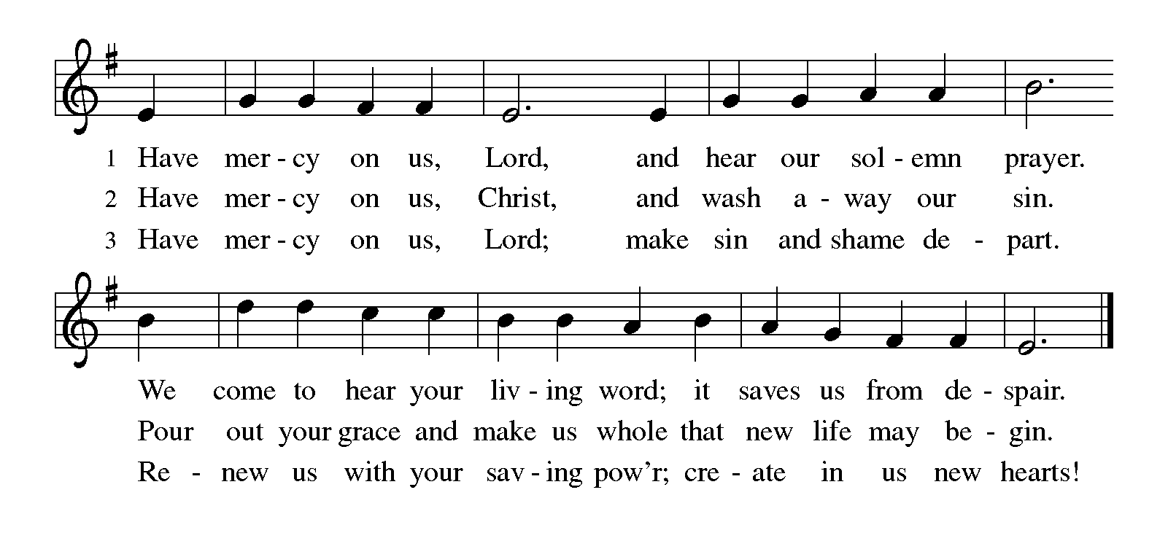Kyrie

Hymn of Praise – #856 *How Great Thou Art*

**WORD –** *We hear God’s teachings to guide our path of serving.*

Prayer of the Day

Let us pray together: **All-powerful God, in Jesus Christ you turned death into life and defeat into victory. Increase our faith and trust in him, that we may triumph over all evil in the strength of the same Jesus Christ, our Savior and Lord.**

**Amen.**

*Please be seated.*

First Lesson 1 Samuel 8:4-11,16-20

A reading from 1 Samuel.

4All the elders of Israel gathered together and came to Samuel at Ramah, 5and said to him, “You are old and your sons do not follow in your ways; appoint for us, then, a king to govern us, like other nations.” 6But the thing displeased Samuel when they said, “Give us a king to govern us.” Samuel prayed to the Lord, 7and the Lord said to Samuel, “Listen to the voice of the people in all that they say to you; for they have not rejected you, but they have rejected me from being king over them. 8Just as they have done to me, from the day I brought them up out of Egypt to this day, forsaking me and serving other gods, so also they are doing to you. 9Now then, listen to their voice; only—you shall solemnly warn them, and show them the ways of the king who shall reign over them.”10So Samuel reported all the words of the Lord to the people who were asking him for a king. 11He said, “These will be the ways of the king who will reign over you: he will take your sons and appoint them to his chariots and to be his horsemen, and to run before his chariots; 16He will take your male and female slaves, and the best of your cattle and donkeys, and put them to his work. 17He will take one-tenth of your flocks, and you shall be his slaves. 18And in that day you will cry out because of your king, whom you have chosen for yourselves; but the Lord will not answer you in that day.But the people refused to listen to the voice of Samuel; they said, “No! but we are determined to have a king over us, 20so that we also may be like other nations, and that our king may govern us and go out before us and fight our battles.”

The word of the Lord. **Thanks be to God.**

Psalm:138

1I will give thanks to you, O Lord, with my whole heart;  
  before the gods I will sing your praise.  
 2**I will bow down toward your holy temple and praise your name,**

**because of your steadfast love and faithfulness;**  
  **for you have glorified your name and your word above all things.**  
 3When I called, you answered me;  
  you increased my strength within me.  
 4**All the rulers of the earth will praise you, O Lord,**  
  **when they have heard the words of your mouth.**  
 5They will sing of the ways of the Lord,  
  that great is the glory of the Lord.  
 6**The Lord is high, yet cares for the lowly,**  
  **perceiving the haughty from afar.**  
 7Though I walk in the midst of trouble, you keep me safe;  
  you stretch forth your hand against the fury of my enemies; your

right hand shall save me.  
 8**You will make good your purpose for me;**  
  **O Lord, your steadfast love endures forever; do not abandon the**

**works of your hands.**

Second Reading 2 Corinthians 4:13-5:1

13Just as we have the same spirit of faith that is in accordance with scripture—“I believed, and so I spoke”—we also believe, and so we speak, 14because we know that the one who raised the Lord Jesus will raise us also with Jesus, and will bring us with you into his presence. 15Yes, everything is for your sake, so that grace, as it extends to more and more people, may increase thanksgiving, to the glory of God.16So we do not lose heart. Even though our outer nature is wasting away, our inner nature is being renewed day by day. 17For this slight momentary affliction is preparing us for an eternal weight of glory beyond all measure, 18because we look not at what can be seen but at what cannot be seen; for what can be seen is temporary, but what cannot be seen is eternal.  
 5:1For we know that if the earthly tent we live in is destroyed, we have a building from God, a house not made with hands, eternal in the heavens.

The word of the Lord.

**Thanks be to God.**

*Please stand, as able.*

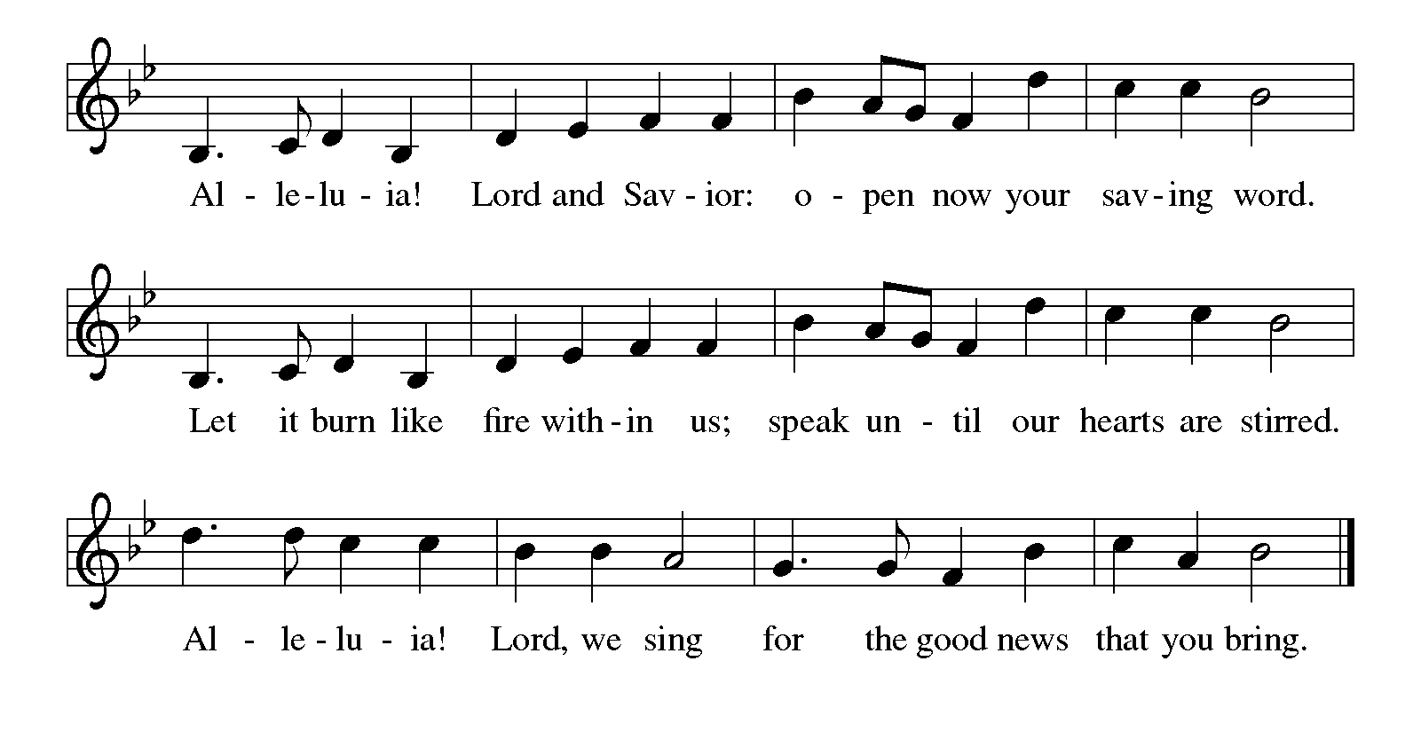

Gospel: Mark 3:20-35

The holy gospel according to Mark, the third chapter.

**Glory to you, O Lord.**

[Jesus went home;] 20and the crowd came together again, so that [Jesus and the disciples] could not even eat. 21When his family heard it, they went out to restrain him, for people were saying, “He has gone out of his mind.” 22And the scribes who came down from Jerusalem said, “He has Beelzebul, and by the ruler of the demons he casts out demons.” 23And he called them to him, and spoke to them in parables, “How can Satan cast out Satan? 24If a kingdom is divided against itself, that kingdom cannot stand. 25And if a house is divided against itself, that house will not be able to stand. 26And if Satan has risen up against himself and is divided, he cannot stand, but his end has come. 27But no one can enter a strong man’s house and plunder his property without first tying up the strong man; then indeed the house can be plundered.  
 28“Truly I tell you, people will be forgiven for their sins and whatever blasphemies they utter; 29but whoever blasphemes against the Holy Spirit can never have forgiveness, but is guilty of an eternal sin”—30for they had said, “He has an unclean spirit.”  
 31Then his mother and his brothers came; and standing outside, they sent to him and called him. 32A crowd was sitting around him; and they said to him, “Your mother and your brothers and sisters are outside, asking for you.” 33And he replied, “Who are my mother and my brothers?” 34And looking at those who sat around him, he said, “Here are my mother and my brothers! 35Whoever does the will of God is my brother and sister and mother.”

The Gospel of the Lord. **Praise to you, O Christ.**

*Please be seated.*

Children’s Time

Sermon

*Please stand, as able.*

Hymn of the Day # 574 *Here I am, Lord*

Apostles’ Creed

**I believe in God, the Father almighty,**

**creator of heaven and earth.**

**I believe in Jesus Christ, God's only Son, our Lord,**

**who was conceived by the power of the Holy Spirit,**

**born of the Virgin Mary,**

**suffered under Pontius Pilate,**

**was crucified, died, and was buried;**

**he descended to the dead.**

**On the third day he rose again;**

**he ascended into heaven,**

**he is seated at the right hand of the Father,**

**and he will come to judge the living and the dead.**

**I believe in the Holy Spirit,**

**the holy catholic Church,**

**the communion of saints,**

**the forgiveness of sins,**

**the resurrection of the body,**

**and the life everlasting. Amen**

Prayers of the Intercession

(petitions)

…Lord in your mercy, **Hear our prayer.**

(prayer concludes)

…**Amen.**

Sharing of the Peace

Offering *Lyric Piece* Keeney

Offertory#686 *We Give Thee but Thine Own - Verses 1 & 2*

Offertory Prayer

Let us pray together. **God of field and forest, sea and sky, you are the giver of all good things. Sustain us with these gifts of your creation,**

**and multiply your graciousness in us, that the world may be fed with your love, through Jesus Christ, our Savior and Lord. Amen.**

The Lord's Prayer

**Our Father, who art in heaven, hallowed be thy name, thy kingdom**

**come, thy will be done, on earth as it is in heaven. Give us this day**

**our daily bread; and forgive us our trespasses, as we forgive those**

**who trespass against us; and lead us not into temptation, but deliver**

**us from evil. For thine is the kingdom, and the power, and the glory,**

**forever and ever. Amen.**

**SENDING -***We are sent out to share hope and make disciples.*

Blessing

The God who calls across the cosmos and speaks in the smallest seed ☩ bless, keep, and sustain you now and to the end of the age. **Amen.**

Sending Hymn *They’ll Know We are Christians by Our Love*

Quiet Meditation

Dismissal

Go in peace. Share the harvest. **Thanks be to God.**

Postlude *March From “Alceste”* Gluck

From [sundaysandseasons.com](http://sundaysandseasons.com/). Copyright © 2023 Augsburg Fortress. All rights reserved. Reprinted by permission under Augsburg Fortress Liturgies Annual License #SAS006821. New Revised Standard Version Bible, Copyright © 1989, Division of Christian Education of the National Council of the Churches of Christ in the United States of America. Used by permission. All rights reserved. Revised Common Lectionary, Copyright © 1992 Consultation on Common Texts, admin Augsburg Fortress. Used by permission. "They'll Know We Are Christians By Our Love" CCLI Song #26997; CCLI Streaming License #20189555 CCLI, Church Copyright License #11344725. "We Are Called" One License Song #00174; "How Great Thou Art" One License Song #24841; "Here I Am, Lord" One License Song #80670; "Great Is Thy Faithfulness" One License Song #105831; "Lyric Piece" One License Song #1013555; "'March' from *Alceste*" One License Song #208097.Livestreamed with permission under ONE License, License # A-732944  All Rights Reserved.

**THE FLOWERS ON THE ALTAR ARE GIVEN TO THE GLORY OF GOD**

and in loving memory of Debbie Barnett by Denny Barnett.

**THE ROSE ON THE ALTAR IS GIVEN TO THE GLORY OF GOD** and in honor of Lori Farrell on her retirement after 30 years of teaching.

**Service Participants**

Lectors: 8:00 am Linda Boyer

10:30 am Jack Molnar

Acolytes: 8:00 am Madison Hoffman

10:30 am Ella Kanouff

Ushers: 8:00 am Bonny Free, Kim Elias

10:30 am Rob Hepler, Curtis Heasley, Karl Henry

Altar Guild: Nancy Basile

**THIS WEEK….**

**Robyn OFFICE HOURS M-TH. 9:00 AM – 2:00 PM FRIDAY 9AM- NOON**

**Sunday**

9:15am Donuts & Divine Discussion

**Wednesday**

11:45 am Fellowship Committee

*VBS Set Up!*

**Monday**

9:00am VBS

6:00pm Joyful Noise Practice

**Tuesday**

9:00 am VBS

10:00 am Prayer Shawl Ministry

6:00 pm Finance Committee

9:00am VBS

**Thursday**

9:00am VBS

7:00 pm Council Meeting

**Friday**

9:00am VBS

**Saturday**

9:00 am Joyful Noise Practice

5:00 pm Worship With Communion

**Evangelism will meet on June 23rd** rather than the 16th as originally planned as the 16th is Father’s Day.

**Youth Singers and Instrumentalists Needed for Rally Day!**

I am looking for Youth Singers and Instrumentalists to present the "Rally Day Song" at the September 8th Rally Day Service!  Please contact Laurie at [lracculia@yahoo.com](mailto:lracculia@yahoo.com) if interested.  All instruments and skill levels are welcome!  Upcoming opportunities for youth musicians will also include Reformation Weekend (October 26/27) and Christmas Eve.

**Donuts and Divine Discussion:**

Share in a time of circular talks and circular snacks. Hangout with Pastor Andrew for a time of fellowship, casual Bible study, theological conversation, and if there are any current or news events, we will circle those in too! *These will be in the hole between the circle of the Sunday worship services (around 9:20-10:10) on June 9 & 23, July 7 & 21, August 11 & 25*

**Camp registrations are still open for summer campers!** $100 off for first time campers. There is a discount code for this it is ***“First”*.** *(It doesn’t apply for Family Camp, Confirmation Camp, Day Camps, or Small Fry Days.)* Please see/call Rob Hepler with any questions, 724-446-2174.

We have scholarships for our campers! We want to be sure that all children and youth that would like to go are able to go! No camper is ever turned away for financial reasons.

**Altar Guild:** Did you order roses or altar flowers? We would love to recycle your bud vases and any altar vases that you may have. Please return any vases to the flower room or church office. Thank you!

**Fellowship:** We are planning a trip to see the Washington Wild Things take on the New York Boulders at 7:05 July 26th.  It’s a fireworks night! We will meet outside the box office at 6:15 to purchase tickets.  General Admission is $15 per seat.   There are various give-away and promotions between innings.   St. Clair Park in Greensburg has many different free concerts on Friday nights throughout the summer.  We might make some Sunday morning announcements or send out e-blasts when congregational members might be going to certain events and where our congregation will be sitting during the event.  The trip to Noah’s Ark in Kentucky will be pushed back until next year.   There are tentative plans to join with the youth water splash event and have a congregational picnic the same time.   Watch for future details.

**Items Available for Sponsorship:**

Flowers available:

Altar Arrangements: June 22,23 (1 Vase), June 29,30 (2 Vases) June 29,30 (2 Vases) July 6,7 (2 Vases)

Roses: June 15 (1 Rose), June 22,23 (2 Roses), June 29, 30 (2 Roses), July 6,7 (2 Roses)

Presence Candle: June 15th, June 22,23, June 29,30, July 6,7

Bulletin: June 15th, June 22,23, June 29,30, July 6,7

***To sponsor items, please sign up in the Communication Center.***

**Church Staff and Office – 724-837-7327**

Rev. Andrew Fitch, Senior Pastor [pastorfitch@outlook.com](mailto:pastorfitch@outlook.com)

Rev. Caroline Clifford, PhD, Asst. Pastor [pastorcarolinehzlc@gmail.com](mailto:pastorcarolinehzlc@gmail.com)

Robyn Henry, Secretary [robynhzlc@gmail.com](mailto:robynhzlc@gmail.com)

Sheri Anderson, Coordinator of Family Ministries hzlcyouth@gmailcom

Laurie Racculia, Director of Music Ministries [lracculia@yahoo.com](mailto:lracculia@yahoo.com)

Debby Schlegel, Custodian

Joanne Gebhardt, Sunday Organist

Melanie Altman, Saturday Organist

**A few of our Favorite Hymns:** This summer we will be using favorite hymns that YOU choose! Please fill out the tear off slip below and contribute to some summer worship music fun! Hymns will be used for all hymns and the hymn of praise. If you know that someone else will be picking the same hymn, then please contribute another one. If we get enough, we will keep using these in worship planning into the fall!

**MY FAVORITE HYMN CHOICE**

**#_______ Title___________________________________________**

*Submitted by* **___________________________**

*Place in offering plate or basket in entrance area.*