Harrold Zion Evangelical Lutheran Church
February 18th 10:30 AM + Joyful Noise
First Sunday in Lent 2024

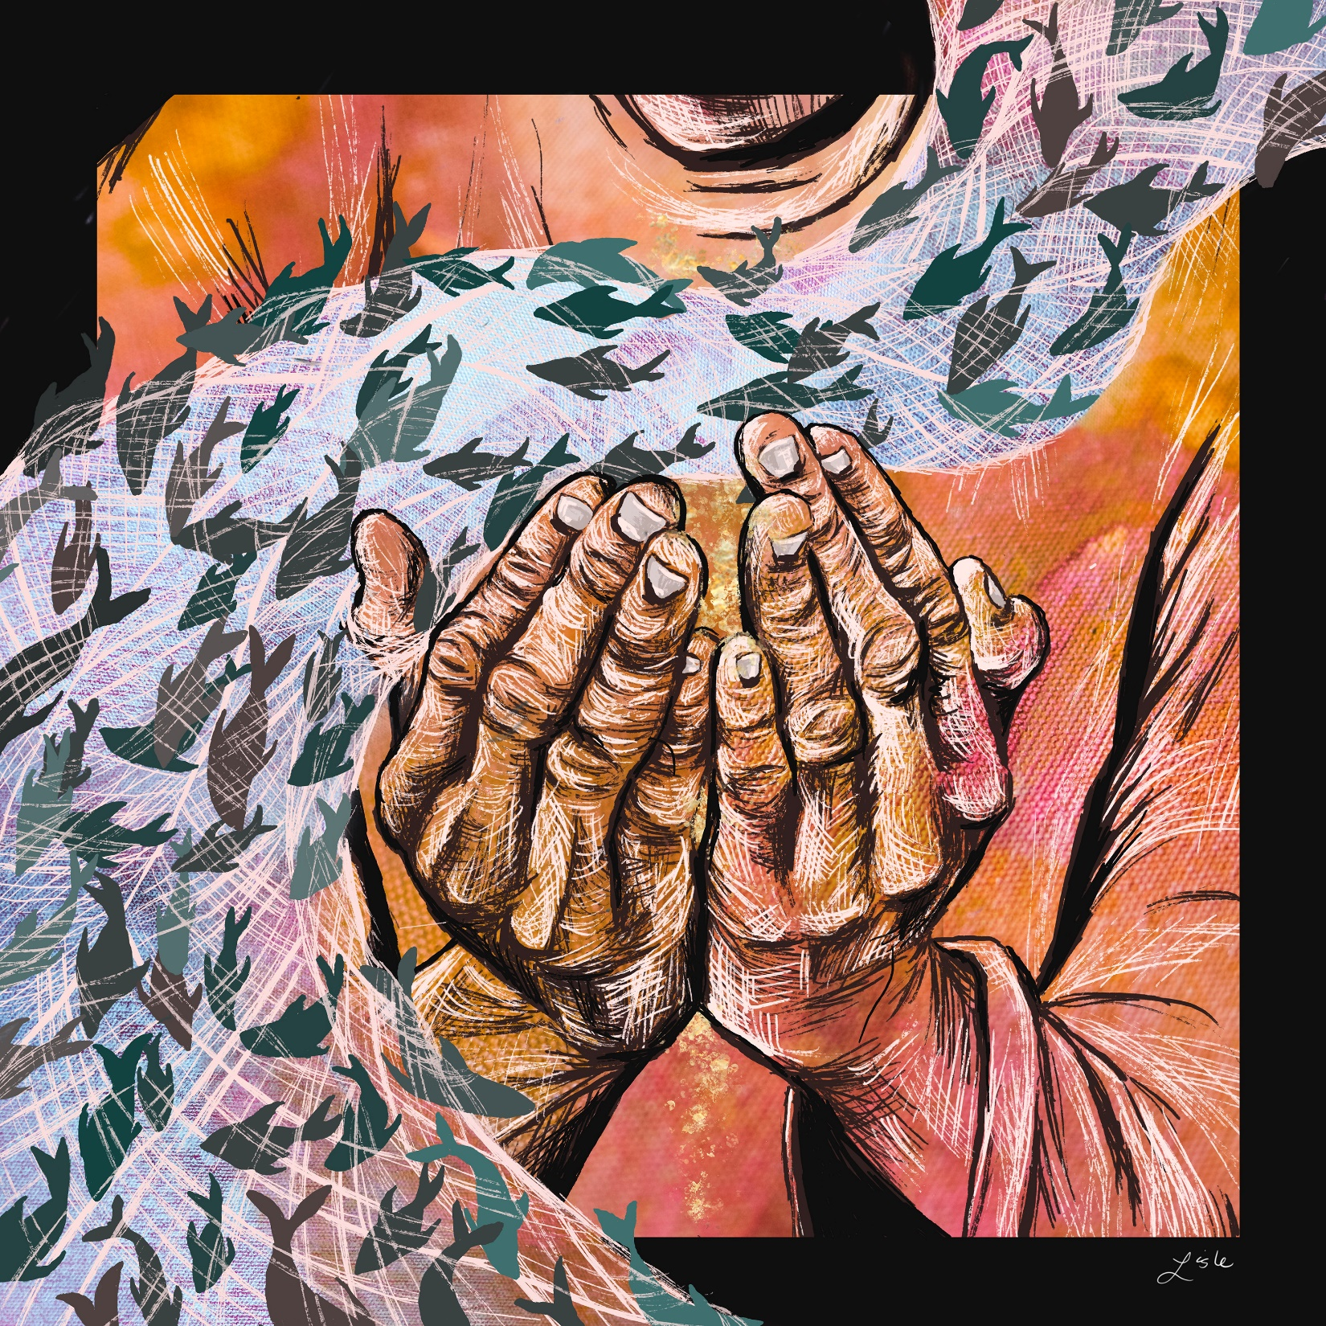

WELCOME TO OUR WORSHIP!

- It is a joy to welcome our visitors! Please sign the guest book in the
Communication Center at the rear of the church, to the right as you exit, and take a Welcome Packet which is filled with information about Harrold Zion. Please introduce yourself to the pastor as you leave worship. We hope you return soon! Follow us on social media!
- Children’s bags are available in the Narthex.
- There is a prayer request book on a podium in the Welcome Center. Please write name(s) in the book prior to the service to have names included in the prayers.
- Large print bulletins are available from any usher for those needing them.
- Hearing devices are available from any usher for those needing them.
- An AED machine can be found on the wall after the Ladies Room on the left.
- Receiving Holy Communion - We believe the body and blood of Christ to be present in the bread and wine. All who are baptized are invited to share in this meal. Please come forward at the usher's direction. Non-communing children may come forward for a blessing. If you desire communion in the pew, please inform one of the ushers so that you may receive communion there.

Our MISSION
To Worship and Serve God,
Grow Disciples and Love our Neighbors

Our Vision
Building Faith that’s Open, Affirming, Authentic,
Positive, Inviting, and that Serves Others.

GATHERING – We are brought together to remember who and whose we are.

Welcome and Announcements – Joys and Concerns

Prelude Are you Washed in the Blood?

Please stand, as able
Call to Worship
Come in. Feel your feet on the floor. Settle your worries. Take a deep breath. Dust the cobwebs from your ears. Relax the tension in your jaw,
for Christ is here. God never stops seeking us.
We have been found.
Let us find God in return.
Let us worship the God of deep waters. Amen.
In our scripture passage for today, we will read about Jesus calling Peter to be a disciple. In the story, Peter is in the presence of the Divine for quite some time before he realizes it. Jesus crawls into Peter’s boat. He tells him to head toward deep water. Together, they let the nets down. And it is only when the boat threatens to sink, due to the extreme abundance of fish, that Peter turns to Jesus and truly sees who’s in his boat. Sometimes we miss what’s right in front of us. Fortunately, Christ keeps crawling into our boats anyhow. So join me in the prayer of confession, not out of fear, but out of a desire to finally see who’s right in front of us. Let us pray:

Loving God, You call us by name. You join us in the deep waters of life. You invite us to drop our nets and follow you, and yet, more often than we’d like to admit, we are like Peter. Over and over again, we stand slack jawed and surprised to find you in our midst. Forgive us for drowning out your voice with our own. Forgive us for assuming that we can tackle deep waters by ourselves. Forgive us for forgetting that you will never stop climbing into our boat. Turn our hearts, our minds, and our spirits toward you, for you are the Lord our God, and it is in your name that we pray. Amen.

Friends, Peter didn’t exactly make a good first impression when Jesus got into his boat. He questioned dropping his nets, as they hadn’t caught any fish all night. He was oblivious to who Christ was for quite some time, and once he realized the Divinity standing in his boat, he quickly deemed himself unworthy. And even still, Jesus called Peter a disciple and a friend. Church family, hear and believe this good news: You can make a thousand bad impressions. You can make every mistake in the book, roll your eyes, and assume you know better. And even still, Christ will forgive you, claim you, and continue to seek your heart. That is the good news of the gospel. Rest, celebrate, and trust in that. Amen.
Creator God, You hear everything. You hear the rush of the wind through the trees. You hear a baby’s first cry. You hear the crickets chirping, our silent prayers, and laughter around tables. You hear it all! We don’t need that same capacity, but we do need to hear your Word, O God, for we cannot live on bread alone. So today we pray: give us the ability to truly listen. Give us the ability to listen with our hearts, and may the truths revealed in your scripture today change us. With hearts full of gratitude we pray, Amen.

You are invited to stand, as able.

Gathering Hymn #319 O Lord, Throughout these Forty Days

Apostolic Greeting
The grace of our Lord Jesus Christ, the love of God, and the communion of the Holy Spirit be with you all. And also with you.

Kyrie
WORD – We hear God’s teachings to guide our path of serving.

Prayer of the Day
Let us pray together. Holy God, heavenly Father, in the waters of the flood you saved the chosen, and in the wilderness of temptation you protected your Son from sin. Renew us in the gift of baptism. May your holy angels be with us, that the wicked foe may have no power over us, through Jesus Christ, our Savior and Lord, who lives and reigns with you and the Holy Spirit, one God, now and forever.
Amen.

Please be seated.

First Reading: Genesis 9:8-17
⁸God said to Noah and to his sons with him, ⁹“As for me, I am establishing my covenant with you and your descendants after you, ¹⁰and with every living creature that is with you, the birds, the domestic animals, and every animal of the earth with you, as many as came out of the ark. ¹¹I establish my covenant with you, that never again shall all flesh be cut off by the waters of a flood, and never again shall there be a flood to destroy the earth.” ¹²God said, “This is the sign of the covenant that I make between me and you and every living creature that is with you, for all future generations: ¹³I have set my bow in the clouds, and it shall be a sign of the covenant between me and the earth. ¹⁴When I bring clouds over the earth and the bow is seen in the clouds, ¹⁵I will remember my covenant that is between me and you and every living creature of all flesh; and the waters shall never again become a flood to destroy all flesh. ¹⁶When the bow is in the clouds, I will see it and remember the everlasting covenant between God and every living creature of all flesh that is on the earth.” ¹⁷God said to Noah, “This is the sign of the covenant that I have established between me and all flesh that is on the earth.” The word of the Lord. Thanks be to God.

Psalm: 25:1-10
¹To you, O Lord,
I lift up my soul.
²My God, I put my trust in you; let me not be put to shame,
nor let my enemies triumph over me.
³Let none who look to you be put to shame;
rather let those be put to shame who are treacherous.
⁴Show me your ways, O Lord,
and teach me your paths.
⁵Lead me in your truth and teach me,
for you are the God of my salvation; in you have I trusted all the day long.
⁶Remember, O Lord, your compassion and love,
for they are from everlasting.
⁷Remember not the sins of my youth and my transgressions;
remember me according to your steadfast love and for the sake of your goodness, O Lord.
⁸You are gracious and upright, O Lord;
therefore you teach sinners in your way.
⁹You lead the lowly in justice
and teach the lowly your way.
¹⁰All your paths, O Lord, are steadfast love and faithfulness
to those who keep your covenant and your testimonies.

Second Reading: 1 Peter 3:18-22
¹⁸Christ also suffered for sins once for all, the righteous for the unrighteous, in order to bring you to God. He was put to death in the flesh, but made alive in the spirit, ¹⁹in which also he went and made a proclamation to the spirits in prison, ²⁰who in former times did not obey, when God waited patiently in the days of Noah, during the building of the ark, in which a few, that is, eight persons, were saved through water. ²¹And baptism, which this prefigured, now saves you—not as a removal of dirt from the body, but as an appeal to God for a good conscience, through the resurrection of Jesus Christ, ²²who has gone into heaven and is at the right hand of God, with angels, authorities, and powers made subject to him. The word of the Lord. Thanks be to God.

Please stand, as able

Gospel Acclamation

Holy Gospel: Luke 5:1-11
The holy gospel according to St. Luke, the fifth chapter.
Glory to you, O Lord.
Once while Jesus was standing beside the Lake of Gennesaret and the crowd was pressing in on him to hear the word of God, ² he saw two boats there at the shore of the lake; the fishermen had gotten out of them and were washing their nets. ³ He got into one of the boats, the one belonging to Simon, and asked him to put out a little way from the shore. Then he sat down and taught the crowds from the boat. ⁴ When he had finished speaking, he said to Simon, “Put out into the deep water and let down your nets for a catch.” ⁵ Simon answered, “Master, we have worked all night long but have caught nothing. Yet if you say so, I will let down the nets.” ⁶ When they had done this, they caught so many fish that their nets were beginning to burst. ⁷ So they signaled their partners in the other boat to come and help them. And they came and filled both boats, so that they began to sink. ⁸ But when Simon Peter saw it, he fell down at Jesus’s knees, saying, “Go away from me, Lord, for I am a sinful man!” ⁹ For he and all who were with him were astounded at the catch of fish that they had taken, ¹⁰ and so also were James and John, sons of Zebedee, who were partners with Simon. Then Jesus said to Simon, “Do not be afraid; from now on you will be catching people.” ¹¹ When they had brought their boats to shore, they left everything and followed him. The gospel of the Lord. Praise to you, O Christ.

Children’s Time

Sermon

Please stand, as able

Hymn of the Day #798 Will You Come and Follow Me

Apostles’ Creed
I believe in God, the Father almighty, creator of heaven and earth.
I believe in Jesus Christ, his only Son, our Lord. He was conceived by
the power of the Holy Spirit and born of the virgin Mary. He suffered
under Pontius Pilate, was crucified, died, and was buried. He
descended into hell. On the third day he rose again. He ascended
into heaven, and is seated at the right hand of the Father. He will
come again to judge the living and the dead.
I believe in the Holy Spirit, the holy catholic Church, the communion
of saints, the forgiveness of sins, the resurrection of the body, and the
life everlasting. Amen

Prayers of Intercession
(petitions)…Lord in your mercy. Hear our prayer.
(prayer concludes)… Amen.

Sharing of the Peace

Offering There is a Fountain

MEAL – We are built up and nourished to be the body of Christ in the world.

Offertory

Offering prayer
Let us pray together. Jesus, you are the bread of life and the host of this meal. Bless these gifts that we have gathered that all people may know your goodness. Feed us not only with this holy food but with hunger for justice and peace. We pray this in your name. Amen.

The Great Thanksgiving and Proper Preface
The Lord be with you.
And also with you.
Lift up your hearts.
We lift them to the Lord.
Let us give thanks to the Lord our God.
It is right to give him thanks and praise.
It is indeed right, our duty and our joy, … we praise your name and join their unending hymn:
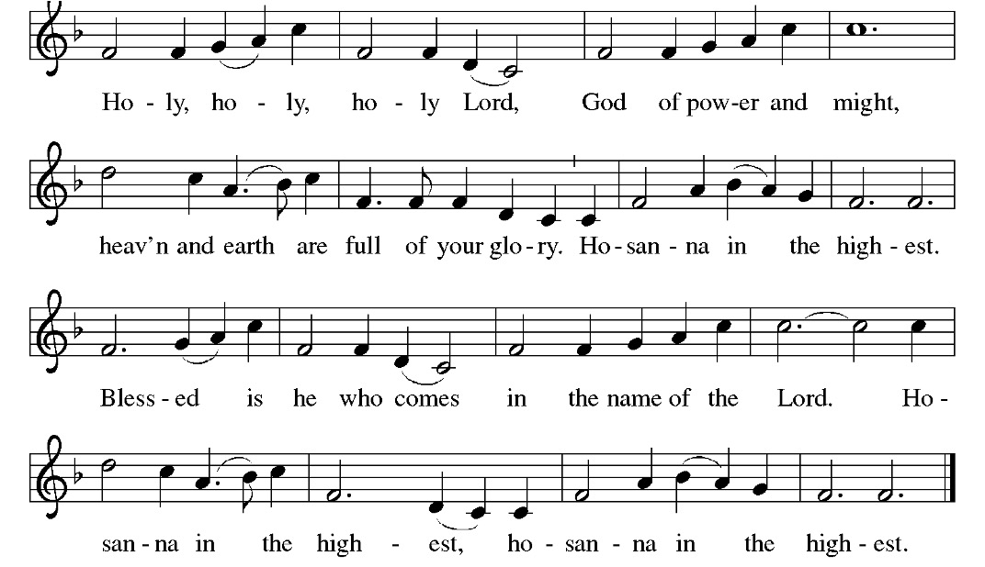

Thanksgiving at the Table Prayer
Holy God, our living water…
…we proclaim the Lord’s death until he comes.
Christ has died.
Christ is risen.
Christ will come again.
…in your holy Church, both now and forever.
Amen.

The Lord’s Prayer
Our Father, who art in heaven, hallowed be thy name, thy kingdom
come, thy will be done, on earth as it is in heaven. Give us this day
our daily bread; and forgive us our trespasses, as we forgive those
who trespass against us; and lead us not into temptation, but deliver
us from evil. For thine is the kingdom, and the power, and the glory,
forever and ever. Amen.

Breaking the Bread and Invitation to Communion
Bread for the journey. A feast for hungry hearts. Come!

Please be seated.

Lamb of God
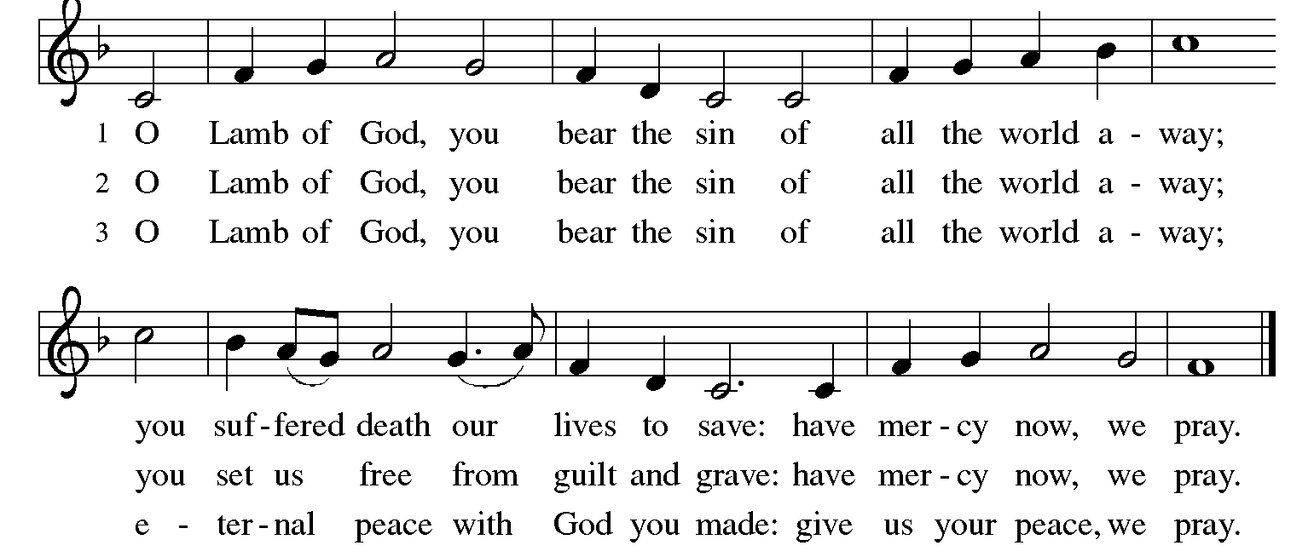
The proclamation is shared for those communing in their place with an all-in-one kit or home elements.

Sharing the elements:
The Body of Christ given for you. The Blood of Christ shed for you.
Each person may respond: Amen.

The leaders share Holy Communion.
The assembly is invited to come forward by the direction of the ushers by the center aisle and receive Holy communion, then return via the side aisle. [For Sunday: You may receive the Sacrament around the altar or at the floor stations.]

Communion Hymns: 336, The Family of God

SENDING – We are set out to share hope and make disciples.

Post-Communion Blessing You are invited to stand.

Prayer after Communion
Let us pray together. Generous God, at this table we have tasted your immeasurable grace. As grains of wheat are gathered into one bread,
now make us one loaf to feed the world; in the name of Jesus, the Bread of life. Amen.

Benediction
Beloved wanderer, as you leave this place, may you carry your curious heart on your sleeve. May you look for God in every face. May you find the courage to get out of the boat, to run to the tomb, and to speak of your faith. And when the world falls apart, may you hear God’s voice deep within, saying, “Take heart, it is I, be not afraid.” You are called. You are blessed. In both your ups and your downs, you always belong to God. Go now in peace. Go trusting that good news.
Amen.

Sending Hymn #759 My Faith Looks up to Thee

Quiet Meditation

Dismissal
Go in peace. Serve the Lord!
Thanks be to God. We will!

Postlude

From sundaysandseasons.com. Copyright © 2023 Augsburg Fortress. All rights reserved. Reprinted by permission under Augsburg Fortress Liturgies Annual License #SAS006821. New Revised Standard Version Bible, Copyright © 1989, Division of Christian Education of the National Council of the Churches of Christ in the United States of America. Used by permission. All rights reserved. Revised Common Lectionary, Copyright © 1992 Consultation on Common Texts, admin Augsburg Fortress. Used by permission. "Lamb of God" CCLI Song #16787; "The Family of God" CCLI Song #17023. CCLI Streaming License #20189555 CCLI, Church Copyright License #11344725. "O Lord, Throughout These Forty Days" One License #11862; "The Summons" One License Song #00076. Live-streamed with permission under ONE License, License # A-732944 All Rights Reserved.

WE THANK TODAY’S SERVICE PARTICIPANTS
Lectors: Christie O’Neill
Acolytes: Maria Gacek
Communion Assistants: Ann Wineman, Melissa Houston
Ushers: David Cronin, Mel Veverka, Cindy Veverka
Altar Guild: Mary Lou Millward

THE FLOWERS NEAR THE PULPIT are dedicated to God and in loving memory of Our Father, John Schein, on his birthday by Jackie Schein-Hohman and John & Coletta Schein

THIS WEEK….
OFFICE HOURS ARE: 9AM-2PM MONDAY-THURSDAY AND 9AM-NOON ON FRIDAY
On Call for pastoral care emergencies:
Pastor Caroline (Sun- Thur) Pastor Andrew (Fr-Sat)

SUNDAY
9:15 AM Sunday School
10:30 AM Joyful Noise
11:45 AM Evangelism Committee
MONDAY
TUESDAY
10:00 AM Prayer Shawl Ministry
WEDNESDAY
6:00 PM Soup & Study/Worship
6:30 PM Bell Choir
7:00 PM Youth Bells
7:30 PM Adult Choir
THURSDAY
11:30 AM Speech PS Library
7:00 PM Boy Scouts
FRIDAY
SATURDAY
8:00 AM Sanctuary Reserved
5:00 PM Worship with Communion
SUNDAY
8:00 & 10:30 AM Worship

LOOKING AHEAD:
- Holy Week begins on March 24, 2024, with Palm Sunday, with services on Maundy Thursday, Good Friday, and Easter, March 31, 2024.
- Palm Sunday breakfast on March 24, 2024, between services.
- Easter Egg hunt on Palm Sunday at 12:00 PM.,
- Shoe collection for Lent.
- Jigsaw Puzzle night – April 12

Lent started on February 14th! (Yes, also known as Valentine’s Day.) The theme for this year will be “Wandering Heart: Figuring Out Faith with Peter.” Each Sunday we will follow the path of (Simon) Peter as he works out what it means to follow Jesus. Special Gospel readings have been chosen that line up this journey and with the typical lectionary appointed Psalm. There will also be a special devotional and liturgical pieces.
On Wednesdays we will follow the path of caretaking and caregiving for matters of the heart and faith with special studies. Each week we will visit a “Stewards of…” set of Bible texts and related questions. We will share in the study while we share some soup and bread (or crackers). Please sign up in the Communication Center if you would like to provide some soup. We will then have a time of discussion, fellowship and clean up before a simple Evening prayer.
Wednesdays in Lent:
6:00pm Soup & Study -Soup and Bread Meal with a Bible study
6:30pm Discussion, Fellowship, Clean-up, and Adult Bell Practice and Midweek Lenten Kids Gathering
7:00pm Evening Prayer and Youth Handbells
7:30pm Adult Choir Practice

Midweek Lenten Kids Gathering
Sheri Anderson will lead a gathering for elementary-age children during the Midweek Lenten services. While the adults gather for bible studies and worship, children will come to the large Sunday school room for fun, lessons, snacks, and more each Wednesday during Lent. If you have any questions, please contact Sheri at 724-837-7327 or hzlcyouth@gmail.com. The start time is 6:30 pm until the end of Worship. Kids Gathering dates: February 21st, February 28th, March 6th, March 13th, & March 20th.

Lenten Youth Bell Choir
Lenten Youth Bell Choir will be taking place during our 2024 Midweek Lenten Services! All ages welcome. No experience needed! Youth Bells will play during the Palm Sunday weekend services!

Easter Instrumentalists Needed!!!
Wanted: instrumentalists of all ages and skill levels to play for the Easter Sunday 2024 services! If you or your children play an instrument, email Laurie at lracculia@yahoo.com to be part of the most joyous celebration of our year!
Palm Sunday Breakfast
Sunday March 24th will be the annual Palm Sunday Breakfast from 8:15– 10:00 AM. Please sign-up in the communication center for donations of breakfast casseroles, pastries, and donuts. There will also be a sign-up for those attending the event. Fellowship committee will be providing breads, bagels, cream cheese, Jellies, coffee, juice, and other drinks.

Easter Egg Hunt
Please donate candy for our Easter egg hunt. The hunt will be on Sunday March 24th at 12 noon. Place donations in the bin marked “Egg Hunt” located in the Communication Center.

Order Easter flowers today! Orders and money is due no later than
Wednesday February 21st, A 6” Lily is $15.00 and a 7” Potted Mum is $15.00. Please complete an order envelope which can be found in the Communication Center. Please place the completed envelope and payment in the offering plate.

ITEMS AVAILABLE FOR SPONSORSHIP:
Altar Flowers – February 24,25 March 2,3 (2 vases)
Bulletin & Eternal candle – February 24,25 March 2,

Church Staff Information
Rev. Andrew Fitch, Senior Pastor - 570-768-8455, pastorfitch@outlook.com
Rev. Caroline Clifford, PhD, Asst. Pastor – 814-769-5662 pastorcarolinhzlc@gmail.com
Sheri Anderson, Coordinator of Family Ministries - hzlcyouth@gmail.com
Laurie Racculia, Director of Music Ministries - lracculia@yahoo.com
Robyn Henry, Secretary, robynhzlc@gmail.com
Debby Schlegel, Custodian
Joanne Gebhardt, Sunday Organist
Melanie Altman, Saturday Organist

