Harrold Zion Evangelical Lutheran Church
February 14, 2024 – 7:00 PM
Ash Wednesday

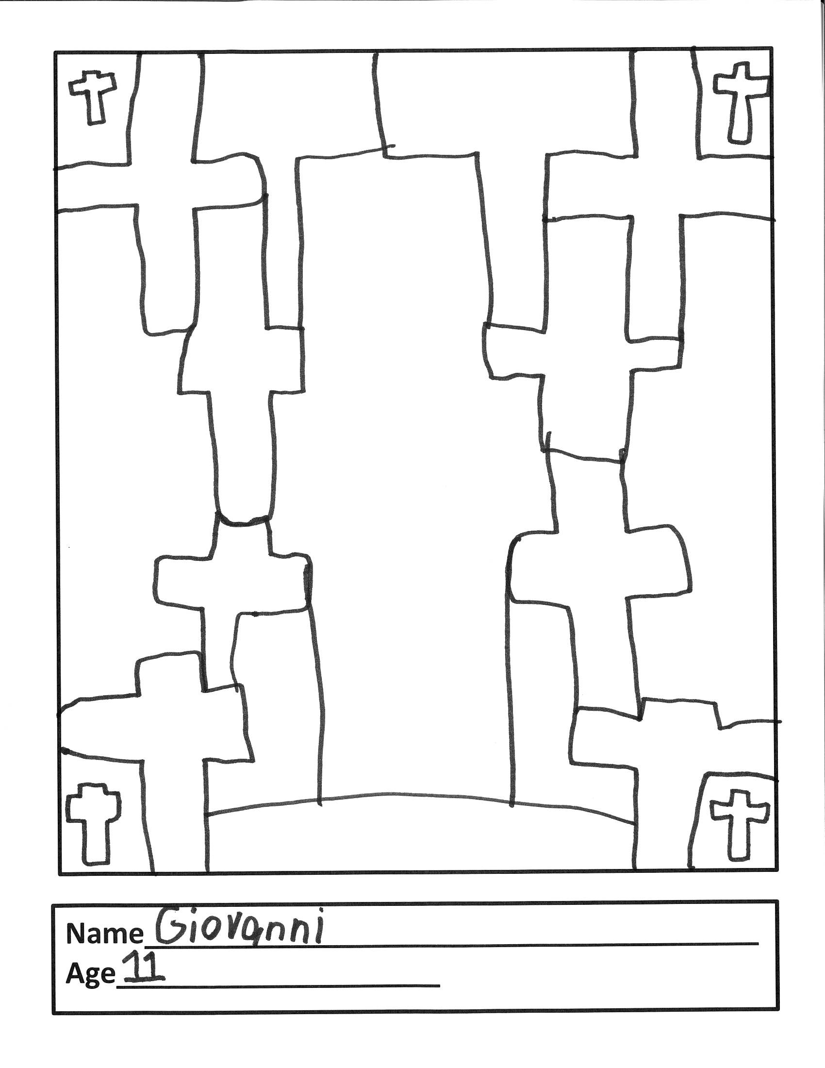

WELCOME TO OUR WORSHIP!
- It is a joy to welcome our visitors! Please sign the guest book in the
Communication Center at the rear of the church, to the right as you exit, and take a Welcome Packet which is filled with information about Harrold Zion. Please introduce yourself to the pastor as you leave worship. We hope you return soon!
- Children’s bags are available in the Narthex.
- There is a prayer request book on a podium in the Welcome Center. Please
write name(s) in the book prior to the service to have names included in the prayers.
- Large print bulletins are available from any usher for those needing them.
- Hearing devices are available from any usher for those needing them.
- An AED machine can be found on the wall after the Ladies Room on the left.
- Receiving Holy Communion - We believe the body and blood of Christ to be present in the bread and wine. All who are baptized are invited to share in this meal. Please come forward at the usher's direction. Non-communing children may come forward for a blessing. If you desire communion in the pew, please inform one of the ushers so that you may receive communion there.

Like us on Facebook

OUR MISSION STATEMENT
To Worship and Serve God,
Grow Disciples and Love our Neighbors

Vision
Building Faith that’s Open, Affirming, Authentic, Positive, Inviting, and that Serves Others.

Please enter in Silence
Prelude

Please face the back of the church and watch the cross as it processes.

Gathering Hymn # 606 Our Father, We Have Wandered

Greeting and Prayer of the Day
Let us pray together. Almighty and ever-living God, you hate nothing you have made, and you forgive the sins of all who are penitent. Create in us new and honest hearts, so that, truly repenting of our sins, we may receive from you, the God of all mercy, full pardon and forgiveness through your Son, Jesus Christ, our Savior and Lord, who lives and reigns with you and the Holy Spirit, one God, now and forever. Amen.

First Reading: Joel 2:1-2, 12-17
¹Blow the trumpet in Zion; sound the alarm on my holy mountain! Let all the inhabitants of the land tremble, for the day of the Lord is coming, it is near— ²a day of darkness and gloom, a day of clouds and thick darkness!
Like blackness spread upon the mountains a great and powerful army comes; their like has never been from of old, nor will be again after them in ages to come. ¹²Yet even now, says the Lord, return to me with all your heart, with fasting, with weeping, and with mourning; ¹³rend your hearts and not your clothing. Return to the Lord, your God, for he is gracious and merciful, slow to anger, and abounding in steadfast love, and relents from punishing. ¹⁴Who knows whether he will not turn and relent, and leave a blessing behind him, a grain offering and a drink offering for the Lord, your God? ¹⁵Blow the trumpet in Zion; sanctify a fast; call a solemn assembly;
¹⁶gather the people. Sanctify the congregation; assemble the aged; gather the children, even infants at the breast. Let the bridegroom leave his room,
and the bride her canopy. ¹⁷Between the vestibule and the altar let the priests, the ministers of the Lord, weep. Let them say, “Spare your people, O Lord, and do not make your heritage a mockery, a byword among the nations. Why should it be said among the peoples, ‘Where is their God?’ ”
The word of the Lord. Thanks be to God.

Second Reading: 2 Corinthians 5:20b--6:10
^{20b}We entreat you on behalf of Christ, be reconciled to God. ²¹For our sake he made him to be sin who knew no sin, so that in him we might become the righteousness of God.
^{6:1}As we work together with him, we urge you also not to accept the grace of God in vain. ²For he says, “At an acceptable time I have listened to you,
and on a day of salvation I have helped you.”
See, now is the acceptable time; see, now is the day of salvation! ³We are putting no obstacle in anyone’s way, so that no fault may be found with our ministry, ⁴but as servants of God we have commended ourselves in every way: through great endurance, in afflictions, hardships, calamities, ⁵beatings, imprisonments, riots, labors, sleepless nights, hunger; ⁶by purity, knowledge, patience, kindness, holiness of spirit, genuine love, ⁷truthful speech, and the power of God; with the weapons of righteousness for the right hand and for the left; ⁸in honor and dishonor, in ill repute and good repute. We are treated as impostors, and yet are true; ⁹as unknown, and yet are well known; as dying, and see—we are alive; as punished, and yet not killed; ¹⁰as sorrowful, yet always rejoicing; as poor, yet making many rich; as having nothing, and yet possessing everything.
The word of the Lord. Thanks be to God.

Gospel Acclamation Please Stand as able.
Return to the Lord, your God, for he is gracious and merciful,
slow to anger, and abounding in steadfast love.

Gospel: Matthew 6:1-6, 16-21
The Holy Gospel according to St. Matthew, the sixth chapter.
Glory to you, O Lord.
[Jesus said to the disciples:] ¹“Beware of practicing your piety before others in order to be seen by them; for then you have no reward from your Father in heaven.
²“So whenever you give alms, do not sound a trumpet before you, as the hypocrites do in the synagogues and in the streets, so that they may be praised by others. Truly I tell you, they have received their reward. ³But when you give alms, do not let your left hand know what your right hand is doing, ⁴so that your alms may be done in secret; and your Father who sees in secret will reward you.
⁵“And whenever you pray, do not be like the hypocrites; for they love to stand and pray in the synagogues and at the street corners, so that they may be seen by others. Truly I tell you, they have received their reward. ⁶But whenever you pray, go into your room and shut the door and pray to your Father who is in secret; and your Father who sees in secret will reward you. ¹⁶“And whenever you fast, do not look dismal, like the hypocrites, for they disfigure their faces so as to show others that they are fasting. Truly I tell you, they have received their reward. ¹⁷But when you fast, put oil on your head and wash your face, ¹⁸so that your fasting may be seen not by others but by your Father who is in secret; and your Father who sees in secret will reward you.
¹⁹“Do not store up for yourselves treasures on earth, where moth and rust consume and where thieves break in and steal; ²⁰but store up for yourselves treasures in heaven, where neither moth nor rust consumes and where thieves do not break in and steal. ²¹For where your treasure is, there your heart will be also.” The Gospel of the Lord. Praise to you, O Christ.

Sermon

Hymn #601 Savior, when in dust to you

Invitation into Lent, Confession, and Imposition of Ashes
Friends in Christ, …the great Three Days of Jesus' death and resurrection.
Let us confess our sin in the presence of God and of one another.

Please kneel or sit, as able

Most holy and merciful God,
we confess to you and to one another, and before the whole
company of heaven, that we have sinned by our fault, by our own
most grievous fault, in thought, word, and deed, by what we have
done and by what we have left undone.
We have not loved you with our whole heart, and mind, and strength.
We have not loved our neighbors as ourselves. We have not forgiven
others as we have been forgiven.
Have mercy on us, O God.
We have shut our ears to your call to serve as Christ served us. We
have not been true to the mind of Christ. We have grieved your Holy
Spirit.
Have mercy on us, O God.
Our past unfaithfulness, the pride, envy, hypocrisy, and apathy that
have infected our lives, we confess to you.
Have mercy on us, O God.
Our negligence in prayer and worship, and our failure to share the faith
that is in us, we confess to you.
Have mercy on us, O God.
Our neglect of human suffering and need, and our indifference to
injustice and cruelty, we confess to you. Have mercy on us, O God.
Our false judgments, our uncharitable thoughts toward our neighbors,
and our prejudice and contempt toward those who differ from us, we
confess to you. Have mercy on us, O God.
Our waste and pollution of your creation, and our lack of concern for
those who come after us, we confess to you.
Have mercy on us, O God.
Restore us, O God, and let your anger depart from us.
Hear us, O God, for your mercy is great.
Let us pray. Almighty God, you have created us out of the dust of the
earth. May these ashes be a sign of our mortality and penitence,
reminding us that only by the cross of our Lord Jesus Christ are we given
eternal life; through the same Jesus Christ our Lord. Amen.

Please come forward by the center aisle to
receive ashes and return to your pew by the side aisle.

Anthem during Imposition of Ashes Sign Us With Ashes Rowan

After imposition:
Accomplish in us, O God, the work of your salvation.
that we may show forth your glory in the world.
By the cross and passion of your Son, our Savior,
Bring us with all your saints to the joy of your resurrection.
Almighty God have mercy on us, forgive us all our sins through our
Lord Jesus Christ, strengthen us in all goodness, and by the power of the
Holy Spirit keep us in eternal life.
Amen.
Please stand, as able.

Prayers of the Church responses:“…Lord in your mercy. Hear our prayer.”

Offertory
Create in me a clean heart, O God, and renew a right spirit within
me. Cast me not away from your presence, and take not your Holy
Spirit from me. Restore unto me the joy of your salvation, and
uphold me with your free Spirit.

Offertory Prayer
Merciful God, receive the sacrifice of our praise and
thanksgiving and the offering of our lives, that following in the way of
the cross, we may know the joy of the resurrection; through Christ
our Lord. Amen.

Great Thanksgiving and Proper Preface
The Lord be with you.
And also with you.
Lift up your hearts.
We lift them to the Lord.
Let us give thanks to the Lord our God.
It is right to give him thanks and praise.
It is indeed right and salutary….we praise your name and join their
unending hymn:
Holy, holy, holy Lord, God of power and might. Heaven and earth
are full of your glory. Hosanna in the highest. Blessed is he who
comes in the name of the Lord. Hosanna in the highest.

Eucharistic Prayer

Lord’s Prayer
Our Father, who art in heaven, hallowed be thy name, thy kingdom
come, thy will be done, on earth as it is in heaven. Give us this day
our daily bread; and forgive us our trespasses, as we forgive those
who trespass against us; and lead us not into temptation, but deliver
us from evil. For thine is the kingdom, and the power, and the glory,
forever and ever. Amen

Lamb of God
Lamb of God, you take away the sin of the world; have mercy on
us. Lamb of God, you take away the sin of the world; have mercy on
us. Lamb of God, you take away the sin of the world; grant us peace.

Distribution of the Sacrament
Instructions

Communion Hymns: #629,592 & 607.

Communion Blessing

Post-Communion Prayer

Benediction

Sending Hymn #599 Lord Jesus, Think on Me

Dismissal
Go in Peace. Serve in Love. Thanks be to God.

Postlude
From sundaysandseasons.com. Copyright © 2023 Augsburg Fortress. All rights reserved. Reprinted by permission under Augsburg Fortress Liturgies Annual License #SAS006821. New Revised Standard Version Bible, Copyright © 1989, Division of Christian Education of the National Council of the Churches of Christ in the United States of America. Used by permission. All rights reserved. Revised Common Lectionary, Copyright © 1992 Consultation on Common Texts, admin Augsburg Fortress. Used by permission. CCLI Streaming License #20189555 CCLI, Church Copyright License #11344725. "Our Father, We Have Wandered" One License Song #27142; "Sign Us With Ashes" One License #87615; "I Lay My Sins on Jesus" One License Song #10133338; "Be Ye Blessed" One License Song #1054215. Live-streamed with permission under ONE License, License # A-732944 All Rights Reserved

PLEASE JOIN US FOR OUR MIDWEEK LENTEN SERIES
Wednesdays in Lent:
6:00pm Soup & Study -Soup and Bread Meal with a Bible study
6:30pm Discussion, Fellowship, Clean-up, and Adult Bell Practice
and Kids Gathering (see below)
7:00pm Evening Prayer and Youth Handbells
7:30pm Adult Choir Practice
**Wednesday March 20 will be the final Wednesday.

Special Thank You
Thank you to our Choir Soloists; Jack Molnar, Fred Wineman, Kelsie Coppetti Bernie Zundel and Shawn Carolan.
Midweek Lenten Kids Gathering
Sheri Anderson will lead a gathering for elementary-age children during the Midweek Lenten services. While the adults gather for bible studies and worship, children will come to the large Sunday school room for fun, lessons, snacks, and more each Wednesday during Lent. If you have any questions, please contact Sheri at 724-837-7327 or hzlcyouth@gmail.com. The start time is 6:30 pm until the end of Worship. Kids Gathering dates: February 21st, February 28th, March 6th, March 13th, March 20th.

