Harrold Zion Evangelical Lutheran Church
Season of Creation 5
Saturday September 28, 2024 5 pm
Sunday September 29, 2024 8 & 10:30 am


From the Bible, Queen Esther,
Persian Queen Who Cared for Her Jewish Community

WELCOME TO OUR WORSHIP!

- It is a joy to welcome our visitors! Please sign the guest book in the
Communication Center at the rear of the church, to the right as you exit, and take a Welcome Packet which is filled with information about Harrold Zion. Please introduce yourself to the pastor as you leave worship. We hope you return soon!
- Children’s bags are available in the Narthex.
- There is a prayer request book on a podium in the Welcome Center. Please
write name(s) in the book prior to the service to have names included in the prayers.
- Large print bulletins are available from any usher for those needing them.
- Hearing devices are available from any usher for those needing them.
- An AED machine can be found on the wall after the Ladies Room on the left.
- Receiving Holy Communion - We believe the body and blood of Christ to be present in the bread and wine. All who are baptized are invited to share in this meal. Please come forward at the usher's direction. Non-communing children may come forward for a blessing. If you desire communion in the pew, please inform one of the ushers so that you may receive communion there

Our MISSION
To Worship and Serve God,
Grow Disciples and Love our Neighbors
Our Vision
Building Faith that’s Open, Affirming, Authentic,
Positive, Inviting, and that Serves Others.

GATHERING -The Holy Spirit calls us together as the people of God.
Welcome, Announcements, Carings and Sharings
Introduction to Setting 8 – Hymn of Praise

Prelude: 5 pm When Morning Gilds The Sky Larson
8 & 10:30 am Ye Servants of God Wilson

Confession and Forgiveness: Please stand, as able.
All may make the sign of the cross, the sign that is marked at baptism.
Blessed be the holy Trinity, ☩ one God,
who forgives all our sin,
whose mercy endures forever.
Amen.
Let us confess our sin and come to God for healing.
Silence is kept for reflection. You may Kneel or stand.
Gracious God,
have mercy on us.
We confess that we have honored you with our lips, but have harmed our neighbors with our tongues. The cravings at war within us cause conflicts and disputes. In our desire to be first we make distinctions among ourselves. We place the needs of the poor and the suffering last.
We confess that we have taken the abundance of your Creation for granted: make us urgent now for its protection.

In your great mercy, forgive us our sins. Draw near to us with grace in time of need and turn us to follow in the way of Jesus Christ, our Savior and Lord. Amen.
God promises to forgive our iniquity and to remember our sin no more.
By grace you have been saved. In the name of ☩ Jesus Christ,
the source of eternal healing, your sins are forgiven.
Amen.

Gathering Hymn # 532 Gather Us In

Apostolic Greeting
The grace of our Lord Jesus Christ, the love of God, and the
communion of the Holy Spirit be with you all. And also with you.

Kyrie (page 184 in hymnal) The assembly sings the refrain
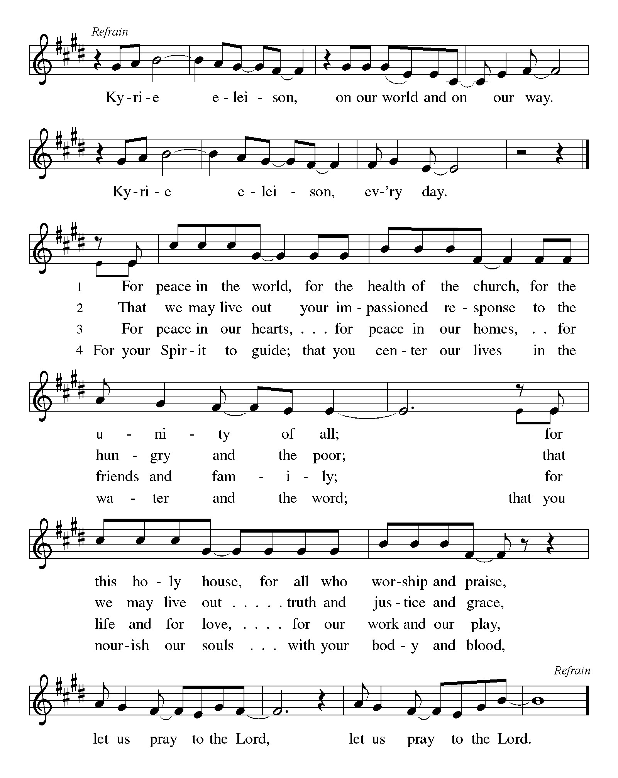
For peace in the world, for the health of the church, for the unity of all;
for this holy house, for all who worship and praise,
let us pray to the Lord, let us pray to the Lord Refrain

That we may live out your impassioned response to the hungry and the poor;
that we may live out truth and justice and grace,
let us pray to the Lord, let us pray to the Lord Refrain

For peace in our hearts, for peace in our homes, for friends and family;
for life and for love, for our work and our play,
let us pray to the Lord, let us pray to the Lord Refrain

For your Spirit to guide; that you center our lives in the water and the Word;
that you nourish our souls with your body and blood,
let us pray to the Lord, let us pray to the Lord Refrain

Hymn of Praise: This is the Feast
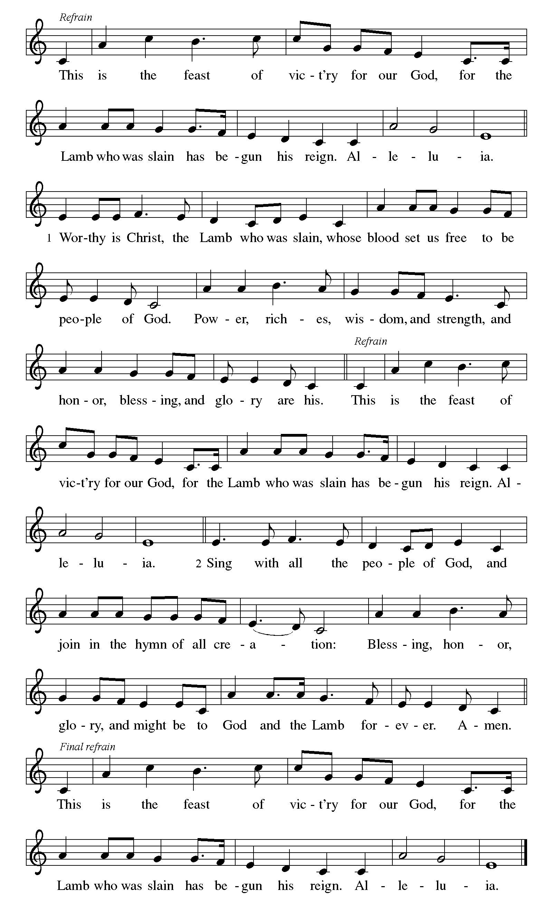

First Reading: Esther 7:1-6, 9-10; 9:20-22
A reading from Esther.
¹[King Ahasuerus] and Haman went in to feast with Queen Esther.²On the second day, as they were drinking wine, the king again said to Esther, “What is your petition, Queen Esther? It shall be granted you. And what is your request? Even to the half of my kingdom, it shall be fulfilled.” ³Then Queen Esther answered, “If I have won your favor, O king, and if it pleases the king, let my life be given me—that is my petition—and the lives of my people—that is my request. ⁴For we have been sold, I and my people, to be destroyed, to be killed, and to be annihilated. If we had been sold merely as slaves, men and women, I would have held my peace; but no enemy can compensate for this damage to the king.” ⁵Then King Ahasuerus said to Queen Esther, “Who is he, and where is he, who has presumed to do this?” ⁶Esther said, “A foe and enemy, this wicked Haman!” Then Haman was terrified before the king and the queen. ⁹Then Harbona, one of the eunuchs in attendance on the king, said, “Look, the very gallows that Haman has prepared for Mordecai, whose word saved the king, stands at Haman’s house, fifty cubits high.” And the king said, “Hang him on that.” ¹⁰So they hanged Haman on the gallows that he had prepared for Mordecai. Then the anger of the king abated.
^{9:20}Mordecai recorded these things, and sent letters to all the Jews who were in all the provinces of King Ahasuerus, both near and far, ²¹enjoining them that they should keep the fourteenth day of the month Adar and also the fifteenth day of the same month, year by year, ²²as the days on which the Jews gained relief from their enemies, and as the month that had been turned for them from sorrow into gladness and from mourning into a holiday; that they should make them days of feasting and gladness, days for sending gifts of food to one another and presents to the poor. The word of the Lord. Thanks be to God.

10:30 am Handbell Anthem: This Little Light of Mine Moats

Psalm 124
¹If the Lord had not been on our side,
let Israel now say;
²if the Lord had not been on our side,
when enemies rose up against us,
³then would they have swallowed us up alive
in their fierce anger toward us;
⁴then would the waters have overwhelmed us
and the torrent gone over us;
⁵then would the raging waters
have gone right over us.
⁶Blessed be the Lord
who has not given us over to be a prey for their teeth.
⁷We have escaped like a bird from the snare of the fowler;
the snare is broken, and we have escaped.
⁸Our help is in the name of the Lord,
the maker of heaven and earth.

Second Reading: James 5:13-20
A reading from James.
¹³Are any among you suffering? They should pray. Are any cheerful? They should sing songs of praise. ¹⁴Are any among you sick? They should call for the elders of the church and have them pray over them, anointing them with oil in the name of the Lord. ¹⁵The prayer of faith will save the sick, and the Lord will raise them up; and anyone who has committed sins will be forgiven. ¹⁶Therefore confess your sins to one another, and pray for one another, so that you may be healed. The prayer of the righteous is powerful and effective. ¹⁷Elijah was a human being like us, and he prayed fervently that it might not rain, and for three years and six months it did not rain on the earth. ¹⁸Then he prayed again, and the heaven gave rain and the earth yielded its harvest.
¹⁹My brothers and sisters, if anyone among you wanders from the truth and is brought back by another, ²⁰you should know that whoever brings back a sinner from wandering will save the sinner’s soul from death and will cover a multitude of sins. The word of the Lord. Thanks be to God.

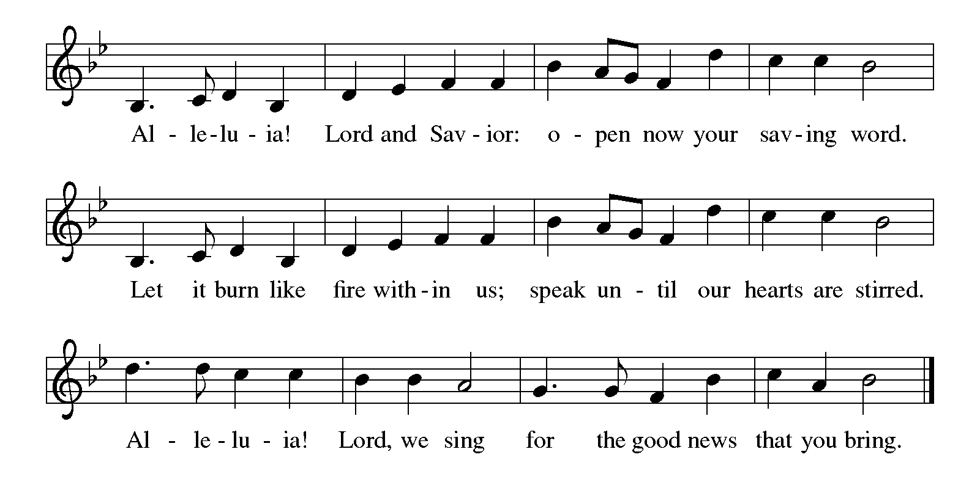
Gospel Acclamation Please stand, as able
Holy Gospel: Mark 9:38-50
The holy gospel according to Mark.
Glory to you, O Lord.
³⁸John said to [Jesus], “Teacher, we saw someone casting out demons in your name, and we tried to stop him, because he was not following us.” ³⁹But Jesus said, “Do not stop him; for no one who does a deed of power in my name will be able soon afterward to speak evil of me. ⁴⁰Whoever is not against us is for us. ⁴¹For truly I tell you, whoever gives you a cup of water to drink because you bear the name of Christ will by no means lose the reward.
⁴²“If any of you put a stumbling block before one of these little ones who believe in me, it would be better for you if a great millstone were hung around your neck and you were thrown into the sea. ⁴³If your hand causes you to stumble, cut it off; it is better for you to enter life maimed than to have two hands and to go to hell, to the unquenchable fire. ⁴⁵And if your foot causes you to stumble, cut it off; it is better for you to enter life lame than to have two feet and to be thrown into hell. ⁴⁷And if your eye causes you to stumble, tear it out; it is better for you to enter the kingdom of God with one eye than to have two eyes and to be thrown into hell, ⁴⁸where their worm never dies, and the fire is never quenched.
⁴⁹“For everyone will be salted with fire. ⁵⁰Salt is good; but if salt has lost its saltiness, how can you season it? Have salt in yourselves and be at peace with one another.”The gospel of the Lord. Praise to you, O Christ.

Please be seated.
Children’s Message

Sermon

Hymn of the Day #455 Crashing Waters at Creation

Please stand as able

The Apostles Creed
I believe in God, the Father almighty,
creator of heaven and earth.
I believe in Jesus Christ, God's only Son, our Lord,
who was conceived by the power of the Holy Spirit,
born of the Virgin Mary,
suffered under Pontius Pilate,
was crucified, died, and was buried;
he descended to the dead.
On the third day he rose again;
he ascended into heaven,
he is seated at the right hand of the Father,
and he will come to judge the living and the dead.
I believe in the Holy Spirit,
the holy catholic Church,
the communion of saints,
the forgiveness of sins,
the resurrection of the body,
and the life everlasting. Amen

Prayers of the Intercession
(petitions)
…Lord in your mercy, Hear our prayer.
(prayer concludes)
…Amen.
Sharing of the Peace

MEAL -We are fed and nourished by the unending life of God.

Offering (8 am & 10:30 am) Serving Him Dillon

Offertory Bless Thou The Gifts (Sung Twice)
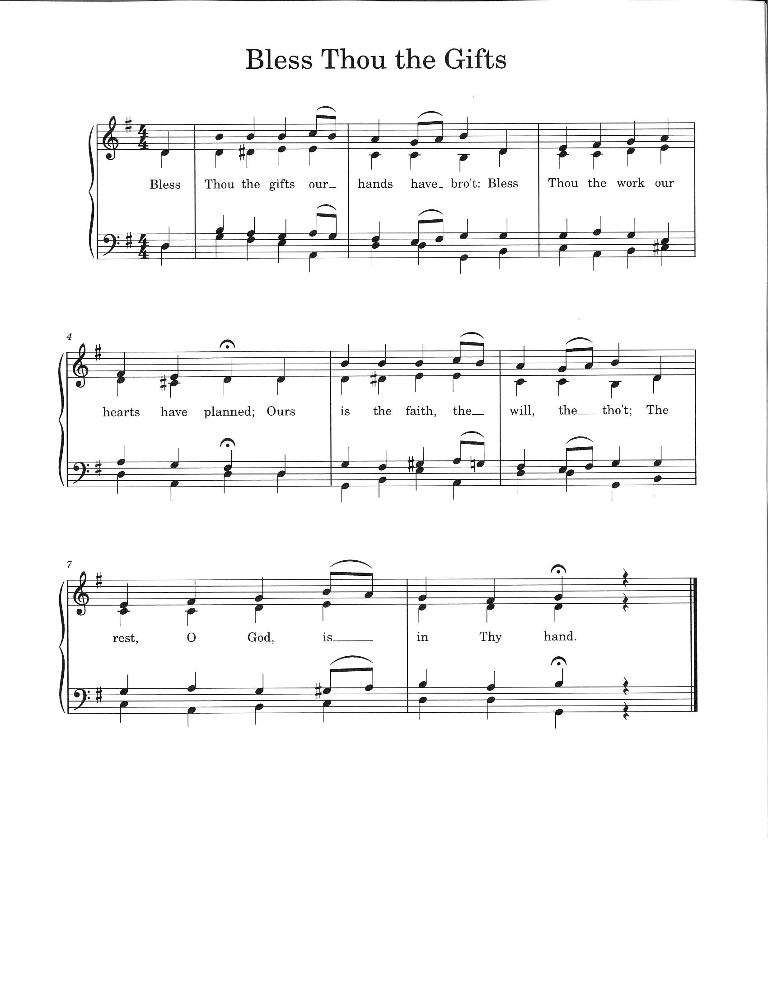
Offering Prayer Let us pray together
Blessed are you, O God,
Source of every gift of your creation.
By these gifts and with our lives,
help us to serve one another and all in need,
through Jesus Christ, our Savior and Lord. Amen.

The Great Thanksgiving and Proper Preface
The Lord be with you.
And also with you.
Lift up your hearts.
We lift them to the Lord.
Let us give thanks to the Lord our God.
It is right to give God thanks and praise.
It is indeed our duty and our joy… and join their unending hymn:
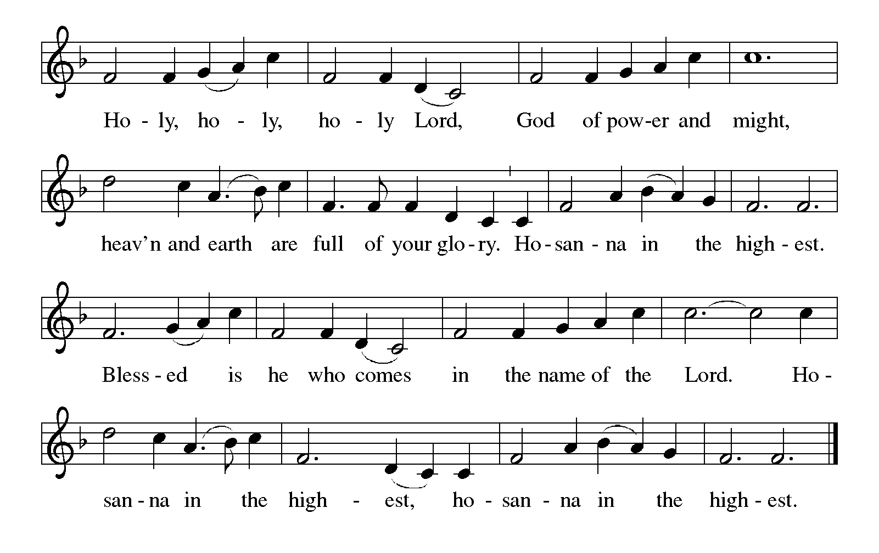
Eucharistic Prayer

The Lord's Prayer
Our Father, who art in heaven, hallowed be thy name, thy kingdom
come, thy will be done, on earth as it is in heaven. Give us this day
our daily bread; and forgive us our trespasses, as we forgive those
who trespass against us; and lead us not into temptation, but deliver
us from evil. For thine is the kingdom, and the power, and the glory,
forever and ever. Amen.

Breaking the Bread and Invitation to Communion
Jesus welcomes you to this table.
Come, here is your God.
Please be seated

Lamb of God
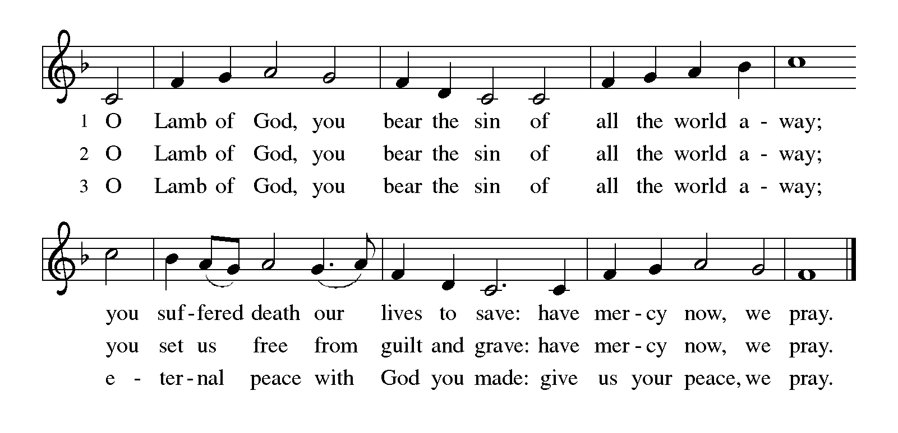
The proclamation is shared for those communing in their place with an all-in-one kit or home elements.

Sharing the elements:
The Body of Christ given for you.
The Blood of Christ shed for you.
Each person may respond: Amen.

The leaders share Holy Communion. Gluten free wafers and grape juice are in the center of each tray. The assembly is invited to come forward by the direction of the ushers by the center aisle and receive Holy communion, then return via the side aisle.

Communion Hymn #753 WOV You Are the Seed
# 674 Let Us Talents & Tongues Employ

You Are the Seed

1. You are the seed that will grow a new sprout, you're a star that will shine in the night; You are the yeast and a small grain of salt, a beacon to glow in the dark.
You are the dawn that will bring a new day; you're the wheat that will bear golden grain; You are a sting and a soft, gentle touch, to witness wherever you go.

Refrain: Go, my friends, go to the world, proclaim the great love of God;
Messengers to tell the way of life, peace and pardon for all.
Be, my friends, a loyal witness, from the dead Christ arose;
"Lo, I'll be with you forevermore, till the end of the world."

2. You are the flame that will lighten the dark, so resplendent with hope, faith and love;
You are the shepherds to lead the whole world to waters and pastures of peace.
"You are the friends that I chose for myself, you're the word that I want to proclaim,
You are the new reign of God built on rock, where justice and truth are at home." Refrain

3. You are the life that will nurture the plant; you're the waves in a turbulent sea;
Yesterday's yeast is beginning to rise, a new loaf of bread it will yield.
There is no place for a city to hide, there's no mountain can cover its might;
Let your light shine so that your loving works give honor and glory to God. Refrain

SENDING -We are sent out to share hope and make disciples.

Post-Communion Blessing The assembly is invited to stand.

Prayer after Communion
Let us pray together. Blessed are you, O God,
Source of every gift of your creation. By these gifts and with our lives, help us to serve one another and all in need, through Jesus Christ, our Savior and Lord. Amen.

Blessing
God all mighty, God most merciful ☩ bless you, keep you, and give you peace.
Amen.
Sending Hymn #855 Crown Him with Many Crowns

Quiet Meditation

Dismissal
Go in peace. Follow Jesus. Thanks be to God. We will!

Postlude: 5 pm He’s Got the Whole World In His Hands Fox
8 am & 10:30 am Exaltation Hughes

From sundaysandseasons.com. Copyright © 2023 Augsburg Fortress. All rights reserved. Reprinted by permission under Augsburg Fortress Liturgies Annual License #SAS006821. New Revised Standard Version Bible, Copyright © 1989, Division of Christian Education of the National Council of the Churches of Christ in the United States of America. Used by permission. All rights reserved. Revised Common Lectionary, Copyright © 1992 Consultation on Common Texts, admin Augsburg Fortress. Used by permission. CCLI Streaming License #20189555 CCLI, Church Copyright License #11344725. "Gather Us In" One License Song #00031; "Crashing Waters at Creation" One License Song #03954; "You Are the Seed" One License Song #22560; "Let Us Talents and Tongues Employ" One License Song #95156; "This Little Light of Mine" One License Song #CGB678; "Ye Servants of God" One License Song #1019991; "Serving Him" One License Song #1048960; "Exaltation" One License Song #11703. Livestreamed with permission under ONE License, License # A-732944 All Rights Reserved.

THE CANDLE IS GIVEN to the glory of God and in loving memory of Don A. Wagner by Mark & Arlene Wagner.

THE BULLETIN IS GIVEN TO the glory of God in honor of Ben on his 13th Birthday, Happy 13th Birthday Ben! From Grandma and Grandpa Cronin.

Service Participants:
Acolytes: 8:00 am Katelyn Holsopple
10:30 am Caleb Heasley
Lectors: 8:00 am Louise Henry
10:30 am Shawn Carolan
Communion Assistants: 8 am Kevin Torrance, Sheri Anderson
10:30 am Cooper Anderson, Erin Black
Ushers: 8:00 am Regis Bombach, Bonny Free
10:30 am Diane Ihlenfeld, Kevin Kurimsky, Stacey Winfield, Jason Barnhart
Altar Guild: Missy Houston

THIS WEEK….
Pastor Andrew is off this Sunday for his Niece’s Wedding

Robyn OFFICE HOURS M-THUR. 9:00 AM – 2:00 PM FRIDAY 9AM- NOON

SUNDAY
8 am Worship w/ Communion
9:15 am Sunday School
10:30 am Worship w/ Communion
MONDAY
9 am PS Speech- meeting room
10:30 am Quilting
1:00 pm Quilting
TUESDAY
3:00 pm Book Study Pastor Caroline
WEDNESDAY
9:00 am PS Library

6:00 pm Bell Choir Rehearsal
7:00 pm Adult Choir
THURSDAY
9:45 am PS Library
3:00 pm Grief Support
7:00 pm Boy Scouts
FRIDAY
10:00 am Ladies Bible Study
4:00 pm Homecoming Parade
SATURDAY
5:00 pm Worship w/ Communion

A Memorial Gift was received in loving memory of George Spong, who passed away this summer. There was a graveside memorial service held this past Saturday at our church. Our condolences are extended to his family.

Hempfield Homecoming Parade 2024
We will be celebrating the homecoming parade at our very own pavilion on Friday Oct. 4th. We will provide Hotdogs and drinks. There will be a bonfire to cook hotdogs and marshmallows (weather permitting). Food will be ready to go by 4:30 - please bring a side dish to share. Rt. 136 closes at 5:00 PM in preparation for the parade.

Hempfield Manor Hymn Sing and Holy Communion
Our next Hymn Sing at Hempfield Manor will be 10 am, Monday October 21,^{st} Saturday November 2nd 2 pm, Tuesday December 17th 6:30 pm. Come join us as we sing classic hymns that the residents have requested. All are welcome!
Helping Hands is sponsoring a Craft Show on Saturday November 9th from 10 am to 4 pm, here in the Social Hall. Anyone interested in a table or donating baked goods please contact Barbara Rigoni at 724-523-2069.

Food2Go4Kids Packers
A sign-up sheet is available in the Communication Area of the church to indicate you would like to help pack the food bags. Even if you have been packing all along, please sign the sheet. Packings are done on Thursday afternoons on the weeks that we are scheduled. I will call you when packers are needed. If you have any questions, please see or call Linda Boyer, 724-635-0339

Pet Blessing, Sunday, October 6 @2:00pm
We will gather in the grassy area by the dumpster. Nail clipping for a free will donation will be offered by Doolittle’s Pet Service to benefit the nonprofit Francis’s Cucina.

Church Envelopes
Envelopes have gone out to some of our congregation that give online. My apologies, we are working on correcting this for the future.

Building Fund
There are envelopes in the Communication Center for donations for our building fund. Please use these to support the sealing of the parking lot (about $15000). Thank you in advance for your support and generosity in how you prayerfully consider responding!

REVELATION FOR EVERYONE – Bible Study in Four Sessions 9/9, 9/16, 9/23, 10/7 at 10am (in Social Hall)
(and separate online postings) See our Newsletter for more details.

FIRST COMMUNION
If you child is showing an interest in receiving the Sacrament, please check you schedule and consider attending this event, a future event, or contacting Pastor Andrew for a session. Jesus extends a radical welcome to all at the Table. We are still learning how radical in love Jesus is! Come learn together—“There is a Place for You.” We use this helpful book by Pastor Daniel Erlander to help us understand our place at the Table.
Sign up by sending an email or text message to Pastor Andrew that you are interested.

BOOK STUDY: EVERYDAY SPIRITUALITY by James Hazelwood
Are you interested in maturing as a Christian, but unsure about spirituality and practices? Our first session will be September 26th at 6:30pm
Advance preparation – read the Introduction and section one of the Book Everyday Spirituality by James Hazelwood.
Future sessions October 24 at 6:30 and November 21 at 6:30pm
See Pastor Andrew with any questions

Laugh with the Lutherans - Comedy Night at Harrold Zion on Friday Nov. 22nd Doors will open at 5:30, dinner served at 6:00, and entertainment to begin around 7:30. All proceeds will go towards the church general operating cost. Tickets will go on sale starting the weekend of Sept. 14th & 15th. Save the date and start rounding up your favorite friends & family members who love to laugh, cheer, and have a jolly good time at the Harrold Zion Comedy See Newsletter for more details.

Fall Book Class: Pastor Caroline is offering a class this fall using the book, “Believe: Living the story of the Bible to become like Jesus,” edited by Randy Frazee. We will be doing the third 10 lessons of the book. We are having the class on Tuesdays, 3:00 PM, here at the church. It has begun on Tuesday, September 10th, and it will last 10 weeks. Please note there is a time change.

Grief Support Group: The group will begin on September 12th at 3 PM here at the church. If you are interested or have questions, please contact Pr. Caroline at pastorcarolinehzlc@gmail.com or call the church office.

WORSHIP NOTES: We will be adding Setting 8 liturgical musical into our worship beginning in September. We will start celebrating Holy Communion on the 5th Sunday of the month (starting this month).

Donuts and Divine Discussion:
Share in a time of circular talks and circular snacks. Hangout with Pastor Andrew for a time of fellowship, casual Bible study, theological conversation, and if there are any current or news events, we will circle those in too! This will be in the hole between the circle of the Sunday worship services (around 9:20-10:10) on October 13 and October 27th.

Calling on all Committees: Please Contact Denny Ernette at 412-352-0508 or email him at dje1127@comcast.net with any changes you may want to make to your committees’ budget.

Finance Committee meets to finalize the budget on October 8th at 7pm

All Saints Day is being recognized on November 2 & November 3rd. This day is to remember our deceased friends and family that have passed since last November. If you would like a carnation for your loved one, there is a list in the communication center and an envelope for you to fill out. White carnations are $1 each, we will take orders and names until October 20th. Thank you!

Sharing Your Vision,
Telling Your Story
Saturday, October 12: 9:30 AM - 2 PM
Harrold Zion Lutheran Church
671 Baltzer Meyer Pike, Greensburg
swpasynod.org/calendar/visionstory2024 >>
Find God’s vision, create a mission plan, tell your story, and invite investment in your congregation. We need to know who we are as congregations, what we believe God is calling us to do, and how we can share what we are doing with other people. The clearer we are about these things, the more people will be willing to invest their time, talents, and treasure in our ministries. This event will encourage those who attend to participate in a visioning and storytelling process. Cost: $15 includes materials, lunch, and refreshments.

Lost & Found: Please look in our lost and found tote found in the back of the church. We have many treasures that have been left after services. Maybe one of them is yours!!!

ITEMS AVAILABLE FOR SPONSORSHIP:
Altar Flowers: October 12,13 (2 Vases), October 19, 20 (1 Vase), October 26,27 (2Vases)
Roses: October 12,13 (2 Roses) October 19,20, October 26,27 (1Rose)
Candle: October 5,6, October 12,13, October 19,20, October 26,27
Bulletin: October 5,6, October 19,20, October 26,27
To sponsor items, please sign up in the Communication Center

Church Staff and Office – 724-837-7327
Rev. Andrew Fitch, Senior Pastor pastorfitch@outlook.com
Rev. Caroline Clifford, PhD, Asst. Pastor pastorcarolinehzlc@gmail.com
Robyn Henry, Secretary robynhzlc@gmail.com
Sheri Anderson, Coordinator of Family Ministries hzlcyouth@gmailcom
Laurie Racculia, Director of Music Ministries lracculia@yahoo.com
Debby Schlegel, Custodian
Joanne Gebhardt, Sunday Organist
Melanie Altman, Saturday Organist

