Harrold Zion Evangelical Lutheran Church
Sunday April 14th, 8:00 AM, 10:30 AM
Third Sunday of Easter 2024

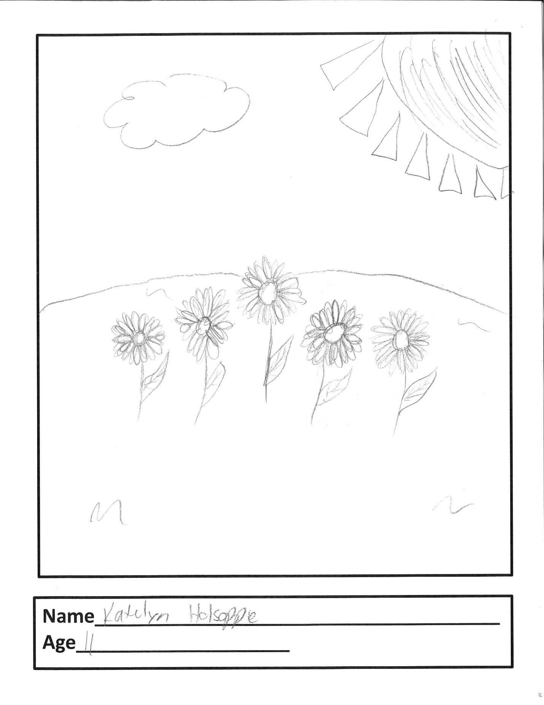

WELCOME TO OUR WORSHIP!

- It is a joy to welcome our visitors! Please sign the guest book in the
Communication Center at the rear of the church, to the right as you exit, and take a Welcome Packet which is filled with information about Harrold Zion. Please introduce yourself to the pastor as you leave worship. We hope you return soon! Follow us on social media!
- Children’s bags are available in the Narthex.
- There is a prayer request book on a podium in the Welcome Center. Please write name(s) in the book prior to the service to have names included in the prayers.
- Large print bulletins are available from any usher for those needing them.
- Hearing devices are available from any usher for those needing them.
- An AED machine can be found on the wall after the Ladies Room on the left.
- Receiving Holy Communion - We believe the body and blood of Christ to be present in the bread and wine. All who are baptized are invited to share in this meal. Please come forward at the usher's direction. Non-communing children may come forward for a blessing. If you desire communion in the pew, please inform one of the ushers so that you may receive communion there.

Our MISSION
To Worship and Serve God,
Grow Disciples and Love our Neighbors

Our Vision
Building Faith that’s Open, Affirming, Authentic,
Positive, Inviting, and that Serves Others.

GATHERING – We are brought together to remember who and whose we are.
Welcome, Sharing and Announcements

Prelude: Resurrection Song Glyncannon

Alleluia! Christ is risen.
Christ is risen indeed. Alleluia!

Thanksgiving for Baptism
All may make the sign of the cross, the sign that is marked at baptism, as the presiding minister begins.
Blessed be the holy Trinity, ☩ one God, the wellspring of grace,
our Easter and our joy.
Amen.
Look, here is water!
Here is our water of life! Alleluia!
Immersed in the promises of baptism, let us give thanks for what God has done for us. We give you thanks, O God, for in the beginning your voice thundered over the deep and water became the essence of life. Adam and Eve beheld Eden’s verdant rivers. The ark carried your creation through the flood into a new day. Miriam led the dancing as your people passed through the sea
into freedom’s land. In a desert pool the Ethiopian official entered your boundless baptismal life. Look, here is water!
Here is our water of life! Alleluia!
At the river your beloved Son was baptized by John and anointed with the Holy Spirit. By the baptism of Jesus’ death and resurrection you opened the floodgates of your reconciling love, freeing us to live as Easter people.
We rejoice with glad hearts, giving all honor and praise to you, through the risen Christ, our source of living water, in the unity of the Holy Spirit, now and forever. Amen. Look, here is water!
Here is our water of life! Alleluia!

Alleluia! Christ is risen.
Christ is risen indeed. Alleluia!

Gathering Hymn #366 The Strife is O’er

Greeting and Kyrie: The grace of our Lord Jesus Christ, the love of God, and the communion of the Holy Spirit be with you all. And also with you.
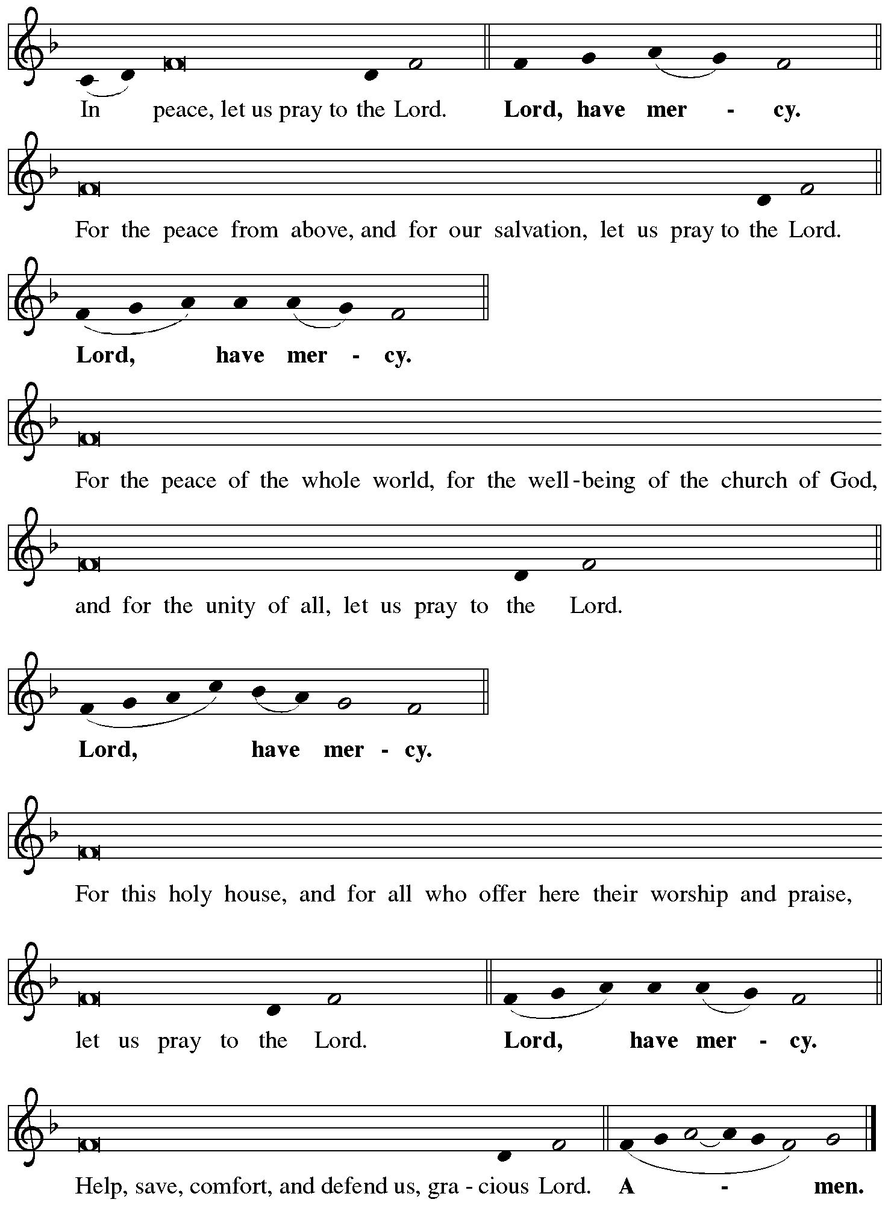

Hymn of Praise
WORD – We hear God’s teachings to guide our path of serving.

Prayer of the Day
Let us pray together.
Holy and righteous God, you are the author of life, and you adopt us to be your children. Fill us with your words of life, that we may live as witnesses to the resurrection of your Son, Jesus Christ, our Savior and Lord, who lives and reigns with you and the Holy Spirit, one God, now and forever. Amen.
Please be seated.
First Reading: Acts 3:12-19
¹²[Peter] addressed the people, “You Israelites, why do you wonder at this, or why do you stare at us, as though by our own power or piety we had made him walk?¹³The God of Abraham, the God of Isaac, and the God of Jacob, the God of our ancestors has glorified his servant Jesus, whom you handed over and rejected in the presence of Pilate, though he had decided to release him. ¹⁴But you rejected the Holy and Righteous One and asked to have a murderer given to you, ¹⁵and you killed the Author of life, whom God raised from the dead. To this we are witnesses. ¹⁶And by faith in his name, his name itself has made this man strong, whom you see and know; and the faith that is through Jesus has given him this perfect health in the presence of all of you.
¹⁷“And now, friends, I know that you acted in ignorance, as did also your rulers. ¹⁸In this way God fulfilled what he had foretold through all the prophets, that his Messiah would suffer. ¹⁹Repent therefore, and turn to God so that your sins may be wiped out.”

The word of the Lord.
Thanks be to God.

Choir Anthem: I Then Shall Live Fettke

Psalm: 4
¹Answer me when I call, O God, defender of my cause;
you set me free when I was in distress; have mercy on me and | hear my prayer.
²“You mortals, how long will you dishonor my glory;
how long will you love illusions and seek after lies?”
³Know that the Lord does wonders for the faithful;
the Lord will hear me when I call.
⁴Tremble, then, and do not sin;
speak to your heart in silence upon your bed.
⁵Offer the appointed sacrifices,
and put your trust in the Lord.
⁶Many are saying, “Who will show us any good?”
Let the light of your face shine upon us, O Lord.
⁷You have put gladness in my heart,
more than when grain and wine abound.
⁸In peace, I will lie down and sleep;
for you alone, O Lord, make me rest secure.

Second Reading: 1 John 3:1-7
¹See what love the Father has given us, that we should be called children of God; and that is what we are. The reason the world does not know us is that it did not know him. ²Beloved, we are God’s children now; what we will be has not yet been revealed. What we do know is this: when he is revealed, we will be like him, for we will see him as he is. ³And all who have this hope in him purify themselves, just as he is pure.
⁴Everyone who commits sin is guilty of lawlessness; sin is lawlessness. ⁵You know that he was revealed to take away sins, and in him there is no sin. ⁶No one who abides in him sins; no one who sins has either seen him or known him. ⁷Little children, let no one deceive you. Everyone who does what is right is righteous, just as he is righteous.

The word of the Lord.
Thanks be to God.

Gospel Acclamation (Please Stand as able.) Celtic Alleluia

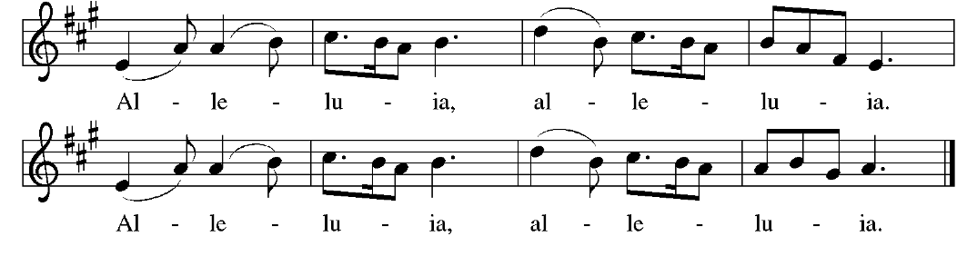

Gospel: Luke 24:36b-48
The Holy Gospel according to Saint Luke, the twenty-fourth chapter.
Glory to you, O Lord.
^{36b}Jesus himself stood among [the disciples] and said to them, “Peace be with you.” ³⁷They were startled and terrified, and thought that they were seeing a ghost. ³⁸He said to them, “Why are you frightened, and why do doubts arise in your hearts? ³⁹Look at my hands and my feet; see that it is I myself. Touch me and see; for a ghost does not have flesh and bones as you see that I have.” ⁴⁰And when he had said this, he showed them his hands and his feet. ⁴¹While in their joy they were disbelieving and still wondering, he said to them, “Have you anything here to eat?” ⁴²They gave him a piece of broiled fish, ⁴³and he took it and ate in their presence.
⁴⁴Then he said to them, “These are my words that I spoke to you while I was still with you—that everything written about me in the law of Moses, the prophets, and the psalms must be fulfilled.” ⁴⁵Then he opened their minds to understand the scriptures, ⁴⁶and he said to them, “Thus it is written, that the Messiah is to suffer and to rise from the dead on the third day, ⁴⁷and that repentance and forgiveness of sins is to be proclaimed in his name to all nations, beginning from Jerusalem. ⁴⁸You are witnesses of these things.”
The gospel of the Lord.
Praise to you, O Christ.

Please be seated.
Children’s Message

Sermon

Please stand, as able.

Hymn of the Day # 379 Now the Green Blade Rises

Nicene Creed
We believe in one God, the Father, the Almighty, maker of heaven and
earth, of all that is, seen and unseen.
We believe in one Lord, Jesus Christ, the only son of God, eternally
begotten of the Father, God from God, Light from Light, true God from true God, begotten, not made, of one being with the Father. Through him all things were made. For us, and for our salvation he came down from heaven; by the power of the Holy Spirit he became incarnate from the virgin Mary, and was made man. For our sake he was crucified under Pontius Pilate; he suffered death and was buried. On the third day he rose again in accordance with the Scripture; he ascended into heaven and is seated at the right hand of the Father. He will come again in glory to judge the living and the dead, and his kingdom will have no end.
We believe in the Holy Spirit, the Lord, the giver of life, who proceeds
from the Father and the Son. With the Father and the Son he is
worshiped and glorified. He has spoken through the prophets.
We believe in one holy catholic and apostolic Church. We
acknowledge one Baptism for the forgiveness of sins. We look
for the resurrection of the dead, and the life of the world to come. Amen.

Prayers of Intercession

(petitions)…Lord in your mercy. Hear our prayer.
(prayer concludes)…Amen.

Sharing of the Peace

Offering Song of the Redeemed Stairs
Our Secure Tithely Giving Form

Offertory

Offertory Prayer
Let us pray together. Blessed are you, O God, ruler of heaven and earth. Day by day you shower us with blessings. As you have raised us to new life in Christ, give us glad and generous hearts, ready to praise you and to respond to those in need, through Jesus Christ, our Savior and Lord.
Amen.

Lord’s Prayer
Lord remember us in your kingdom and teach us to pray:
Our Father, who art in heaven, hallowed be thy name, thy kingdom come, thy will be done, on earth as it is in heaven. Give us this day our daily bread; and forgive us our trespasses, as we forgive those who trespass against us; and lead us not into temptation, but deliver us from evil. For thine is the kingdom, and the power, and the glory, forever and ever. Amen.

SENDING – We are set out to share hope and make disciples.

Benediction
Alleluia! Christ is risen!
Christ is risen indeed! Alleluia!
The God of resurrection power, the Christ of unending joy, and the Spirit of Easter hope ☩ bless you now and always.
Amen.

Sending Hymn: #377 Alleluia! Jesus is Risen

Dismissal
Alleluia! Go in peace. Rejoice and be glad.
Thanks be to God. Alleluia!

Postlude: Postludium Nordman

From sundaysandseasons.com. Copyright © 2023 Augsburg Fortress. All rights reserved. Reprinted by permission under Augsburg Fortress Liturgies Annual License #SAS006821. New Revised Standard Version Bible, Copyright © 1989, Division of Christian Education of the National Council of the Churches of Christ in the United States of America. Used by permission. All rights reserved. Revised Common Lectionary, Copyright © 1992 Consultation on Common Texts, admin Augsburg Fortress. Used by permission. CCLI Streaming License #20189555 CCLI, Church Copyright License #11344725. "Resurrection Song" One License # 228240; "Song of the Redeemed" One License #1056081; "Postludium" One License #1012642; "Now the Green Blade Grass" One License #AF20210624; "Alleluia! Jesus is Risen" One License #01600; "I Then Shall Live" (Gaither, Sibelius, Arr. Fettke) Copyright 1981 and 2018 Hanna Street Music and Lorenz Publishing Company. Livestreamed with permission under ONE License, License # A-732944 All Rights Reserved.

FLOWERS ON THE ALTAR ARE DEDICATED To the honor of God and in memory of my mom, Betty McCormick by Missy DiRado.
THE ROSE ON THE ALTAR IS DEDICATED to the honor of God and in honor of Fred Wineman on his birthday by Ann, Lori and Trisha,
THE CANDLE IS DEDICATED to the honor of God and is in memory of Bessie B. Benson by Mark and Arlene Wagner.

PLEASE TAKE A MOMENT to fill out a “communion card” for each person if you have not done so this year. They can be found in the pew rack in front of you. Please place the completed card in the offering plate.

WE THANK TODAY’S SERVICE PARTICIPANTS
Lectors: 8:00 AM Linda Boyer
10:30 AM Jack Molnar
Acolytes: 8:00 AM Madison Hoffman
10:30 AM Zach Hayes
Ushers: 8:00 AM Pat Boyer, Linda Boyer
10:30 AM Jerry Starenchak, Rick Yaksic, Dave Henry
Altar Guild: Susie Eicher
OFFICE HOURS MON-TH 9:00 AM–2:00 PM, FRIDAY 9 AM-12PM
On call for pastoral emergencies: Pastor Andrew is from Monday-Thursday. Pastor Caroline is from Friday– Sunday.

Sunday
9:15 AM Parent’s Breakfast
9:15 AM Altar Care Training
11:45 AM Fellowship Committee
Monday
Tuesday
9:30 AM PS Library Speech
Wednesday
6:00 PM Bell Choir
7:00 PM Adult Choir

Thursday
10:30 AM Bible Study w/ P Andrew
11:00 AM PS Library
7:00 PM Boy Scouts
Friday
10:00 AM Ladies Bible Study
Saturday
5:00 PM Communion

New Bible Study with Pastor Andrew: “Resurrection Ripples” – every Thursday at 10:30am starting April 11th. We will be covering the contexts, background, and everyday impacts of the Acts texts, the Revelation texts, and related Bible sections of the Easter season. We will wrestle with the faith questions of what does it mean to be Easter people in this day?

Camp Lutherlyn is having a Camp Blast on Saturday May 11 from 11 am to 4:30 pm. it will be a day of fun with all that Lutherlyn has to offer. Campfire. Gaga ball, Archary, Zipline, Crafts, Bouldering Room, Hiking, Nature Activities Canoeing, Hay Rides, Games, Sports, Archaeology, Jump Pillow, Kayaking, Lego Room, Tours, Great Food and more. There is no registration. This is a free event!
Please Consider: Camp registrations are now open for summer campers! $100 off for first time campers…IT IS $50 OFF for half week campers. There is a discount code for this it is First. It doesn’t apply for Family Camp, Confirmation Camp, Day Camps, or Small Fry Days. Register at LUTHERLYN.COM/SUMMERCAMP Please see/or call Rob Hepler for more information. 724-446-2174. We want to be sure that every child or youth that wants to go to Lutherlyn can go—we have camp scholarships!

Giant Yard Sale/Craft Vendors
Saturday June 1st from 8 AM – 1 PM Harrold Zion will be having a Yard Sale/Craft Sales. If you have stuff to sell, this is the event for you. To be a vendor at the event, the cost will be $20 for parking lot space or $25 for space and one table provided by the church for your setup (Only 20 table are available for first 20 registered). If you have items to sale but do not want to be a vendor during the event, we will be accepting donations of sellable items which will be sold by the Trash & Treasure Sale volunteers. (There is a separate Sign up in communication center for this) You may bring your items to church on May 28th, 29th, or 30th from 5 – 7 PM. Drop off will be in the upstairs Pre-School room. All items will be tagged and marked to sell so please don’t be emotionally upset if items are priced different than what you intend. Please sign-up in the communication center to reserve spot and if you need a table. We would also like to have baked goods to sell at the event so we are looking for volunteers to bake cookies/cakes/pies/breads/etc… There will be a concession table selling breakfast and lunch items for sale all day. All proceeds from the rentals, item donations, and concession/baked goods tables go towards the church general fund and meeting the yearly budget. Vendors are always welcome to donate a percentage of their earnings from the event. Registration money is payable to Brad Zundel or the church office (You will receive a numbered Vendor ticket).

Blood Drive There is a Vitalant Blood Drive on May 10. It will be from 12:00 pm-6:00 pm. Register online at Vitalant, org, call 412-209-7000 or the church at 724-837-7327.

Grief Support Group: We are going to begin another grief support group here at Harrold Zion for those who have lost loved ones. The group will begin on April 18th at 3:00 PM here at the church. The group will meet for at least six weeks. We may have other groups after this group ends. If you are interested or have questions, please contact Pr. Caroline at pastorcarolinehzlc@gmail.com or call the church office.

Summer Book Class: Deb Mertz and Pr. Caroline are offering a class this summer using the book, “Believe: Living the story of the Bible to become like Jesus,” edited by Randy Frazee. We will be doing the second 10 lessons of the book. You are welcome to attend even if you could not attend the previous class. There is a book and a study guide. Please contact Pr. Caroline at pastorcarolinehzlc@gmail.com or Deb Mertz at deb_mertz@att.net if you are interested or talk to either one at church. We are having the class on Tuesdays, 6:30 PM, here at the church. It will begin Tuesday, April 16th, and it will last 10 weeks. We will not meet during the week of VBS, June 11th. The last class will be on June 25^{th.}

ITEMS AVAILABLE FOR SPONSORSHIP:
Flowers available:
May 4/5 (2 Vases), May11/12 (1 Vase)
Roses April 20/21 (2 Roses), April 27/28 (2 Roses), May 4/5 (2 Roses), May11/12 (2 Roses)
April 27/28 (Candle), May 11/12(Candle)
Bulletin April 20/21, May 4/5, May 11/12
To sponsor items, please sign up in the Communication Center.

Church Staff and Office
Rev. Andrew Fitch, Senior Pastor - 570-768-8455, pastorfitch@outlook.com
Rev. Caroline Clifford, PhD, Asst. Pastor – 814-769-5662 pastorcarolinehzlc@gmail.com
Sheri Anderson, Coordinator of Family Ministries - hzlcyouth@gmail.com
Laurie Racculia, Director of Music Ministries - lracculia@yahoo.com
Robyn Henry, Secretary, robynhzlc@gmail.com
Debby Schlegel, Custodian
Joanne Gebhardt, Sunday Organist
Melanie Altman, Saturday Organist

